


United Nations Development Programme
Country: Egypt
PROJECT DOCUMENT
Project Title: Grid-Connected Small-Scale Photovoltaic Systems
UNDAF Outcome(s): Environment and Natural Resources Management
UNDP Strategic Plan Environment and Sustainable Development Primary Outcome: Growth is inclusive and sustainable, incorporating productive capacities that create employment and livelihoods for the poor and excluded
Expected CP Outcome(s): The Government of Egypt, private sector and civil society have complied with Multilateral Environmental Agreements, adopted policies, and implemented operational measures towards a green and sustainable economy and society including, EE, RE, low carbon cleaner technologies, SWM, POPs, ODS, and carbon finance mechanisms.
Executing Entity/Implementing Partner: Industrial Modernisation Centre of the Ministry of Industry and Foreign Trade
Implementing Entity/Responsible Partners: United Nations Development Programme

Brief Description
The project will catalyse the development of decentralised, grid-connected small-scale renewable energy (RE) power generation market in Egypt and the solar PV in particular. The target is to facilitate the installation of at least 4 MW_{p} of new decentralised private PV capacity during the lifetime of the project, resulting in direct GHG reduction benefits of 66 kilotonnes of CO_{2eq}. Complementary indirect mitigation benefits are expected from the sustained market growth of the PV market after the project with estimated GHG reduction of about 0.6-0.7 million tonnes of CO_{2eq}.
Programme Period: 2014-2019
Atlas Award ID: 00080742
Project ID: 00090324
PIMS # 4998
Start date: March, 2014
End Date August 31, 2019
Management Arrangements NIM
PAC Meeting Date 29 March 2015

table of contents
Total resources required US$ 33,796,364
Total allocated resources: US$ 33,796,364
- Regular UNDP (TRAC-Cash) US$ 50,000
- UNDP projects (Cash) US$ 400,000
- Other:
  - GEF (cash) US$ 3,536,364
  - Egypt ERA (Parallel) US$ 15,000,000
  - MoEE (Parallel) US$ 10,000,000
  - EEU (Parallel) US$ 4,110,000
  - IMC (in-kind) US$ 500,000
  - RCREEE (in-kind) US$ 200,000

Breakdown in Page 52
1. Situation analysis 6
1.1. Context and Global Significance 6
1.2 Baseline, barriers and current government policy to address the root causes
and threats 12
1.3 Institutional Framework and Stakeholder Analysis 15
1.4 Baseline Projects and Other Related Past and Ongoing Activities 18
2. Project Strategy 21
2.1 Project Objective, Outcomes and Outputs 21
2.2 Project indicators, Risks and Assumptions 32
2.3 Expected Global, National and Local Benefits 35
2.4 Project Rationale and GEF Policy Conformity 37
2.5 Country Ownership: Country Eligibility and Country Drivenness 38
2.6 Financial Modality and Cost-Effectiveness 39
2.7 Sustainability (including Financial Sustainability) 40
2.8 Replicability 40
3. Project Results Framework 42
3.1 Project Outputs and Related Target(s) / Sub-target(s), as applicable 45
3.2 Total Budget and Workplan 48
3.3 Budget Notes 49
3.4 Summary of Funds 50
3.5 Summary of project co-financing (in USD) 51
4. Management Arrangements 52
5. Monitoring Framework and Evaluation 54
6. Legal Context 58
7. ANNEXES 59
Annex 7.1 Offline Risk Log 59
Annex 7.2 Agreements 62
Annex 7.3 Summary of Proposed PV Support Scheme and Related GEF Cost-Sharing 69
Annex 7.4 Terms of Reference 71
Annex 7.5 Greenhouse Gas Emission Reduction Analysis 77
Annex 7.6 Stakeholder Involvement Plan 80
Annex 7.7 Electricity tariffs and consumers as of 2012-2013 (Source: EgyptERA) 82
Annex 7.8 UNDP Environmental & Social Safeguards 83
Annex 7.9 Letter of Agreement between UNDP and the Industrial Modernisation
Center of Egypt 92
SIGNATURE PAGE 95

List of acronyms
AFD Agence Française de Développement (French Agency for Development)
AfDB African Development Bank
AIB Association of Issuing Bodies governing the European Energy Certificate System (EECS)
BOO Build, Own and Operate
CAPMAS Egyptian Central Agency for Public Mobilisation and Statistics
CC Combined Cycle
CDM Clean Development Mechanism
CO UNDP Country Office
CO₂ Carbon dioxide
CSP Concentrating Solar Power
EE Energy Efficiency
EEAA Egyptian Environmental Affairs Agency
EECS European Energy Certificate System
EEHC Egyptian Electricity Holding Company
EEIGGR UNEP/GEF Energy Efficiency Improvement and Greenhouse Gas Reduction Project
EETC Egyptian Electricity Transmission Company
EEU Energy Efficiency Unit
EEUCPRA/EgyptERA Electric Utility and Consumer Protection Regulatory Agency
EFI Egyptian Federation of Industry
EGP Egyptian Pound
EU European Union
GDP Gross Domestic Product
GEF Global Environment Facility
GHG Greenhouse Gas
GoE Government of Egypt
GoO Guarantee of Origin
GT Gas turbine
HQ UNDP Headquarters
IEA International Energy Agency
ICT Information and Communication Technology
IDSC Information and Decision Support Centre
IMC Industrial Modernisation Centre of the Ministry of Industry and Trade
JCEE Egyptian-German High Level Joint Committee for Cooperation on Renewable Energy, Energy Efficiency and Environmental Protection
LOLE Loss of Load Expectation
LNG Liquefied Natural Gas
MMBtu Million British Thermal Units
M&E Monitoring and Evaluation
MoEE Ministry of Electricity and Energy
MoFA Ministry of Foreign Affairs
MoTI Ministry of Trade and Industry
MRV Monitoring, Reporting and Verification
NAMA Nationally Appropriate Mitigation Action
NG Natural Gas
NGO Non-Governmental Organisation
NREA New and Renewable Energy Authority
O&M Operation & Maintenance
PB Project Board
PIR Project Implementation Review
PMU Project Management Unit
PPG Project Preparation Grant
PPP Purchasing Power Parity
Pt Piaster (1/100 of Egyptian Pound)
PV Photovoltaic
QPR Quarterly Progress Report
RCU UNDP Regional Coordination Unit
RCREEE Regional Centre for Renewable Energy and Energy Efficiency
RE Renewable Energy
RTA Region-Based Technical Advisor (UNDP)
ST Steam turbine
SWH Solar water heater
TPR Tripartite Review
TTR Terminal Tripartite Review
TWh Terawatt hour
WB World Bank
UNDAF United Nations Development Assistance Framework
UNDP United Nations Development Programme
UNEP United Nations Environment Programme
UNFCCC United Nations Framework Convention on Climate Change

Situation analysis

Context and Global Significance
- Egypt’s electricity consumption has continued to increase rapidly from 85 TWh in 2004/2005 to over 140 TWh in 2012/2013, with a corresponding increase in electricity generation from 101 TWh to 164 TWh, representing an average annual growth rate of 7%. Since more than 99% of the population has access to grid electricity, the growth in demand is driven by higher consumption of existing customers and growth of the customer base rather than by increasing connectivity (grid expansion).
- The total installed power generation capacity in the end of June 2013 was 30,800 MW. Close to 90% of this capacity is thermal power generation running primarily (80%) on natural gas. Heavy fuel oil is used as complementary fuel. Electricity produced by renewable energy represented less than 10% of all power generation in 2012/2013.

Figure 1.1 Installed Capacity Development, 2008 - 2013³
- The GHG emissions from electricity generation in 2011/2012 were over 74 million tonnes of CO_{2eq}: i.e. 40% of all energy-related GHG emissions, or 33% of Egypt’s total anthropogenic GHG emissions. The total energy-related GHG emissions in 2011/2012 are estimated as 182 million tonnes of CO_{2eq}, placing Egypt among the top 20 GEF programme countries globally. Thus, any successful carbon mitigation activities in Egypt will also have a significant impact on GHG emissions in the global context.
- Egypt has been experiencing a significant power shortage in recent years. Blackouts had previously been confined to rural areas, where the grid quality is lower and power supply tends to be restricted first when there are supply-demand imbalances. However, the appearance of load-shedding in the major cities is indicative of increasingly severe problems. Although recent power cuts have been blamed primarily on a lack of fuel rather than a lack of power generation capacity, there is actually a shortage of both. Recent statements by the Minister of Electricity indicate that consumers will experience power outages of up to six hours a day this summer.
- In order to keep up with demand, the sixth Five Year Plan of the Government of Egypt (2007-2012) included construction of new combined cycle gas power plants with a total capacity of 3,000 MW at El Atf, Sidi Krir, El Nubaria and Kuriemat, and new conventional steam units with a total capacity of 4,000 MW at El Tebein, Cairo West, Abu Kir and El Sokhna. Delays in the Abu Kir and El Sokhna projects and the cancellation of Newibaa project, in addition to unexpectedly high summer temperatures in the past few years, resulted in drastic shortages of electricity supply. Therefore, a “fast track programme” for constructing gas turbines with total installed capacity of 2,600 MW was implemented in 2011/2012 to meet the peak demand during the summer.
- The seventh Five Year Plan (2012-2017) foresees the construction of 12,400 MW of new thermal power capacity, of which the 3,000 MW combined cycle plants in North Giza (1, 2, 3) and Banha and the 3,900 MW conventional steam unit plants in El Suez, South Helwan and Safaga are envisaged to be built, owned and operated by the EEHC, while the private sector will be invited to build, own and operate a 3 x 750 MW combined cycle power plant in Dayrout, a 2 x 650 MW steam power plant at Kena and a 3 x 650 MW steam power plant in El Ayat.
- The total investment needs for the construction of the listed power generation projects in the seventh Five Year Plan have been estimated as being approximately EGP 77 billion (USD 11.2 billion), of which the EEHC and its affiliated companies are expected to finance EGP 43 billion and the private sector the remaining EGP 34 billion.
- The power generation costs of the planned new thermal power plants depend primarily on the price of the natural gas used. Natural gas is explored and produced in Egypt by international oil and gas companies on the basis of production-sharing agreements, under which a fraction of the production is considered to be the Government of Egypt's (GoE’s) share. Until the late 1990s, the agreed GoE share was sufficient to meet domestic demand, including the needs of power generation as the main user of natural gas. Since 2000, however, the balance has started to shift to the extent that the main gas producers in Egypt have been forced to significantly cut their gas (LNG) exports and the GoE has reduced its piped gas to Israel and Jordan. In order to ensure adequate gas supply for power generation, gas supply has also been reduced to domestic industry and has been accompanied by price increases. The new gas price to the cement industry, for instance, is now set at USD 6 per MMBtu, up from $3/MMBtu in 2011.

Figure 1.2 Production and export of natural gas in Egypt, 2008-2012. (Sources: IEA Energy Statistics for 2008-2011 and BP Statistical Review of World Energy 2013 (https://www.bp.com/statisticalreview).
- The price that Egypt pays to international gas companies for the gas exceeding the initial GoE production allocation has not been published, but can be expected to be in the range of USD 2.5 to 4+ per MMBtu. For complementary sources, such as imported LNG, which has been considered by the GoE to meet rapidly growing demand, the price is significantly higher, at an estimated USD 10-15 per MMBtu, including terminal, regasification and distribution costs. The price the local power generation companies are asked to pay for natural gas is USD 1.25 per MMBtu while, in reality, they have been reported to pay only USD 0.67 USD per MMBtu. The difference has been considered as a debt to be paid later. However, the issue of whose responsibility it is to pay this debt, given that electricity tariffs are artificially low and controlled by the Government, has been highly debated. For further information, a good overview of natural gas pricing policy in Egypt can be found, among others, in the May 2013 issue of “Egypt Oil and Gas” and the Country Reports of the EU-funded “Paving the Way to the Mediterranean Solar Plan” (PWMSP) project.
- In Figure 1.2, the power generation costs of different types of gas-fired power plants are compared with the costs of electricity produced by wind and PV. As demonstrated by the graph, with the current subsidised fuel prices there is no room for cost competition by any new renewable energy power source. However, when calculating the costs on the basis of applicable market prices or the marginal costs of fuel (which, by virtue of the current gas supply situation in Egypt, would correspond to the price of imported LNG), the situation is fundamentally different. Wind energy especially, but also increasingly solar PV, can provide a competitive power generation source to traditional fossil fuel-based thermal power generation.

Figure 1.2 Estimated power generation costs of different types of new power plants in Egypt (with a discount rate of 5% over 25 years). For the gas price, USD 1.8 per MBtu (subsidised) and USD 14 per MBtu (marginal) for imported LNG including re-gasification and distribution costs has been used.
- While the Government has started to take steps to rationalise energy prices to better reflect the real costs of supply, tariff reform is difficult to design and implement rapidly on a full cost-recovery basis and also has to factor in social considerations. The original plan was to phase out subsidies for electricity and gasoline completely by 2014 and only continue them for butane, but this schedule has been delayed due to the global financial crisis in 2009 and later political instability.
- After the Government announced that butane would be excluded from the reform plan, a decision was taken in April 2013 to raise the price of gas cylinders sold for domestic use from 5 to 8 Egyptian pounds (a 60% increase), and to double to EGP 16 the price of butane for commercial use. This was met by public discontent, but the real problem was the shortage of supply, driving prices in the informal market up to 60-70 Egyptian pounds. Although not directly related to electricity supply, this illustrates the problems faced by the Government with regard to energy price reforms.
- Since 2007, electricity subsidies for industrial customers have been gradually reduced, together with the introduction of new time-of-use (ToU) tariffs for major consumers, while some cross-subsidies between the different industrial consumer groups still remain. For the residential sector, the subsidies have largely remained intact, reaching EGP 13.2 billion in total in 2012/2013. Another significant subsidy is provided to support the electricity tariff in the agricultural sector, so as to encourage land reclamation projects. The current electricity tariffs for different consumer groups are presented on the website of the Egyptian Electric Utility and Consumer Protection Regulatory Agency. The EEHC long-run marginal cost of electricity generation, transmission and distribution have been estimated to reach EGP 0.80-1 (around 12-15 US cents) per kWh, while the average power generation costs of the current system with subsidised fuel prices has been estimated to be around 4.5 US cents per kWh, with transmission and distribution losses accounting for an extra 2 US cents per kWh.
- While large capital investments are required for securing adequate and reliable supply of energy, at the same time subsidised energy prices remain a burden on the state budget. Every unit of natural gas or oil consumption saved through improved energy efficiency and/or increased use of renewable energy would contribute positively to the State budget by releasing more gas for export and/or obviating the need for imported gas.
- In addition to the observed downward cost trend of renewable energy power generation, a major advantage of both wind and PV plants is their short construction time compared with their thermal counterparts. As such, they can contribute to the mitigation of the most acute gas and power supply problems, while in the longer term becoming a sustainable element of the overall energy supply structure and strategy.
- The situation also needs to be looked at from the overall power system operation and load management perspective. In Egypt, peak loads are typically in the evenings after sunset and are addressed through easily-regulated hydro power, for which regulation capacity is almost in full use already, as illustrated by Figure 1.3 below.
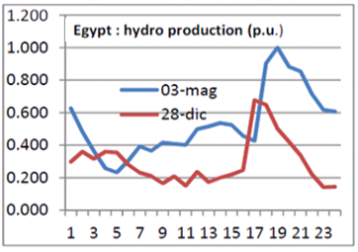
Figure 1.3 Hydro power generation per hour during a typical winter and summer day.
- The targeted, relatively small, amount of PV capacity to be installed in the context of this project is not going to have any significant impact from the overall system management point of view. But, with a longer-term market take-off similar to that of Germany, for instance, this would become an issue and the specific characteristics of the PV power generation would need to be taken into account from the overall power system management perspective. In this context, the possibilities for electricity trade with neighbouring countries should also be considered. As an example, an agreement between Egypt and Saudi Arabia already exists to balance daily loads through electricity transfer facilitated by the construction of a new high-capacity (500 kV- 3,000 MW) transmission line between the two countries. While the peak load in Egypt is typically in the evenings, Saudi Arabia experiences its peak in the middle of the day. Such differences, and the resulting opportunities for load management through cross-border electricity trade, provide notable opportunities to also increase variable RE power generation. The tendering for the construction of the new transmission line between Egypt and Saudi Arabia is expected to be finalised during the first half of 2014, in which case it could start to operate in 2-3 years’ time.
- Until now, electricity trade between Egypt and neighbouring countries has been limited. This trade has the potential to be significantly scaled-up, thereby creating a truly regional electricity market, as illustrated in Figure 1.4 below. Besides the already-agreed interconnection with Saudi Arabia, Egypt has participated in the Nile Basin Initiative and the study of energy trade between Egypt, Ethiopia and Sudan. Egypt is also part of the East African Power Pool, with Sudan, Libya, Kenya, Burundi, the Democratic Republic of Congo, Ethiopia, Rwanda, Tanzania and Uganda. Egypt is also a member of the Union for the Mediterranean (UfM) and has participated in related technical studies, such as the Mediterranean Solar Plan of the UfM Secretariat and the Observatoire Méditerranéen de l’Energie (OME) study of electrical interconnection of the Mediterranean countries: i.e. connecting the European network with North Africa and the Middle-East through Turkey, Spain and, eventually, Italy.
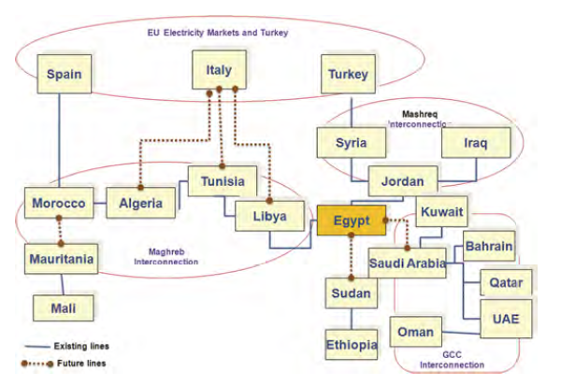
Figure 1.4 Egypt’s potential for becoming an energy hub (Source: African Development Bank, Power Sector in Brief, 2010).
- The potential for significantly expanding hydro-power generation in Egypt is limited, as elaborated in further detail below (paragraph 32), but gas turbines and utility-scale gas diesels may provide a complementary alternative for required hourly and daily load management when accompanied by potential demand-side measures (such as smart meters, time-of-use tariffs, etc.).
- In recent years, the demand for ‘green’ electricity has increased from a range of Egyptian consumers, who have expressed their willingness to pay a premium price for electricity produced in an environmentally sustainable way as a part of their corporate social responsibility programmes and/or to comply with their parent multinational company policies to reduce their carbon footprint and to enhance their environmental image in general. Examples of such companies include Mobinil Egypt, which has been using PV power generation instead of diesel generators in remote sites such that its renewable energy generation now exceeds 1 GWh per year (corresponding to a capacity of about 670 kW_{p}). Another example is HBEG (HSBC Bank Egypt), which, in 2011, as part of the global HSBC Climate Partnership Programme, developed almost 30 Climate Champions in Egypt, which have been contributing to the reduction of the collective carbon footprint of Egypt by various means.
- The move towards “going-green” has also gained Government support, especially in the tourism sector. Hotels have received Government incentives, such as investment tax exemptions, to increase the share of energy they receive from renewable energy sources. In June 2013, the Ministry of Tourism signed a protocol with the National Bank of Egypt and the Egyptian Hotel Association to extend concessional loans (with an average interest rate of 2%) to facilities wishing to invest in renewable energy, primarily solar water heating.
- From the global perspective, it is essential that new markets be opened up for sustaining the positive trend of PV and other small, decentralised RE applications. As recently concluded by the European Photovoltaic Industry Association, this process has already started. The total installed global PV capacity at the end of 2012 was estimated at about 102,000 MW_{p}, an increase of more than 40% since 2011. In 2011, more than 70% of all new PV installations were in Europe, whereas by 2012 this share had fallen to 55%. In 2013, the countries driving the PV market growth were China, the USA, Japan and India. As illustrated in Figure 1.5 below, the available solar resources in Egypt would compete well with all of these countries.
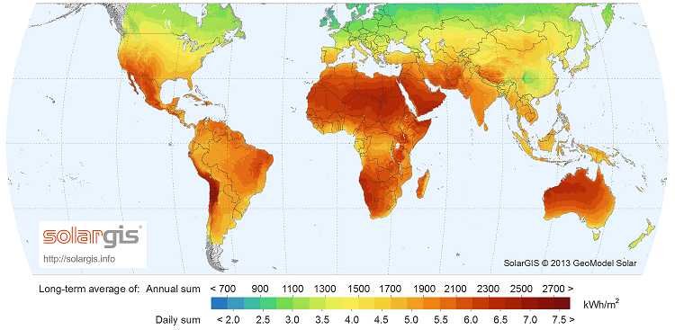
Figure 1.5 World solar resource map, showing Egypt among the areas with highest solar irradiance.
  - Baseline, barriers and current government policy to address the root causes and
threats
- Egypt’s national power sector strategy (www.moee.gov.eg) includes the following targets:
- To optimise the use of available energy resources and minimise environmental pollution;
- To provide electricity at minimum price and best quality;
- To restructure the electricity sector to optimise investments and improve electrical services;
- To utilise modern and sophisticated technical systems in the electricity sector's operation and activities; and
- To develop the expertise and skills of engineers and technicians working in the sector.
- On April 10, 2007, the Supreme Energy Council of Egypt adopted an ambitious plan to increase the share of electricity produced by renewable energy sources up to 20% of total electricity generation by 2020. Hydro-power is envisaged to contribute 6%, wind 12% and other renewable energy sources, in particular solar energy, 2%. To complement this plan, the Cabinet of Ministers agreed in July 2012 to enforce the Egyptian Solar Plan, which aims to establish 3,500 MW of installed solar capacity by 2027, including 2,800 MW of CSP and 700 MW of PV and with the participation of the private sector in 67% of this capacity.
- Despite power shortages and abundant solar (and wind) resources in Egypt, private-sector (Independent Power Producer, IPP) solar and wind power generation is still virtually non-existent in Egypt. According to the most recent report of New and Renewable Energy Authority (NREA), the total installed wind capacity in 2012 was 550 MW, consisting of the 5 MW Hurghada and 545 MW Zarafana wind farms, both owned by NREA and financed by international cooperation initiatives with grants and low-cost loans. For solar power, the current estimated capacity is around 35 MW, consisting of the 20 MW solar thermal power generation plant in Kuriemat supported by Japanese and GEF financing (see paragraph 31 for further details) and 15 MW of decentralised, primarily off-grid, PV installations for lighting, cooling, water pumping, telecommunications and advertising purposes. The prevailing fossil fuel and electricity subsidy environment, together with inadequate financial and fiscal incentives to encourage further development of RE power generation, have effectively prevented the private sector from investing further in RE development. By virtue of recent Government initiatives, as discussed in further detail below, this situation may, however, be starting to change.
- Apart from Law 102, which was adopted in 1986 and which established the New and Renewable Energy Authority (NREA), there is no specific renewable energy law in Egypt. The new Electricity Law, which has been drafted but which has not yet entered into force, does include, however, several provisions to determine how the next phases of renewable development should proceed in Egypt. Article 45 of the draft law sets out the process for the procurement of electricity from renewable energy sources using several options, including competitive bidding and feed-in tariffs. The intention is to use competitive bidding for larger projects on state-owned land together with complementary (to the extent feasible) criteria for the domestic content of such projects to support the development of a national RE industry. This competitive bidding is also expected to inform the Government about the prices that developers will accept, thereby providing a basis for feed-in tariffs to be introduced and applied later for smaller projects. For wind energy, projects subject to feed-in tariffs are expected to be those with capacity less than 50 MW, while for solar PV the limit is likely to be smaller.
- Article 46 of the draft Electricity Law requires the holders of transmission and distribution licences to connect renewable generators to their networks and to make the required investments to strengthen their networks to facilitate this. Articles 47-50 of the draft law include provisions for the establishment of a Renewable Energy Fund, with the main purpose to compensate the Egyptian Electricity Transmission Company (EETC) for the extra costs of purchasing electricity from RE power producers. The Fund is foreseen to be financed mainly from the State budget, with its statutes and governance to be defined in a separate Decree. In earlier talks, the EU has expressed interest in supporting the establishment of such a Fund and may still do so.
- Other measures to support renewable energy development in Egypt include:
- The Ministry of Finance has reduced customs duties from 5% to 2% for all renewable energy equipment and spare parts;
- RE projects requiring licences will obtain them from a single point of contact, the Egyptian Electricity Regulatory Agency (EgyptERA).
- The possibility of long-term PPAs of 20-25 years is being discussed, while the Central Bank of Egypt will guarantee all the financial obligations of EETC under those PPAs.
- Wind and solar atlases have been prepared and are available to investors at a low price (US $100 each).
- A new grid code, taking into account the specific requirements of RE integration into the Egyptian grid, is being introduced, with an appendix to the distribution grid code for PV already developed and published, while the work on the transmission grid code is still underway.
- EgyptERA provides information to producers, developers and consumers, including mutual information exchange between the transmission and/or distribution utilities and the new producers. This includes capacity data, load/generation patterns and other useful information. It is envisaged that EgyptERA will supply all relevant information (except confidential investor information) via a dedicated website.
- EgyptERA is also in the process of developing a Guarantee of Origin (GoO) scheme, which will allow the sale of electricity from renewable energy sources at a premium price. EgyptERA has already received training and support for compiling information for the establishment and administration of such a system. At the end of 2012 it held a workshop to present the idea, with considerable interest expressed by relevant stakeholders. To complement the GoO scheme, EgyptERA is preparing a net-metering scheme targeting the highest tariff category residential and commercial customers (with consumption exceeding 1,000 kWh per month). Both initiatives, which are also considered as baseline projects for this UNDP-implemented, GEF-financed project, are discussed in further detail in Section 2 of this project document.
- For wind energy, the stated Government target is to have 7,200 MW of new installed wind energy capacity by the year 2020, of which 2,200 MW will be operated by NREA, 2,500 MW (10 x 250 MW) will be allocated to the private sector on the basis of competitive bidding (with guaranteed purchase of electricity by EETC for 20-25 years), and another 2,500 MW will be implemented by the private sector with the support of feed-in tariffs yet to be adopted. Although the new Electricity Law has not yet been approved, competitive bidding can already be used because it is not in conflict with any existing legislation. In addition, investors are allowed to build and operate renewable energy power plants to satisfy their own electricity needs (‘auto-producers’) or to make direct contracts and sell electricity to other consumers with third-party access rights to the grid. For reaching the stated renewable energy targets, the Government has also allocated over 7,000 square kilometres of state-owned land in the Gulf of Suez and east and west of the River Nile primarily for wind farms.
- The first solar thermal power plant in Egypt, supported by financing from the GEF and the Japan Bank for International Development, started commercial operation in June 2011. The Kuriemat power plant has total installed capacity of 140 MW, of which solar accounts for 20 MW. For solar thermal power generation, the plant is using parabolic mirror technology to first convert solar energy into thermal energy, which is then fed into the integrated combined cycle power plant using natural gas as the primary fuel. The Solar Energy Programme within the seventh Five Year Plan (2012-2017) foresees the construction of two new concentrating solar power (CSP) plants at Kom Ombo, with total capacity of 100 MW, and four photovoltaic plants with total capacity of 20 MW. Given the more favourable cost evolution of PV over the past several years, however, the current Government focus appears to be more on PV and EETC has launched a pre-qualification process for 200 MW of privately-owned photovoltaic plants (10 x 20 MW) to be constructed on a Build, Own and Operate (BOO) basis. Although nothing official has been published yet, the implementation of any new CSP plants appears be on hold at the moment.
- For hydro-power, the Hydro Power Plants Execution Authority and the Egyptian Electricity Holding Company (EEHC) are coordinating the planning and preparation of feasibility studies for the construction of the New Assiut Barrage hydro-power plant, with a total installed capacity of 32 MW and with expected commissioning by 2017.
- Renewable energy technologies typically face a range of barriers to achieving wide-scale deployment and maturity in the market. The nature of these barriers also depends on the type of technology: utility-scale CSP, PV and wind power face different barriers than small, decentralised RE applications. The most common barrier for all types of systems, however, is the cost of the technology, although technology and market development over the past several years has narrowed the gap with fossil fuel-based power generation. It is also essential that, for grid-connected systems, there are a “RE-friendly” grid code and power purchasing arrangements in place and that, for all systems, the performance and quality of the RE installations meet investors’ expectations. To ensure the latter, there is a need to adopt an adequate quality control and certification scheme with associated testing standards and enforcement mechanisms, and to build the capacities of the local supply-side and targeted end-users so as to prevent early market failure due to poor-quality hardware or installation. Finally, in many countries policy-makers, potential investors and the general public are not yet sufficiently aware of the current costs and opportunities provided by new RE technologies. Therefore, complementary marketing and public awareness-raising activities are typically included in all RE market development support.
- Experience in a range of countries has demonstrated that, through appropriate policy design, countries can effectively catalyse the RE market by funding R&D and by providing incentives to overcome economic and financial barriers. As summarised in the IPCC report on Renewable Energy Sources and Climate Change Mitigation (2012), “price-driven incentive frameworks were popularised after new Feed-In Tariffs (FiTs) boosted levels of PV deployment in Germany and Spain. Quota-driven frameworks, such as renewable portfolio standards and government bidding, are common in the USA and China, respectively. In addition, fiscal policies and financing mechanisms (e.g. tax credits, soft loans and grants) are often employed to support manufacturing and to increase consumer demand. Most successful RE policies have been those that have been tailored to the barriers imposed by specific applications and which have been sending clear, long-term and consistent signals to the market.” The impact of different public instruments on financing and resulting power generation costs, has been studied, among others, in a recent (2013) UNDP report: “Derisking Renewable Energy Investment”.
- As elaborated earlier, a number of steps have already been taken by the Government of Egypt to create an enabling framework for accelerating the development of renewable energy power generation, including small-scale decentralised PV systems, but more remains to be done. Among the remaining key barriers and support needs that the UNDP-implemented, GEF-financed project seeks to address are:
- Legal and regulatory barriers: While the new draft Electricity Law includes several provisions that are essential to boost renewable energy development in Egypt, there are several items of secondary legislation that still need to be prepared after the adoption of the law to facilitate the actual implementation of the proposed measures. New secondary legislation may be required, for instance, for obliging the distribution companies to install meters or second meters for consumers with PV systems and giving them the authority to charge customers based on net-metering rather than gross-metering. This requires the modification of distribution companies’ standard contracts and eventually also their charters, as they were originally established as entities that could only sell electricity to consumers, not to buy it from them;
- Technical barriers: Complementary technical assistance may be required to review and adjust the grid code and required technical criteria for PV products offered on the market to match the specific characteristics of the power supply system in Egypt;
- Financial barriers: There are currently no attractive financing mechanisms available through which households can obtain financing for small-scale renewable energy projects by using a PPA or a Renewable Energy Certificate as security. Low-income households often do not have the financial documentation or loan histories required by the banks to issue loans. The interest rates of the currently available consumer loans in Egypt reach 10-15% per year, and are therefore unattractive for financing RE projects that require long-term financing at moderate interest rates (as with the case of financing larger power plants);
- Information/Awareness and Perception Barriers: There is very little general awareness of renewable energy amongst the public and in the private sector. Although many citizens and institutions support the idea of the development of renewable energy in general, many of them do so without having adequate awareness and education about the characteristics of these products and the possibility of using renewable energy as a deliberate consumer choice;
- Capacity barriers and weak supply chain: In the absence of a well-developed PV market, the capacity for building, installing and maintaining PV systems in Egypt is still low. Furthermore, there is a lack of suppliers, competition and marketing and no adequate maintenance or repair services, thereby making potential owners wary of long-term ownership; and
- Lack of adequate quality control: Equipment suppliers import products of various quality levels. Since no systematic quality control mechanism yet exists, all kind of products and systems may be brought into the market with an objective of making short-term profits without considering market sustainability. As such, consumers face a high risk of acquiring systems that do not meet the expected performance. Energy standards for different type of products have been adopted, but the controls on domestic production and imports are not yet adequately organised.

Institutional Framework and Stakeholder Analysis
- Egypt’s energy sector falls under the responsibilities of two ministries: the Ministry of Petroleum, which oversees upstream and downstream oil and gas activities, and the Ministry of Electricity and Energy, which is responsible for electricity generation, transmission and distribution. The Council of Ministers is the main forum for coordination and operates through specific Ministerial Committees. It is also responsible for setting tariffs for petroleum products and electricity.
- The Supreme Energy Council (SEC), established in 2006 by Decree of the Prime Minister, used to be the highest forum for energy policy in the country: it decided and oversaw national energy strategies and policies, including energy efficiency measures, incentives for renewable energy, private sector investment in energy services and revised energy prices for large industrial facilities and other end-users. The SEC was chaired by the Prime Minister and included the Ministers of Defence, Finance, Petroleum, Electricity, Economic Development, Trade and Industry, Environment, Investment, Housing and Foreign Affairs as its members. In the aftermath of the political changes in the summer of 2013, the Supreme Energy Council was abolished, but was quickly re-established amid discussions of also re-establishing the Organisation for Energy Planning, which would report directly to the Prime Minister.
- The Energy Efficiency Unit (EEU) of the Cabinet of Ministers was initially established with the support of a joint programme funded by the UN Spanish MDG Fund to serve as a technical secretariat to the Supreme Energy Council. The Unit is currently assisting with the re-establishment of the Organisation for Energy Planning, and is also implementing projects for the installation of PV systems and energy efficient lighting in Government buildings with EU funding.
- The Ministry of Electricity and Energy (MoEE) oversees power sector development. The electricity industry, which was vertically integrated under the Egyptian Electricity Authority (EEA) until 2000, has been structurally unbundled both “vertically” (along the functional lines of generation, transmission, and distribution/supply) and “horizontally” in the generation and distribution/supply segments, with a number of companies operating in each segment. This unbundled structure is linked together under the umbrella of the Egyptian Electricity Holding Company (EEHC), which has 16 fully stated-owned subsidiaries, including one hydro-power and five thermal electricity generation companies, nine electricity distribution companies, and a transmission and dispatch company: the Egyptian Electricity Transmission Company, EETC. The EEHC acts as an Integrated Economic Unit for these companies, providing support for, and coordinating with, the Ministry of Finance to leverage financing for their investment plans.
- Ministry of Foreign Affairs: Government focal point for UNDP development projects
- The Egyptian Electricity Transmission Company (EETC) is responsible for the management, operation and maintenance of the high voltage power transmission grids in Egypt. It purchases electricity from power plants according to need and sells it to consumers connected to the high-voltage grid, including the electricity distribution companies. In co-operation with the EEHC, it also prepares technical and economic studies relating to the expansion of power supply and grid stability.
- There are also three privately-owned independent power producers (IPPs), with total generation capacity of about 2,049 MW (natural gas-fired thermal power plants), which started operations in 2002-2003 under 20-year power purchase agreements with EETC.
- As described earlier in Chapter 1.1, the power generation and pricing system in Egypt is based on a relatively complex subsidy system, whereby the power plants owned by EEHC receive fuel at regulated and subsidised prices and sell the electricity to EETC at similarly regulated prices.
- Local electricity distribution companies (nine in total) are responsible for managing, operating and maintaining medium- and low-voltage grids, in compliance with the instructions of the dispatch centres. They distribute and sell the electricity purchased from EETC to customers on low- and medium-voltage lines and can also purchase electricity from industrial auto-producers and other IPPs exceeding their own electricity needs, provided that the approval of the EEHC Board is obtained. They also prepare forecast studies on energy loads and conduct research, design and implementation of projects for different purposes on the medium- and low-voltage networks, and carry out all associated works. Furthermore, they manage, operate and maintain the isolated power generation units. Over 1,200 customer service centres and branch offices in the cities and rural areas provide the contact point between the distribution companies and their customers.
- In addition to the EEHC affiliates, there are six authorities operating in the electricity sub-sector and reporting directly to the MoEE. These are: (i) the Rural Electrification Authority (REA), (ii) the Hydropower Projects Executive Authority, (iii) the New and Renewable Energy Authority (NREA), (iv) the Atomic Energy Authority, (v) the Nuclear Power Plants Authority, and (vi) the Nuclear Materials Authority. These authorities are concerned with research activities, planning and execution of projects in their domains. In the case of new hydro-power projects, once they have been completed, they are transferred to EEHC, which has all operational responsibilities.
- The New and Renewable Energy Authority (NREA) serves as the focal point for expanding the use of renewable energy sources in Egypt and implements projects involving the use of wind energy, solar energy and biofuels. NREA also has a well-equipped testing laboratory for different electric and renewable appliances, and is expected to be one of the key UNDP-implemented, GEF-financed project stakeholders in the context of testing-related activities.
- The Egyptian Electric Utility and Consumer Protection Agency (EEUCPRA) or “EgyptERA” has been operational since 2001 as the power sector regulator. Its mandate is to:
- Ensure that all activities of electric power generation, transmission, distribution and sale are carried out in compliance with the relevant laws and regulations, including those relating to environmental protection;
- Regularly review the plans prepared for electric power consumption, production, transmission and distribution, including the investments necessary for such plans, in order to ensure availability of power for various usages in conformity with Government policy;
- Set regulations that ensure lawful competition in the field of electric power production and distribution in the best interests of the consumer;
- Ensure that the costs of power production, transmission and distribution guarantee the interests of all parties involved in these activities;
- Ensure the realisation of a fair return to the electric utilities to ensure the continuity of their activities and sound financial position;
- Review the policies and procedures of the National Energy Control Centre to ensure compliance with the optimal operational standards and technical performance levels in coordination with EEHC and in the best interest of all parties;
- Follow up on the technical, financial and economic capabilities of the electric utility;
- Ensure the quality of the technical and administrative services provided by the electric utility to consumers;
- Publish such information, reports and recommendations that assist the electric utility and consumers to be aware of their rights and responsibilities;
- Investigate consumer complaints to ensure protection of their interests and settlement of any disputes that may arise among the parties involved; and
- Issue licences for the construction, management, operation and maintenance of the electric power generation, transmission, distribution and sale project.
- The Ministry of Trade and Industry and its underlying and affiliated agencies will be project counterparts to discuss any activities associated with local industrial development and international trade. The Egyptian Organisation for Standards and Quality (EOS) will be a key project partner and Government counterpart for the introduction of new standards and certification schemes, while the Egyptian Accreditation Council, under the auspices of the Ministry of Trade and Industry, is responsible for accrediting local testing laboratories. The General Organization for Export, Import and Control, the General Organisation for Standardisation and the Industrial Control Authority are responsible for inspection of imported and locally-manufactured equipment. The Egyptian Federation of Industry represents the local manufacturing industry.
- The Egypt Industrial Modernisation Centre (IMC), which reports to the Ministry of Industry, was established in 2000 to implement and coordinate the modernisation of Egyptian industry under the Industrial Modernisation Programme (IMP), jointly funded by the EU, the Government of Egypt and the Egyptian private sector. IMC also collects and stores data on a range of industrial activities and is implementing specific EE programmes, including free “walk-through” energy audits and financial incentives for follow-up EE investments. Cooperation opportunities with the IMC in the field of small decentralised RE power generation will be explored during project implementation. In fact, the current problems with inadequate gas and power supply have particularly badly affected industrial facilities, for which the availability of alternative clean energy sources could be a welcome idea.
- The Egyptian Ministry of Finance (MoF) plans, prepares and manages the national budget and public debt. As a part of its role, the MoF analyses and designs tax policies, customs duties and tariff policies and other types of public income. It also monitors macroeconomic, macro-fiscal and financial developments in order to provide policy advice on a wide range of economic issues. As such, the MoF can be considered as one of the key project counterparts with regard to financial matters. The Egyptian Customs Authority works under the auspices of the MoF.
- The Ministry of State for Environmental Affairs (MSEA) – through its executing entity, the Egyptian Environmental Affairs Authority (EEAA) – acts as the Climate Change National Focal Point and coordinates climate change activities at the national level. The Minister of Environment is the Chair of the National Climate Change Committee, which reports to the Prime Minister on coordination among the relevant ministries on climate change mitigation and adaptation.
- The Regional Centre for Renewable Energy and Energy Efficiency (RCREEE) is an independent, not-for-profit regional organisation (http://www.rcreee.org), which aims to increase the energy efficiency and adoption of renewable energy in the Arab region. RCREEE acquired its legal status in 2010 through a Host Country Agreement with the Government of Egypt. RCREEE partners with regional governments and global organisations, including UNDP, to initiate and lead clean energy policy dialogues, strategies and capacity development. Through its alliance with the League of Arab States, RCREEE is seeking to tackle each Member State’s specific needs through collaboration with policy-makers, businesses, international organisations and academic communities in its key areas of work: capacity development and learning, policies and regulations, research and statistics, and technical assistance. RCREEE is financed by Member State contributions, grants provided by German Development Cooperation (GIZ), the Danish International Development Agency (DANIDA) and the New and Renewable Energy Authority (NREA). RCREEE can also finance its operations through selected fee-for-service contracts.
- The Egyptian-German High Level Joint Committee for Cooperation on Renewable Energy and Energy Efficiency and Environmental Protection (JCEE) was established in 2007, based on a Memorandum of Understanding signed between the Governments of Egypt and Germany. JCEE offers a platform for energy policy discussion, for developing initiatives for investment and institutional projects, awareness and capacity building activities, and establishing contacts and exchanges between the two countries. Among other activities, JCEE has supported EgyptERA in studying applicable feed-in tariff structures and contractual relationships for wind power in Egypt.

Baseline Projects and Other Related Past and Ongoing Activities
- The ongoing initiatives of EgyptERA to develop a market for small, decentralised renewable energy power generation through (i) a Guarantee of Origin (GoO) scheme in combination with (ii) mandatory or voluntary purchase of renewable electricity by selected consumer segments (such as the tourism industry, service-sector companies and exporters), and (iii) the complementary net-metering scheme for the highest-tariff-category residential and commercial consumers are considered to be the principal baseline projects for the UNDP-implemented, GEF-financed project. Prior to the eventual introduction of more general feed-in tariffs, these EgyptERA initiatives are seeking to initiate the market for small, decentralised RE power generation. The UNDP-implemented, GEF-financed project will complement these initiatives by sharing their start-up costs and by supporting sustainable development of the supply-side of the PV market. Both the EgyptERA and the complementary GEF-supported activities are described in greater detail in Section 2 of this project document.
- Development of feed-in tariffs: To complement the GoO scheme, specific feed-in tariffs for power plants less than 50 MW are being considered to help catalyse the development of small-scale renewable energy without the need for a cumbersome bidding process. For PV, two tariff levels have been proposed – one for installations above 10 kW and another for those below 10 kW. The tariff below 10 kW is proposed to be lower, considering that the developer is likely to be an individual owner who is an early adopter and willing to accept a smaller return on investment for a home-based unit. Commercial developers are likely to develop units larger than 10 kW and may require a higher feed-in tariff to encourage them to invest. What is delaying the introduction of the feed-in tariff scheme is the need for Government funding to pay the required premium. Consequently, there are still some political reservations to adopt this scheme and the schedule for its approval cannot be accurately predicted at the moment. The UNDP-implemented, GEF-financed project, together with the three EgyptERA baseline project initiatives discussed above, will, however, help to test and simulate the use of premium power purchasing prices among a limited target group, without placing the burden of its financing on the Government. It will, therefore, serve as an early model to test and catalyse the further development of a scheme similar to feed-in tariffs.
- Development of the Grid Code: In addition to its other activities, EgyptERA has been developing a new grid code that will govern how renewable power generation units are allowed to connect to the grid. The grid code for the distribution network has already been updated, specifically taking into account small, decentralised solar installations, while for the higher voltage transmission grid the code is still under development.
- The Ministry of Electricity has announced a challenging programme to install PV capacity up to 40 MW_{p} in total (estimated as 1,000 systems of 40 kW_{p} each) on the roofs of Government buildings, accompanied by replacement of lighting systems with more energy-efficient (CFL and LED) equivalents. The implementation of this programme has already started, with the Ministry of Electricity and EEHC having two 40 kW_{p} PV systems and EgyptERA one 14 kW_{p} system in operation. Starting in 2014, the programme will be expanded to other Government buildings, subject to the availability of funding. GEF funds will not be directly used to support any investment-related activities of this Government programme, but the envisaged activities of the UNDP-implemented, GEF-financed project on the supply-side under Outcome 3 should serve to support the sustainable market development of both the public and the private sectors. Similarly, the projected public sector investments in PV will contribute to overall PV market development, thereby also supporting the goals of the GEF-financed project.
- The Egyptian Small Scale Renewable Energy Carbon Credit Programme: The Egyptian Environmental Affairs Agency (EEAA) has invested in the development of a national-level carbon finance programme (including a NAMA component) specifically aimed at small-scale wind and PV renewable energy technologies. The programme is intended to improve the economics of PV power by providing carbon funds to help to bridge the gap between the cost of PV power and conventional power. PV projects developed under the UNDP-implemented, GEF-financed project will be eligible to receive carbon credits, should the programme be successfully registered. Although new Egyptian CDM projects have been excluded from the EU Emissions Trading Scheme (EU-ETS) since January 2013, the projects may still qualify for voluntary carbon market credits, such as under the Gold Standard. Further support from UNDP projects supporting low emission development funding mechanisms will comprise the bulk of UNDP parallel financing to this project.
- National Standardised Baselines: Egypt is in the process of developing a standardised baseline for greenhouse gas emissions from the power sector. Such a standardised baseline would significantly simplify the GHG emission reduction estimates from any complementary renewable energy power generation activities and, if successfully registered, would greatly reduce the burden and risk associated with applying for any carbon credits for such projects.
- Second National Communication (SNC): Egypt submitted its Second National Communication to the UNFCCC in 2010 and is currently preparing the third one. The SNC identified the reduction of GHG emissions from the power sector to be among the main mitigation objectives. The SNC proposed two high-priority projects for the development of small-scale solar power: (i) an “Energy efficient buildings and buildings that use renewable energy technologies” research programme to be coordinated by the National Building and Housing Research Centre, and (ii) a mitigation programme, “Expanding the use of photovoltaic systems for different applications”, to be implemented by the Ministry of Electricity and Energy and the New and Renewable Energy Authority. The SNC estimated that the financing needs for the first project would be in the range of US$3 million and for the latter about US$15 million. Due to the unstable political situation in Egypt since 2011, the first project has not made significant progress, but, in connection with the second one, MoEE has initiated the installation of PV systems on the roofs of all Government buildings, as described above.
- The African Development Bank: AfDB currently has an initiative to develop low-head solar water pumping on a large scale in Egypt. The UNDP-implemented, GEF-financed project will coordinate with AfDB, since a significant part of the technical capacity development associated with PV system installation and maintenance will overlap. Coordination with financial institutions may also enable the use of the same, or similar, financial instruments to finance PV units. Similarly, the public awareness-raising activities will be coordinated, especially where the projects are active in the same geographical areas. At the time of project submission to the GEF Secretariat, the AfDB PV pumping project had not been presented to the AfDB Board for final approval. The project is, though, supported by the Egyptian Government and is expected to receive Board approval. The anticipated financial support from the AfDB initiative, amounting to $1.2 million, will be reported as leveraged finance in the appropriate UNDP-GEF Project Implementation Review.
- In addition to the above, AfDB is currently in discussions with the UK Government on further development and implementation of the UK Low Carbon Technology Promotion Programme in Egypt, with an expected start date in 2015 and funding of around €20 million, for which support for PV may qualify. As the development of this project is still in progress, further opportunities for cooperation will be explored during project implementation.
- The EU-funded regional project, “Paving the Way for the Mediterranean Solar Plan” (PWMSP), concluded its activities at the end of August 2013 with a final event that took place in Madrid. The project was launched in September 2010 with a total budget of €4.6 million and involved a number of Mediterranean Partner Countries, including Algeria, Egypt, Israel, Jordan, Lebanon, Morocco, Palestine, Syria and Tunisia. For three years, PWMSP provided a platform for regional debate on the MSP and supported it with studies covering a wide range of related issues, including financial, legal and regulatory frameworks, electricity network analysis and sustainable energy policy development. These studies and country reports present a good overview of the different drivers and inhibitors influencing RE development, both in Egypt and other countries of the region. With some updating, they will provide an invaluable source of information for the planned technical assistance activities of the UNDP-implemented, GEF-financed project.
- Several donor-funded projects have been or are supporting rural electrification with off-grid PV systems, including initiatives funded by the Governments of Italy, India and the United Arab Emirates.

Project Strategy

Project Objective, Outcomes and Outputs
- The objective of the project is to remove the barriers to increased power generation by small, decentralised, grid-connected PV systems implemented by households and small- and medium-size enterprises. The project strategy builds on the planned Government initiatives to develop a market for small, decentralised renewable energy power generation by ensuring adequate returns on targeted private sector investments through tradable Guarantee of Origin (GoO) certificates in combination with a net-metering scheme for the highest tariff category residential and commercial customers. These mechanisms will be complemented by the initial market support to be provided by the UNDP-implemented, GEF-financed project together with its financing partners discussed in further detail in Chapter 2.6.
- The project strategy is presented in a logical framework approach. The essence of this approach is that outputs are clustered by outcomes, which together will achieve the project objective. These are discussed briefly below, with further details in Section 3, “Project Results Framework”.
- By the end of the project, the project seeks to facilitate the installation of at least 4 MW_{p} of new, decentralised PV capacity and to establish a basis for sustainable market growth by:
- Supporting the design, purchase and installation of the first PV systems as an easily replicable model to reach the target of 4 MW_{p} of total installed PV capacity by the end of the project;
- Establishing an enabling policy and institutional and regulatory framework to provide the basis for sustainable market growth of small, decentralised RE (primarily PV) applications and for attracting adequate financing for the required investments;
- Strengthening the supply chain by building the capacity of the key supply-side stakeholders such as system designers, equipment vendors and installers to offer competitively-priced, good-quality products and services to the targeted stakeholders (including required after-sales services) and by introducing adequate quality control mechanisms to build up customer confidence and positive customer experiences of small, decentralised PV systems; and
- Facilitating the establishment of a financing framework and a network of local financial institutions to support the development of the decentralised PV market by providing long-term financing on attractive terms for PV investments and, as applicable, dedicated funds especially for those households which, without a previous credit history and/or required collateral, may face difficulties in convincing the banks of their credit-worthiness.
Outcome 1: A total of 4 MW_{p} of small PV systems (of a few kW each) installed based on easily replicable and scalable system design.
- The activities under Outcome 1 will build on and complement the plans of EgyptERA to introduce a Guarantee of Origin (GoO) and a net-metering scheme to provide adequate financial incentives to the private sector to invest in small decentralised PV power generation.
- The required power purchase price for PV-generated electricity to reach financial break-even for the investment made, and the sensitivity of this purchase price to the discount rate (i.e. financing cost) and the expected pay-back period, is illustrated in Figures 2.1 and 2.2 below. The lifetime of PV systems is typically 25 years or more, but private investors are usually not sufficiently attracted to make investments in renewable energy measures that reach break-even only after 25 years: therefore, the power purchase price needs to be sufficiently high to facilitate a shorter pay-back period. The cost of financing (i.e. the applicable discount rate) is another variable, which can be influenced, for instance, by establishing specific-purpose credit lines with more favourable loan terms than for fully commercial loans. Therefore, when determining an adequate level of grant support (or premium power purchase tariffs) to attract investments in PV, these aspects and variables need to be looked at together.
- The initial analysis is presented for two investment cost alternatives, where LE 16,500 (or USD 2,350; EUR 1,680) per kW_{p} is close to the current costs of installed rooftop PV systems in Germany and LE 13,200 (USD 1,880) represents a price that, according to some supply-side stakeholders and EgyptERA interviewed during project preparation, is considered possible to reach in Egypt. Since there is currently no certainty on being able to achieve system costs of LE 13,200/kW_{p}, the more conservative kW_{p} cost of LE 16,500 has been used as a basis for assessing the financial support required to reach the project objective.
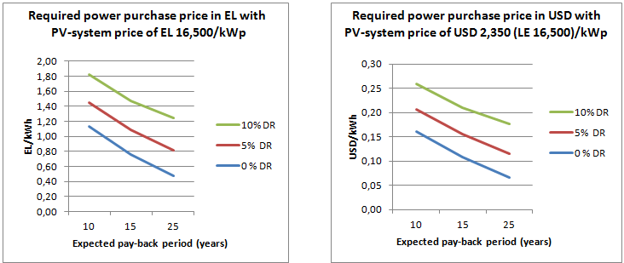
Figure 2.1 An estimate of the required power purchase price with different discount rates (DR) and with a PV system price of LE 16,500/kW_{p} (approximately USD 2,350 or EUR 1,680 per kW_{p}) including installation, sales tax of 10% and assuming average annual production of 1,500 kWh/kW_{p.}

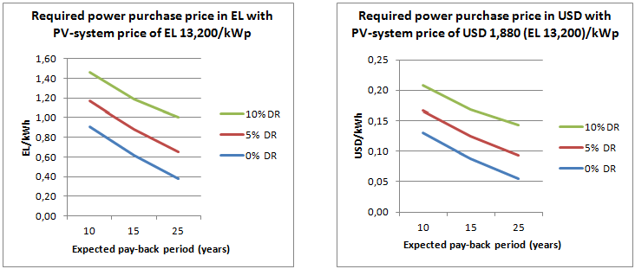
Figure 2.2 An estimate of the required power purchase price with different discount rates (DR) and with a PV system price of LE 13,200/kW_{p} (approximately USD 1,880 or EUR 1,350 per kW_{p}) including installation, sales tax of 10% and assuming average annual production of 1,500 kWh/kW_{p}.
- In order to make the return on the proposed PV investment sufficiently attractive for the first investors, while also taking into account the amount of funding that realistically can be leveraged for this, it is suggested that, through a combination of different instruments (the Government’s net-metering and Guarantee of Origin schemes, and supplementary GEF grants), financial returns equal to a power purchasing price of LE 1.34 (USD 0.19) per kWh could be offered to the first wave of investors (households and small businesses) who, collectively, will contribute to the aggregate project target of 4 MW_{p}. This price would consist of LE 0.67 (USD 0.095) per kWh from the net-metering scheme (being the highest residential tariff category at the moment), the anticipated value of LE 0.40 (USD 0.06) per kWh of the RE GoO certificate, and an LE 0.27 (USD 0.04) per kWh premium for 10 years to be paid by the UNDP-implemented, GEF-financed project as an upfront grant equal to LE 4,000 (USD 570) per kW_{p}, after the system is in operation and the quality of the installation has been verified. This grant could be paid either to the investor (i.e. the owner of the new PV system) or directly to the system supplier after the commissioning test has been successfully passed, thereby reducing the investor’s initial financing needs. For the remaining amount, the households and other targeted clients will use their own financial resources and/or apply for a bank loan (see Outcome 4 for a complementary discussion about this). As an option, and by building on the observed results of the first year, a gradually degressing support scheme can also be considered, with USD 570 per KW_{p} for the first year (or for reaching the first MW_{p} target), USD 550 per KW_{p} for the second year, etc. The proposed support scheme is discussed in further detail in Annex 7.3.
- Combined financial incentives equivalent to an LE 1.34/kWh power purchase price can be compared with the feed-in tariffs offered in Germany for small rooftop systems up to 10 kW_{p} of 13.44 Euro cents per kWh (approximately LE 1.32 per kWh), reduced to 13.28 Euro cents per kWh (LE 1.30 per kWh) in April 2014, and with average installed PV system prices of USD 2,300 (EUR 1,640; LE 16,100) per kW_{p} at the end of 2013 and estimated annual production of 1,000-1,200 kWh per kW_{p} depending on the location.
- According to the most recent electricity sales statistics of EgyptERA (see Annex 7.7 for further details), among the total of 24 million residential customers there are approximately 150,000 billed at the highest residential tariff category of LE 0.67/kWh (9.5 US cents) for consumption exceeding 1,000 kWh per month, while in the second tariff category there are 340,000 customers paying LE 0.53/kWh (7.5 US cents) for consumption exceeding 650 kWh per month. According to EgyptERA, these two tariff categories may be combined in the future.
- Based on the same EgyptERA statistics, the average monthly consumption of the highest tariff category residential consumers is about 1,500 kWh per month, meaning that, through the proposed net-metering scheme, a tariff of LE 0.67/kWh could be applied to PV systems producing, on average, about 6,000 kWh per year (which corresponds to a system size of about 4 kW_{p} in Egypt). By combining the highest and second-highest tariff categories, the weighted average consumption would be around 990 kWh per month: i.e. exceeding the lowest limit of 650 kWh for the second-highest tariff category by about 340 kWh per month or 4,000 kWh per year. This would correspond to a system size of about 2.5-3 kW_{p}. By further assuming that 1% of the 150,000 customers currently billed at the highest tariff rate would be attracted to benefit from the proposed net-metering and GoO schemes with complementary backstopping by the UNDP-implemented, GEF-financed project, and would each install a system of 3 kW_{p}, this would add approximately 4.5 MW_{p} (1,500 x 3 kW_{p}) of total PV capacity in Egypt.
- As mentioned earlier in Chapter 1.1, while the electricity subsidies for industrial customers have been gradually reduced, together with the introduction of new time-of-use (ToU) tariffs for major consumers, the subsidies for the residential sector have remained largely intact, reaching LE 13.2 billion in total in 2012/2013. The higher tariff residential categories are less subsidised or not subsidised at all, depending on which costs are considered as the ‘real baseline’ costs. The EEHC long-run marginal cost of electricity generation, transmission and distribution is estimated to be approximately LE 0.80-1 (around 12-15 US cents) per kWh, while the average power generation costs of the current system with subsidised fuel prices are estimated to be around 4.5 US cents per kWh, with transmission and distribution losses accounting for an extra 2 US cents per kWh.
- The impact of an investment subsidy of USD 570 (LE 4,000) per kW_{p} on the PV power generation price is illustrated in Figure 2.3 below. This USD 570 figure has been determined by calculating a GEF grant amount that will permit a roof-top PV investment to become sufficiently attractive when this investment also benefits from the proposed net-metering scheme (with the anticipated value of EL 0.67 per kWh) and the GoO scheme (EL 0.4 per kWh). Using all these three instruments together would bring the pay-back period of the investment down to 8-15 years (depending on the discount rate used), which is expected to be sufficiently attractive for targeted investors given that, after payback, the system can still continue to operate practically for free for another 10-15 years. The corresponding financial benefits for a 3 kW_{p} system, in the form of the free cash flow after the investment has been fully paid, would be in the range of LE 2,400-3,000 (USD 340-430) per year.
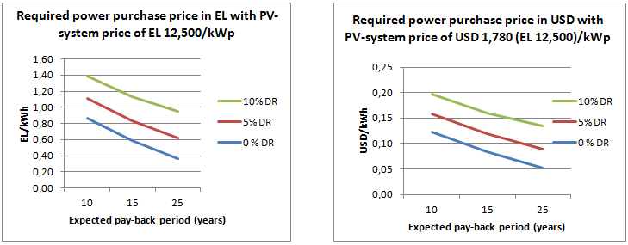
Figure 2.3 An estimate of the required power purchase price with a PV system price of LE 12,500/kW_{p} (about USD 1,800) including an GEF investment subsidy of LE 4,000 (USD 570) per kW_{p}
- For a 4 MW_{p} target, the total required grant allocation to finance a subsidy of USD 570 per kW_{p} is approximately USD 2.3 million. The premium paid through the GoO scheme is covered by non-project resources (i.e. co-finance) and will be channeled through EgyptERA as a financial intermediary.
- The proposed GoO scheme can build on the work done in the EU to define the procedures and rules for such a scheme in accordance with the provisions of the EU Directive 2009/28/EC “On Promotion of the Use of Energy from Renewable Sources” including, among others, that:
- A guarantee of origin shall be of the standard size of 1 MWh. No more than one guarantee of origin shall be issued in respect of each unit of energy produced, ensuring that the same unit of energy from renewable sources is taken into account only once;
- Any use of a guarantee of origin shall take place within 12 months of production of the corresponding energy unit. A guarantee of origin shall be cancelled once it has been used;
- Designated competent bodies shall supervise the issuance, transfer and cancellation of guarantees of origin. The designated competent bodies shall have non-overlapping geographical responsibilities, and be independent of production, trade and supply activities. Appropriate mechanisms need to be put into place to ensure that guarantees of origin shall be issued, transferred and cancelled electronically and are accurate, reliable and fraud-resistant.
- A guarantee of origin shall specify at least: a) the energy source from which the energy was produced and the start and end dates of production; b) whether it relates to electricity or heating or cooling; c) the identity, location, type and capacity of the installation where the energy was produced; d) whether and to what extent the installation has benefited from investment support, whether and to what extent the unit of energy has benefited in any other way from a national support scheme, and the type of support scheme; e) the date on which the installation became operational; and f) the date and country of issue and a unique identification number.
- EgyptERA will be the entity for issuing GoO certificates for renewable energy in Egypt. It has already received its Board approval to proceed with the GoO scheme, and has also received initial training for defining its operational procedures and institutional arrangements. Complementary support for the establishment of the GoO scheme will be provided by the UNDP-implemented, GEF-financed project. In this context, the possibility for cooperation and information exchange with the AIB (Association of Issuing Bodies) governing the European Energy Certificate System (EECS) will be further explored.
- The issuance of GoO certificates obviously has to be matched by adequate demand for such certificates in order to create a market and generate a price for them. While some companies in Egypt have already indicated their interest to voluntarily pay a higher price for electricity produced by renewable energy in order to comply with their corporate policies (as discussed in further detail in Chapter 1.1), no guaranteed demand for GoO certificates in Egypt yet exists. Therefore, EgyptERA is considering an option to introduce, together with the GoO scheme, a decree to oblige certain consumer groups, such as commercial and industrial clients, to purchase a minimum share of their overall electricity consumption from renewable energy sources, thereby creating a demand for the GoO certificates.
- Before the market has been fully established, EgyptERA has also considered the option of regulating the GoO certificate price. This is not without problems, however, as it would essentially convert a tradable certificate into a fixed production subsidy. Defining a single price would also be problematic because the level of financial support required by different types of RE power generation varies considerably. Similar considerations apply to those NREA-managed projects that have already received significant support from elsewhere, for instance from bilateral grant funding or concessional loans. Options for overcoming such obstacles, however, exist, notably through bundling GoO certificates from different sources into one tradable package, thereby balancing the prices between more expensive PV (with greater financial support needs) and cheaper wind. These options will be studied and elaborated in further detail with project support at the project inception phase. This work will also be backstopped by the price information to be received from the competitive bidding currently underway for larger-scale wind and PV plants.
- For net (or two-way) metering, EgyptERA has confirmed that meters facilitating this are already available in Egypt and can be installed for customers seeking to benefit from this PV initiative. Furthermore, the meters can be equipped for remote reading, thereby providing a basis for real-time monitoring of the PV systems installed.
- In addition to providing direct financial support to ‘kick-start’ the market, the UNDP-implemented, GEF-financed project will, under Outcome 1, support the technical design, installation and, eventually, the loan negotiations required for the purchase of the PV systems. Further guidance on the required technical specifications and other criteria for supporting the first installations will be provided in the documents to be finalised at the project inception phase. Besides the financial evaluation, all projects to be supported with GEF funding will be subject to technical due diligence and verification of the proper installation and performance of the system during the commissioning stage by the project’s technical expert(s) and/or installers authorised by the project before releasing the GEF support. The investors receiving support are also expected to commit themselves to collecting and sharing with the project’s Implementing Partner and the UNDP-GEF project team monthly performance data of the installed systems for the duration of the UNDP-implemented, GEF-financed, which then can be used for further public awareness-raising and research activities.
- Stakeholder discussions and research undertaken during project preparation indicate that the installation of approximately 1,500 PV systems of 2.5-3 kWp each, up to the total capacity of 4 MW_{p}, would be a realistic target by the end of the project. Together with the ongoing Government initiatives to install PV systems on the roofs of public buildings, it would also create an adequate initial demand for meaningful strengthening of the supply-side. For reaching this target, the project will establish a central information and support centre, initially served by the project management unit, to help to screen and select the first investors and provide information and support to interested participants. Other supporting activities and outputs under Outcome 1 (supported also by other outputs under Outcomes 2, 3 and 4) consist of:
- Finalised design of the support scheme to facilitate market take-off for the first 4 MW_{p} of small, decentralised, privately-owned, grid-connected PV power generation (rooftop) systems, including finalisation of procedures and sample documents and templates to apply for this support;
- A manual and template for PV system design and installation (with a link to Output 3.1), including sizing, orientation, technical requirements and economics to be released as a hard copy, internet-based and/or eventual smartphone application;
- Public awareness-raising and marketing campaigns to promote the 4 MW_{p} programme and to support the implementation of the planned GoO and net-metering schemes;
- Two in-depth reviews and evaluations of the progress of the 4 MW_{p} programme and issues faced (prior to the project’s standard mid-term review and final evaluations), including:
- Customer satisfaction surveys among the programme participants, who have invested in a PV system;
- Technical analysis of the performance of the systems and their interaction with the grid;
- Supply-side analysis and surveys;
- Analysis of the performance of the financial support mechanisms implemented;
- Lessons-learned and recommendations for further development of the scheme.
- Mid-term and final workshop to present and discuss the results and potential next steps.
- The observations, experiences and lessons-learned from implementing the first activities under Outcome 1 will directly feed into further activities under Outcomes 2, 3 and 4 to scale-up the effort as it concerns further development of the legal and regulatory framework, supply-side strengthening and financing to facilitate self-sustaining further market growth after the project ends.
Outcome 2: A supportive policy, institutional and regulatory framework for providing a basis for sustainable growth of the small, decentralised RE (in particular PV) power generation market.
- The activities under this outcome will support the establishment and implementation of an enabling legal and regulatory framework to promote small, decentralised, grid-connected power generation, from PV systems in particular. While the provisions of the draft Electricity Law (see Chapter 1.2 for further details) and the draft decrees prepared by EgyptERA for net-metering and the Guarantee of Origin scheme, together with the already-finalised (although yet to be adopted) grid code, provide an excellent basis for achieving Outcome 2, the activities and outputs elaborated in further detail below will support the finalisation of the required implementation decrees, close the remaining gaps in the existing or drafted legislation, and support other required steps to ensure their effective implementation, including:
- Finalised implementation decrees and other required documents for putting in place fully-operationalised guarantee of origin and net-metering schemes to support small, decentralised PV installations, including mechanisms for monitoring and verification and collection and transfer of funds between EgyptERA/national funds, distribution companies and PV owners, as well as procedures and criteria for quality control and due diligence in evaluating the PV applications wishing to benefit from these mechanisms;
- Completed analysis of the performance of the first residential PV systems and those implemented in parallel in public buildings, identifying possible technical constraints in connecting small, decentralised PV systems into the grid and updating the related technical guidelines (or grid code), as needed, to overcome those constraints and to scrutinise the connections with support of the local electricity distribution companies. In this respect, due attention will also be given to safety issues, such as requiring modern inverters that cut generation immediately in the event of the mains power supply being shut off.
- As applicable, recommendations for eventual grid strengthening needs and/or new guidelines for grid and load management for integrating small, decentralised PV systems into the power system on a larger scale;
- Completed analysis of the current building regulations for both construction and management to identify any barriers to widespread implementation of rooftop PV systems in residential buildings and proposed amendments and measures to remove or overcome those barriers.
- Drafted amendments to the existing laws and regulations and eventual new regulations to ensure adequate quality control of the PV systems and the installation services offered in the market;
- Finalised proposal (together with drafted legal and regulatory provisions) for the any required complementary financial and fiscal incentives and other measures (such as RE purchase obligations of national electric utilities, mechanisms for administering and setting national feed-in tariffs, etc.) to support sustainable growth of the small, decentralised PV market after reaching the initial 4 MW_{p} target; and
- An assessment and recommendations for waste management and recycling options for the PV systems and their components upon reaching the end of their lifetimes (including, as needed, related drafting of new regulations/amendments to the existing legislation addressing the issue).
- The project will support the required background analysis, consultations, awareness-raising and capacity building of the key stakeholders to finalise the drafting of any required new legal amendments, implementation decrees and guidelines and facilitate their effective adoption and implementation. It will build on the experiences and lessons-learned in other countries and will benefit from the results of a number of international projects that have been undertaking research on the typical legal, regulatory and institutional barriers to successful development of the small, decentralised RE market. As examples of the work done in EU countries, the EU-supported PV LEGAL and the new PV GRID projects are noteworthy. For the required background analysis, the project will also build on the work done by the recently finalised ‘Paving the Way for the Mediterranean Solar Plan’ project mentioned earlier, the ongoing work of EgyptERA, as well as the support provided by the Regional Centre for Renewable Energy and Energy Efficiency (RCREEE) for creating policy frameworks supportive of renewable energy and energy efficiency in its member countries. Prospects and required support for the establishment of a local Solar Energy Industry Association (if there is sufficient interest on the supply-side) will be further explored under Outcome 3 of the project, with such an Association envisaged to become one of the key stakeholders to identify and lobby for the required further legal, regulatory and institutional changes to boost the PV (and solar thermal) market.
- For any policy work, the cost-efficiency analysis of different RE technologies requires regular updating, as both RE costs and other framework conditions are evolving rapidly. Regularly updated market analysis to provide this information will be provided as a part of the project’s market monitoring activities under Outcome 3 (Output 3.5).

Outcome 3: Strengthened domestic supply chain and quality control system, including, as applicable, increasing domestic manufacturing/assembly of PV panels
- Given the absence of adequate financial or fiscal incentives to implement PV projects in Egypt on a larger scale, there is not yet a real market for small PV systems in Egypt. A major impediment to the growth of solar power in Egypt is, therefore, the availability of credible resources and technical know-how on the supply side. The activities under this outcome will focus on ensuring that the demand sought to be created by this and other supporting initiatives can be met by competitively-priced, good-quality PV systems and related after-sales services so as to sustain customer satisfaction and positive market growth. The targeted stakeholders will include system designers, constructors, equipment vendors, potential manufacturers, system installers, and repair and maintenance specialists across the country, supported by well-designed training materials and manuals, workshops and ’on-the-job’ training by allowing the trainees to practice with real systems.
- Besides the supply-side capacity building, an essential element to sustain positive market growth is a credible and effectively-enforced quality control scheme. For RE system hardware, this typically consists of: i) product standards covering safety, performance and durability of the system components, as well as the system as a whole (i.e. configuration of the components); ii) a methodology for testing; and iii) a certification procedure (essentially, a surveillance system that guarantees constant quality). The certification scheme for installations should complement the hardware quality control scheme.
- The specific elements of this quality control system will be further elaborated at the outset of project operations, but some initial remarks and recommendations in this respect are that:
• Mandatory minimum energy performance and quality requirements for the entire market should rely on well-elaborated, technology-specific market surveillance plans, which are enforced by supporting legislation and adequately capacitated market surveillance authorities;
- A voluntary quality control scheme can be promoted, for instance, by embedding the agreed minimum performance and other quality requirements into the eligibility criteria of the available financial support schemes. The suppliers can prove their products meet the requirements by means of a certificate issued by an accredited authority either abroad or in Egypt. For the quality control of installations, an in-country certification and inspection scheme will be required.
- A quality control scheme without associated training of the key stakeholders, including public authorities responsible for implementing the scheme and local service providers such as installers, to meet the minimum quality requirements is useless. Therefore, an essential part of the activities under Outcome 3 will be to facilitate the training of the key stakeholders. For this, the project will cooperate closely with local universities and professional and vocational schools to ensure that, for instance, a sufficient number of trained and certified small RE system installers will be available in the market to provide their services.
- Development of a certification scheme initiated by EgyptERA and to be managed by NREA is already in progress in Egypt with the first 12 companies now undergoing such a certification process. The scheme is based on verifying that adequately trained and skilled installers exist within each company and that the hardware supplied by the companies - panels, inverters, etc. comes with internationally recognised quality certificates and has adequate warranties. In the case of defaults, the installers will be responsible for providing warranty service and communicating with the equipment manufacturers throughout the warranty period of the installation.
- A consumer seeking to benefit from the financial support schemes promoted in the framework of the UNDP-implemented, GEF-financed project can choose a supplier among certified installers based on price, responsiveness, and other such criteria typical for selection of a vendor. The list of certified installers will be made publicly available online and customers will also be able to provide feedback on installers’ performance, which can be publicly displayed as well – subject to having a sufficient volume of customers first. Random checks and inspections initiated by eventual complaints received from customers can be performed by the project’s/NREA’s technical experts, on the basis of which an installer’s certification may be revoked, if it is shown that the installer has not maintained the required standards for the installations. EgyptERA also has a plan to establish specific RE/EE units within the local Electricity Distribution Companies to check the installations before connecting to the grid.
- The principal public authorities involved in quality control, including NREA (which will manage the installer certification process) and the electricity distribution companies (which will connect the PV systems to the grid) should be trained to recognise power and quality problems when they arise and, therefore, will be among the first beneficiaries of the project technical assistance and capacity building activities under component 3.
- A specific problem in Egypt is the dust accumulating on the surface of PV panels, which, if not regularly cleaned, will affect the performance of the panels. Therefore, recommendations and suggested arrangements for facilitating regular cleaning of the panels will be taken into account in the system design and included in the operational manuals. Since the PV units are income-generating devices, there is an in-built incentive for the owners of the PV panels to ensure they are well maintained. The need for regular cleaning of the panels may also open up new employment opportunities.
- The work on the quality control of small PV systems in Egypt can build on the international work already done in this field, such as the development of the IEC (International Electrotechnical Commission) standards 61215 and 61646 for Design Qualification and Type Approval of Crystalline Silicon and Thin-Film PV modules and the related certification schemes of the IECEE on quality control schemes developed for other RE systems. In developing a quality control scheme for installations, the project can take advantage of the research, training materials, manuals and expert networks developed, among others, under the EU-supported international Qualicert scheme (implemented in 2009-2011) and the PVTRIN project. RCREEE has been active in promoting the adoption of the ‘Solar Keymark’ for solar thermal applications, but no regional standards for PV systems currently exist and there is unlikely to be a need for such regional standards either given the international standards that already exist.
- For enhancing the testing and related training opportunities, the project contains a small budget for the purchase of monitoring and testing equipment. In that context, a more detailed evaluation of testing facilities in Egypt will be carried out for exploring synergies and opportunities for cooperation and for avoiding duplication of activities.
- Finally, under Outcome 3 the project will support public awareness-raising and general (not company-specific) marketing costs of decentralised PV systems, and will also explore prerequisites for establishing a local Solar Energy Industry Association to: (i) promote the market; (ii) represent the interests of the supply-side in further policy dialogue; and (iii) become a knowledge management and eventual training centre for issues associated with further promotion of the solar energy market in Egypt after the UNDP- implemented GEF-financed project has ended. To save costs, such an Association could serve both the solar power generation (PV) and the solar thermal (SWH) market as they share many common features. Options for increasing domestic manufacturing and/or assembly of the PV systems will be explored as well.
Outcome 4: A financing framework and a network of local financial institutions to facilitate the financing of small, decentralised PV systems for a broad range of consumers.
- Component 4 is focused on leveraging financing for the required initial investment of PV systems for those customers who may not be able, or may not wish, to pay these initial costs from their own cash resources. This includes an effort to expand the PV market to consumers in lower electricity tariff categories by facilitating their access to long-term and attractively-priced credit, and to provide the required comfort for the banks which, in the absence of a previous credit history or lack of adequate collateral, may have concerns about the credit-worthiness of some potential customers. Based on consultations during project preparation, average annual interest rates for LE denominated consumer loans are generally between 9-15%.
- While the proposed GoO and net-metering schemes for higher tariff category consumers, together with the proposed complementary project support, are expected to create a sufficiently attractive financial return for investing in a PV system, the high upfront costs of a 2.5–3 kW_{p} system (in the range of some LE 45,000-50,000) may still present a barrier for some targeted beneficiaries. To overcome this barrier, the project will explore opportunities for collaboration with financing entities already active in Egypt, such as the National Bank of Egypt, the African Development Bank, the Islamic Development Bank, the European Investment Bank, the EU Neighborhood Investment Facility and Misr El Kheir (an Egyptian NGO, with a history of investing in small charity projects that help their owners generate livelihoods), as well as bilateral funding organisations such as KfW, the Japanese Bank for Development, French AFD, the Swiss Agency for International Cooperation, the Government of Italy, the Government of China and others. Consultations during project preparation were held, among others, with the African Development Bank, the Swiss Agency for International Cooperation, the EU Delegation in Egypt and the Italian Embassy, with all showing interest in the project but requiring more time to clarify their possible participation. In discussions with the EU Delegation, possible EU support for the establishment of the Renewable Energy Fund was also brought up, should such support be requested by the Government of Egypt in the future.
- Beside a goal to create a lending mechanism/credit line able to provide long-term financing for small, decentralised RE investments at attractive interest rates, a specific effort will be made to facilitate the use of Guarantee of Origin certificates and/or Power Purchase Agreements as adequate securities (or as part of the required collateral) for the banks issuing the loans. This would be particularly important for lower-income households, which may not otherwise have the required credit-worthiness to obtain loans. Complementary guarantee arrangements can also be put in place with the support of other international funding organisations. The National Energy Efficiency and Renewable Energy Action (NEEREA) financing scheme established in the framework of UNDP-implemented, GEF-financed activities in Lebanon provides one good example of such a scheme, which, with some modifications and with the support of other financing entities, could also be applied in Egypt. Another example is the Loan Guarantee Mechanism established by a UNDP-implemented, GEF-financed energy efficiency project in Egypt, which was used to support the implementation of an energy efficient lighting initiative with local power distribution companies and lamp manufacturers acting as ESCOs.
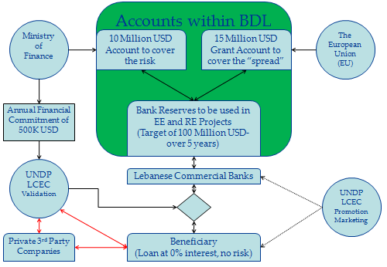
Figure 2.3 Basic design of the National Energy Efficiency and Renewable Energy Action (NEEREA) financing scheme in Lebanon, used to finance different types of EE and RE investments.
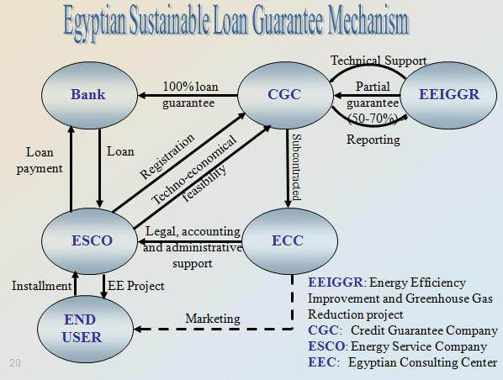
Figure 2.4 Egyptian Loan Guarantee Mechanism established under the UNDP-implemented, GEF-financed EEIGGR project, primarily used to support the implementation of the energy efficient lighting initiative with local power distribution companies and lamp manufacturers acting as ESCOs.
- The specific role of the UNDP-implemented, GEF-financed project under Component 4 will be limited to technical assistance and acting as a facilitator for further consultations; the actual establishment of any new lending mechanism will primarily rely on the project’s financing partners. The specific activities to be supported by the project under Component 4 may include:
- Required background studies, analysis and initial drafting of the proposed financing scheme(s) and support for required follow-up consultations with the financing entities interested in developing the scheme(s) further;
- Support for technical due diligence of the projects proposed for financing and training of the participating banks on technical aspects of the projects;
- Involving local community including men and women associations to act as intermediaries, helping to promote the lending mechanism and support the projects; and
- Monitoring the impact and performance of the financing schemes introduced.

Project indicators, Risks and Assumptions
- In accordance with GEF Focal Area Objective #3 to “Promote Investment in Renewable Energy Technologies” of the GEF-5 Climate Change Strategy, the key success indicators of the project are:
- Extent to which policies and regulations for decentralised RE are adopted and enforced;
- Volume of investment mobilised; and
- Tons of CO₂ equivalents avoided.
- In addition to facilitating the installation of at least 4 MW_{p} of new PV capacity by the end of the project, other specific targets of the project include the following:
- The market for Guarantee of Origin certificates for small, decentralised, on-grid RE applications is established and the issued certificates are fully used;
- The net-metering scheme for higher tariff category customers is successfully in operation and the number of customers benefitting from the scheme and investing in small, decentralised PV systems shows an increasing trend;
- An enabling legal and regulatory framework with adequate financial and fiscal incentives is in place for sustaining the market growth of small, decentralised PV power generation after the UNDP-implemented, GEF-financed project is over;
- A strong supply-side is in place with professional companies and adequate price competition, quality control and after-sales services to make the purchase and installation of PV systems safe and convenient with a “one-stop-shop” approach (i.e. obtaining all the required products and services from one place);
- The quality of the PV systems installed meets investors’ expectations and the minimum performance targets set by the project; and
- With the support of the project’s financing partners, a longer-term financing mechanism is established, which is able to provide long-term financing at attractive interest rates for small decentralised PV investments and with collateral requirements accessible by the majority of targeted beneficiaries (with a possibility to use the GoO certificate and/or PPA as a part of the required securities).
- For further details about the specific targets and success indicators, see the project’s results framework in Section 3.
- The main identified project risks, their probability, impact and possible mitigation measures are briefly discussed below.
- Political risk (Medium): The present political outlook in Egypt is uncertain. Historically, the Government has relied upon international participation and donors to develop new renewable energy programmes similar to the proposed project. Although there is a strong will to realise the stated goals of achieving 20% renewable power generation by 2020, the new Government may still find it difficult to implement such a novel and unproven programme, besides facing significant budgetary constraints to finance any such initiative from the State budget. This may also slow down the adoption and progress of the measures elaborated in the new draft Electricity Law.
- The effort to secure reliable energy supply is likely to remain high on the political agenda, however, regardless of which party is in power in the future. Moreover, individual entities within the Government structure, such as the Ministry of Electricity and Energy, EEHC and EgyptERA, may proceed with many initiatives on the basis of their internal/Board decisions without the need for new laws. The project design also contains some flexibility to adapt the proposed strategy in supporting, for instance, the first PV installations up to 4 MW_{p} to the progress achieved with the proposed guarantee of origin and net-metering schemes (subject to the availability of other co-financing sources), while also proposing measures that do not directly burden the State budget. Close cooperation with, and the involvement of, EgyptERA during the project design phase has also served to mitigate the political risks since EgyptERA has a strong influence on the development of the electricity sector in Egypt. For the reasons above, the political risks to the project are considered to be of medium severity.
- Combined financial, political and market risk (Medium): A major obstacle to sustainable development of the renewable energy sector would be an unstable financing environment, where different financial and fiscal incentives, cost-recovery mechanisms and other supporting measures are introduced and removed at short intervals in an unpredictable manner. The long-term predictability of any financial and fiscal incentives is a key condition for sustainable growth of the RE market, whether PV or a different technology. Therefore, regulations and incentives based on a law typically have a stronger impact than short-term incentive programmes based on ad-hoc budget lines. The latter have often been applied in Egypt, but their short-term success has sometimes turned into a barrier in the context of sustainable longer-term growth. Should the budget of an incentive programme not be adequate to cover the demand, the funds can be disbursed long before the end of the budget period, in which case the potential buyers typically postpone their purchases in anticipation of programme reactivation. This leads to short-term overheating followed by a breakdown of the market, when incentives are temporarily or permanently stopped. The impact of such ’stop-and-go’ dynamics can be particularly negative, since the sustainable growth of a decentralised RE market relies on the development of a strong network of specialised distributors, system designers and installers, which likewise need to count on sustained demand for their services.
- Given the above, a typical recommendation for projects promoting RE development is that, whatever incentives are applied, they should be set on a long-term basis with sufficient funds backing them up until the market reaches a critical mass and can be expected to continue to develop on its own. The scheme has to be sufficiently transparent and predictable for several years, both for the targeted clients and the supply-side. While the support may sometimes need to be revisited upwards to reflect the market response and changing market environment, preferably the level of support should gradually degress and phase-out over time, thereby encouraging the early-movers as well as the supply-side to gradually improve the cost-efficiency of their products. This should, of course, be done without compromising quality.
- The financial support mechanisms promoted in the framework of this UNDP-implemented, GEF-financed project rely primarily on the proposed net-metering and Guarantee of Origin schemes and, as such, are anticipated to provide the required stability and predictability, and to mitigate any damaging stop-and-go dynamics. As it concerns, in particular, the current electricity tariffs (affecting the net-metering scheme), the risk of decreasing tariffs in the future is considered to be minimal. Indeed, a more likely scenario is that tariffs will increase.
- Significantly higher risks are associated with the future market value of Guarantee of Origin certificates (with risks similar to the volatility witnessed in carbon trading markets in recent years), but specific measures to mitigate these risks will be further studied and, as applicable, introduced as part of the scheme. As discussed before, some regulatory measures to mitigate this risk have been considered by EgyptERA already.
- Since the proposed complementary incentives to be provided by the UNDP-implemented, GEF-financed project are aimed at only ‘kick-starting’ the initial market and contribute less than one-third of the budget of the planned support scheme, their removal after reaching the initial 4 MW_{p} target is not expected to have any major negative impact at that stage, by which time the market will already have started to develop under its own momentum. This will need to be closely monitored and assessed during project implementation, however. In this respect, a gradually degressing GEF subsidy or replacement of the GEF subsidy near the end of the project with other financing sources leveraged during project implementation may also be considered. Overall, the sustainability-related risks associated with the proposed financial support mechanisms are considered to be of medium severity.
- Financial risk (Medium): Despite the proposed financial incentive mechanisms, the high upfront costs of PV systems may still pose a barrier to some targeted clients; for them, the availability of long-term and affordable financing (lending) mechanisms may be critical. Currently-available consumer loans in Egypt typically have relatively short payback periods (from 3 to 5 years) and high interest rates (typically 9-15% per year), which undermines their attractiveness for financing RE investments. In some cases, the tight requirements for securities or the perceived lack of credit-worthiness of the applicants (e.g. in the absence of a past credit history) may also be an obstacle. However, consultations on this issue during the project development period support the conclusion that, after being able to demonstrate adequate cost-recovery of the planned investments by the proposed financial support mechanisms, the availability of upfront financing should not present a problem. There are several international and national financing entities active in Egypt that are likely to recognise a new market niche, once the initial demand has been demonstrated. As such, the risk of obtaining adequate upfront financing is considered a medium-risk only, though one that nonetheless requires active steps and measures by the project to mitigate it. A need for regular contacts and consultations with different financing entities active in Egypt, as well as the possibility of the project supporting the preparation of high-quality investment proposals and provision of technical backstopping to the banks for the appraisal of these proposals, has been taken into account in the project design and implementation strategy under Outcome 4.
- Technology risk (Low): A long history of successfully installing and operating rooftop PV systems in a range of countries, including in the region, already exists and thus the technology-related risks are considered to be low. This does not, however, undermine the utmost importance of adequate quality control of both the hardware and installation so as to ensure positive customer experience and sustainable growth of the market. Activities to support this are proposed under Component 3 of the project.
- Inadequate and/or non-capacitated human resources on the supply-side to successfully implement the project and support the mainstreaming of its results (Low): A necessary element of the proposed project is to develop technical capacity within the country. A base of technically-skilled professionals exists, who, with appropriate training, can provide the required installation and repair services. A typical risk for training and capacity building activities is also that, after the completion of training, there is no real demand for the services of the trained experts. The integrated approach adopted by the project is expected to mitigate this risk by combining the training with concrete possibilities to apply the new skills in practice for the planned investment projects and their envisaged replication.
- Climate change risks (Low): Climate change is not likely to adversely impact the project. Indeed, the reverse may be true: as summers become warmer (a trend already underway), the demand for summer cooling will increase commensurately. Since this demand will coincide with the periods of highest solar insolation, it serves to reinforce the value of the project. The installed PV systems will be able to contribute a substantial portion of their power generation at times of peak demand.
- Some reports, including the Second National Communication to the UNFCCC, anticipate an increase in sand storm frequency and severity, in particular in coastal areas, which may have some negative impact on the performance of PV panels. Given the abundant solar resource in Egypt, however, this is not expected to pose any major risk to having adequate annual electricity output from the PV systems installed. In defining the technical quality criteria for installation and in inspecting them, however, due attention will need to be given to ensuring that the supporting structures and fixtures for installing PV modules can withstand the potentially stronger storms. Households that invest in PV equipment will be given full instructions on proper cleaning and maintenance so as to minimise the impact of dust accumulation.
- Operational project management risk (Medium/High): There is overwhelming evidence from many earlier GEF-financed projects, both in Egypt and elsewhere, that, regardless of the rigour of project design, the capacity of the project management ultimately determines the success or failure of a project. As such, a committed full-time project manager with adequate outreach and networking skills is absolutely essential for meeting the targeted results of the project. He/she should have an ability to: (i) have a clear vision of where the project is heading and how to achieve its targeted development goals and outcome targets; ii) engage the key stakeholders in constructive discussion about future development of the decentralised RE (in particular PV) power generation market in Egypt; (iii) to guide and supervise the studies undertaken and effectively cooperate with the international experts who are engaged to support this work; (iv) to present their findings and recommendations in a convincing manner to key policy-makers and opinion leaders by taking into account the main macroeconomic and policy drivers for the development of the local RE market; and (v) identify areas of future work. In doing this, the project manager also needs to be supported by qualified technical, legal, financial and PR experts.
- Some nationally-implemented, GEF-financed projects in a variety of countries have evidenced problems in attracting sufficiently experienced local project managers, who can manage the project entirely on their own without external management support and advice, who can bring state-of-the-art knowledge and experience from similar projects implemented in other countries, and who can monitor the progress and substantive impact of the project and effectively practice adaptive project management, when and as needed, starting from project inception. To mitigate this risk, inclusion of an experienced international project adviser in the project management and implementation structure, with demonstrated capacity and adequate experience from similar projects implemented in other countries to support the local project manager in monitoring and adaptive management, has been integrated into the project design. The draft Terms of Reference for this position are presented as an Annex to this project document. In the course of time, and after the local project management has demonstrated its capacity to effectively manage and implement the project on its own, the level of external project management and implementation support can be reduced.

Expected Global, National and Local Benefits
- The calculated global GHG reduction benefits of the project will consist of the combination of:
- Direct GHG emission reduction benefits from the PV investment projects implemented in the framework of the project and supported by project funding;
- Indirect GHG reduction benefits resulting from broader market transformation arising from project activities.
- No post-project GHG emission reduction benefits arising from the financing mechanisms established or supported by the project have been accounted in the GHG analysis, as the GEF cash contribution to capital investments represents a one-time capital grant without expected payback.
- The direct GHG reduction benefits of the project have been estimated at 66 kilotonnes of CO_{2eq}, resulting from the investments supported directly with GEF grant funding during the lifetime of the project and calculated over the 20-year default lifetime of the investments.
- Complementary indirect mitigation benefits can be expected from sustained market growth after the project, arising from the creation of enabling conditions for continued investments in small, decentralised PV power generation capacity. These indirect mitigation benefits are estimated to reach from 0.6 to 0.7 million tonnes of CO_{2eq} from investments made by the end of 2029 (i.e. 10 years after the project end) over their estimated default lifetime of 20 years and with a project causality factor of 60%. For further details about the assumptions and results of the project’s GHG reduction analysis, see Annex 7.5.
- The associated national and local benefits include reduced local pollution from fossil fuels for power generation and strengthened national energy security through reduced dependency on natural gas and oil and on a highly-centralised power generation structure.
- The UNDP-implemented, GEF-financed project has the potential to drive a major transformation in the small, decentralised renewable energy power generation market in Egypt, specifically contributing to the following:
- Allowing Egypt to scale-up the supply of electricity to meet ever-growing demand without burdening the State with additional subsidy payments and the need to invest in large power plants, while also contributing (although still at a relatively modest level) to the Government’s target of having 20% of all power generation produced by renewable energy sources by 2020;
- Establishing a premium price for the sale of power from decentralised rooftop PV systems to serve as a precursor and powerful proof-of-concept for a feed-in tariff;
- Creating a cadre of stakeholders who profit from renewable energy and have an interest in promoting it;
- Involving individuals and households in their own power generation, when today they are only consumers.
- Strengthening a base of skilled PV technicians;
- Strengthening a supply chain for PV system components; and
- Working with local financial institutions to increase the available financing for small- and medium-size renewable energy projects.
- The project is also envisaged to achieve a range of other socio-economic benefits such as:
- Creating new ‘green’ jobs: The project will create jobs on several levels. Field technicians and installers will be needed to install and trouble-shoot the PV units. These are expected to be mid-level technicians with basic electrical backgrounds. They will receive training as part of the project and will be able to generate new income by learning about PV technology. Significant job creation is also expected in the supply chain of PV units. Certain components can be readily manufactured locally, such as the steel and aluminium support structures and panel frames. Other components are expected to develop as the market grows, such as the assembly of panels from cells. Components, such as the silicon cells, are expected to be imported, at least in the near-future. The Government in Egypt has set a priority of reducing unemployment and providing skilled jobs for the youth. It is estimated that approximately 20% of the youth in Egypt are unemployed, 82% of whom have a university degree. The creation of green jobs, which can employ skilled graduates, will therefore contribute to Egypt’s economic security and help ameliorate the unemployment problem. It will also help to improve national energy security and position the country for low-carbon economic opportunities domestically and regionally.
- Poverty reduction: Economic development is linked directly to access to energy. The Human Poverty Index (HPI) contains a component on ‘material wellbeing’ that uses access to electricity as one of its determinants. Currently, the Egyptian power system cannot meet the growing demand for power, resulting in periodic blackouts. The blackouts disproportionately affect rural and low-income areas, where the grid may not be as developed or robust as in other locations. Although not the primary target group of this project, the installation of PV panels may help to stabilise the grid and power supply to under-supplied and low-income areas, with related socio-economic benefits.
- Improving energy supply and security: Recent power shortages have been blamed mainly on a lack of fuel. The development of renewable energy supply is, therefore, critical for ensuring stable future power availability. So far, both renewable and conventional power generation has primarily relied on centralised, state-owned power plants. The development of technical capacity for small, distributed power generation will help to engage complementary resources and power generation modalities for securing a stable future supply of electric power and reducing the reliance on fossil fuels. Recent years have seen increasing power outages as the power generation and transmission infrastructure has struggled to maintain supply to a growing user base. The availability of on-site power generation, especially during afternoon hours (when demand is highest and when the potential supply of solar-generated electricity is also high), may help to alleviate some of the peak demand problems and may also reduce transmission and distribution losses (the official figure for which is 11%) by generating power closer to where it is used.
- Catalysing Private Investment: The project will help to provide an avenue for small-scale private investment in clean and environmentally-friendly technology. The increased awareness of opportunities for profit and support of sustainable development through private investment is expected to have a compounding effect, catalysing other private investments in similarly sustainable technologies.
- A Pilot Feed-in-Tariff: By providing guaranteed payments to customers for renewable power generation and putting in place the financing mechanisms to do so, a de-facto feed-in tariff will have been established on a pilot scale. The experience and lessons-learned will directly inform the development of a national level feed-in tariff and provide an example to policy-makers and financiers.
- Helping close the gender gap in income: As many home-makers are women, the maintenance of the solar PV systems provides an opportunity for them to generate income without leaving their homes and without substantial physical burden or time investment. This will have a number of beneficial impacts, allowing women to participate in a more meaningful manner in the income generation of their households, as well as introducing women to a new technology in which they may participate and therefore contribute to gender income convergence.

Project Rationale and GEF Policy Conformity
- The project will contribute to GEF Climate Change Focal Area Objective #3, to “Promote Investment in Renewable Energy Technologies”, recognising that renewable energy plays an indispensable role not only in combating global climate change but also in addressing energy access, energy security, environmental pollution and sustainable development. In accordance with the adopted strategy, the GEF support under this objective will expand beyond the creation of enabling policy and the regulatory environment and will also invest in renewable energy projects that will lead to a step-change in the deployment and diffusion of reliable, low-cost renewable energy technologies. In addition, the UNDP-implemented, GEF-financed project will promote local SMEs to enhance their technical capacities to provide installation, operation and maintenance services for renewable energy technologies.
- The specific outcomes of the GEF-5 climate change strategy that the project is addressing include:
- Favourable policy and regulatory environment created for renewable energy investments
- Investment in renewable energy technologies increased; and
- GHG emissions avoided
- The project aims to develop and accelerate the adoption of grid-connected photovoltaic (PV) power generation through adoption by individual users, households and small- and medium-size enterprises. Although Egypt is very rich in solar resource and is not able to meet its aggregate power demand, present circumstances do not allow the development of widespread small-scale renewable power generation to complement the more centralised thermal power plants, wind farms and solar power plants that form the main focus of Government policy at the moment.
- The project seeks to play a critical role in creating a market that does not currently exist and supporting it through a nascent stage to the point where it becomes self-sustaining. The related barriers and measures to overcome them have been discussed in greater detail in the previous sections of this project document.

Country Ownership: Country Eligibility and Country Drivenness
- According to the Instrument for the Establishment of the Restructured Global Environment Facility, Egypt qualifies for GEF financing on the following grounds:
- It has ratified the UN Framework Convention on Climate Change; and
- It receives development assistance from UNDP’s core resources.
- The proposed project is fully consistent with the current strategies and priorities of the Government of Egypt, as illustrated in detail in Chapter 1.2 of this project document. The project will contribute to the stated Government target of increasing the share of electricity produced by renewable energy sources to 20% of total electricity generation in 2020, of which solar energy is expected to contribute 2%. To complement this, the Cabinet of Ministers agreed in July 2012 to implement the Egyptian Solar Plan, which aims to reach 3,500 MW_{p} of solar power capacity by 2027, including 2,800 MW_{p} CSP and 700 MW_{p} PV, with the participation of the private sector in two-thirds of these projects. Given the more favourable cost development of PV over recent years, current Government focus appears to be tilted towards PV.
- UNDP Egypt supported the preparation of the GoE’s Second National Communication to the UNFCCC, which specifically highlighted the mitigation potential of PV in Egypt. UNDP is currently supporting the preparation of the Third National Communication as a strategic document, which identifies and assesses Egypt’s climate change mitigation opportunities and challenges.
- UNDP has extensive experience in the design and implementation of climate change mitigation projects in Egypt, including ongoing UNDP-implemented, GEF-financed energy efficiency, sustainable transport and biomass energy initiatives. UNDP is also leading six UN agencies in the design and implementation of a Joint Programme on Climate Change Risk Management in Egypt, financed by the UN-Spain MDG Fund. Under this Programme, UNDP, in collaboration with UNEP, has established a unit inside the Cabinet of Ministers to support the Supreme Energy Council on issues relating to renewable energy. In addition, together with UNEP and UNIDO, UNDP established a Clean Development Mechanism (CDM) Awareness and Promotional Unit inside the Egyptian Environmental Affairs Agency (EEAA), which was able to triple the CDM project portfolio in Egypt in less than two years. Furthermore, UNDP Egypt is embarking on a new initiative, funded by the EU, on building national capacities to implement Low Emission Development Strategies (LEDS), Nationally Appropriate Mitigation Actions (NAMAs) and emission-reduction Monitoring, Reporting and Verification (MRV) systems for the public and private sectors. UNDP Egypt has strong working relationships with the stakeholders central to the success of this UNDP-implemented, GEF-financed project, notably the Egyptian Electric Utility and Consumer Protection Regulatory Agency, the Ministry of Electricity and Energy, the Ministry of Industry and Foreign Trade, the Egyptian Environmental Affairs Agency and the country’s financial community.
- UNDP’s role, under its environment finance service line, is to assist countries to identify, combine, access and sequence funding to meet their environmental finance needs, which is also consistent with UNDP’s mandate as the head of the UN Development Group. For the project under consideration, UNDP has worked with stakeholders including the Egyptian Government, the private sector and international organisations to broker US$31.46 million in co-financing, including US$450,000 from UNDP. Moreover, UNDP will provide support through its broader environment portfolio and through the range of technical staff working on energy and environmental issues.
- The project falls under UNDAF Goal 3 on Environmental Sustainability and Outcome 3 on strengthening national capacities to mainstream climate change into national development plans, including Output 3.1 on the promotion of sustainable use of natural resources for income-generation and improving livelihoods and Output 3.3 on increasing access to energy services and cleaner fuels. The project is also in line with UNDP Country Programme Outcome 28 on the incorporation of sustainable management of environmental and natural resources into poverty reduction strategies/key national development frameworks and sector strategies.
- UNDP Egypt has a strong track record of implementing GEF projects. The team consists of two Officers, each with more than 20 years of experience, a Junior Officer and an Assistant. The Environment Team oversees a portfolio with a total budget of approximately $40 million from a range of donors, including the GEF, the Italian Government and the Finnish Government, in addition to parallel funding from the Netherlands, Switzerland, KfW, GIZ, the EU and UN agencies such as UNIDO, UNEP and UNESCO. The Environment Team works very closely with the Governance and Poverty Reduction Teams within UNDP Egypt on cross-cutting issues such as income-generation activities, micro-credit schemes, job creation, industrial development, etc.
- The GEF Operational Focal Point of Egypt, Ministry of Environment, endorsed the project with a letter signed on 7 August 2012.

Financial Modality and Cost-Effectiveness
- From the GEF financing for Outcome 1 (US$2,490,000), US$2,300,000 has been allocated for use as complementary investment grant co-financing to attract investments for the early market development phase of the decentralised PV market. The GEF funds will not be mingled with the other resources, but they will be used as a complementary financial incentive (without expected payback) in accordance with the criteria elaborated in greater detail in Chapter 2.1. The remaining US$190,000 for Outcome 1 covers the costs of required technical assistance to facilitate further development of the proposed financial support schemes and ensure the first projects with an aggregate capacity of 4 MW_{p} are successfully implemented.
- The GEF financing for Outcomes 2, 3 and 4 will consist of grants for technical assistance, which will support the Government of Egypt to further develop and implement a supportive policy and regulatory environment for attracting investments for privately-owned, grid-connected renewable energy power generation, for facilitating effective monitoring, quality control and dissemination of the results of the RE investments made, to leverage complementary financing for the required investments, and to support the sustainable development of the PV market in Egypt.
- The total co-financing of the project is $30,260,000, of which $15 million will be used to share the costs of the purchase and installation of the targeted PV investments by the private sector, approximately US$14 million for the planned PV investments on Government buildings, and the rest for cost-sharing the project’s technical assistance activities and management costs. For a more detailed breakdown, see Table 3.4 in Section 3.
- The combined direct and indirect global benefits of the project have been assessed at about 0.7 million tonnes of CO_{2eq}. With a GEF funding request of US$ 3.5 million, this corresponds to an abatement cost of approximately US$5 per tonne of CO_{2eq} reduced.

Sustainability (including Financial Sustainability)
- Among all RE-based electricity generation options, PV appears to have the largest market potential in Egypt at the moment for small, decentralised RE power generation. PV is less sensitive to site selection, it has demonstrated the largest cost reduction potential over recent years, it has a lifetime of up to 25-30 years with limited annual maintenance needs (if considering the PV panels only), and can be considered as a compact, easy-to-install RE package. While in some specific rural areas wind, micro-hydro or biogas may be able to provide even more cost-effective solutions for local, small-scale electricity generation than PV, PV is likely to maintain the highest and most widespread potential for small-scale, decentralised RE power generation in Egypt.
- As shown by the cost analysis presented in further detail in Chapter 1.1 of this project document, the costs of PV-generated electricity are already approaching very close to the estimated marginal costs of fossil fuel-based power generation and, in some cases, can even be lower depending on the discount rate, time-frame and other assumptions used in the analysis. Some financial support is still required, however, to make the purchase of PV systems sufficiently attractive for the targeted consumers. With an expected further downward trend in international PV market prices and the growing size of the local market and related supply chain development, the future cost of electricity generated by PV will, however, not be very different from the baseline electricity options and will have a realistic chance of competing with more conventional energy sources even without any additional grant support, subject to equal terms of available financing to cover the initial investment when compared with large thermal power plants.
- Emphasis in the project design and throughout project implementation will be placed on post-project sustainability – on building the capacity of the local supply-side to sell, install and maintain the systems, support the establishment of an adequate quality control scheme to ensure satisfactory consumer experience with the new technology, and a market monitoring mechanism to track progress and facilitate ongoing targeted support for the sector. When planning any new post-project financial or fiscal support mechanism, specific emphasis will be placed on the effort to avoid damaging ‘stop-and-go’ dynamics, in which the financial and/or fiscal incentives emerge or are removed in an unpredictable manner or the support scheme suddenly runs out of resources just at the point when the market has started to grow. This risk is discussed in greater detail in Chapter 2.2 of this project document.
- Besides an emphasis on financial sustainability, attention has been paid to institutional sustainability by embedding the proposed activities and measures (including the proposed financial support mechanisms) into the already-ongoing initiatives and plans under development, for instance, in EgyptERA and the Ministry of Electricity and Energy.

Replicability
- Given the interest of several GEF programme countries to develop and implement similar projects, the materials developed and the results and lessons-learned in this project are expected to be of direct interest to other countries. Close monitoring and evaluation of project implementation and results will also be of primary importance in this respect.
- The project seeks to facilitate continuing contacts and cooperation between the different stakeholder groups at the national and international level by organising seminars, workshops and other public events, thereby bringing project proponents, policy-makers and potential investors / other donors together.

  - Gender Strategy:
- Gender considerations are extremely relevant to the successful adoption of renewable energy. Women and men have different attitudes towards energy consumption and energy saving; and accordingly, they experience issues related to shortages, pricing and quality differently. For example, it is a known fact that in general women are closer to nature than men and that they are less sympathetic to certain energy resources than men such as for example nuclear energy. It is also known that more women do saving activities than men and that men are less inhibited by financial considerations than women whereas the adoption of alternative sources of energy is concerned. Considering these differences, the project will mainstream gender in data collection, capacity development as well as in its policy dialogue and communication and information dissemination activities. In this context, the project will ensure that customer survey data is sex disaggregated and that critical gender related findings are included in stakeholder consultations and policy dialogues. Women and men should be given the opportunity to enter the field of green business consumers, investors and/or as service providers. Hence, both the capacity development packages and financial schemes/incentives will take into account the different perspectives/preferences/life conditions of women and men.

In order to ensure that the environmental, economic and social benefits of renewable energy are inclusive, the project will adopt a communications and outreach strategy which is based on gender sensitive language and partnerships with equal opportunity units (EOUs) in the relevant ministries/authorities, business associations as well as community groups/organizations that can reach out to different constituencies policy makers, private sector, youth groups, women and the disabled

Level | Gender Rating (output level) | Description of Gender Consideration(s):
Objective | 2 | If women and men are not convinced of the value of using alternative energy then the objective of the project which is to reduce greenhouse gas emissions by the removal of barriers to widespread application of decentralised PV-based power generation, will not be achieved.
Outcome 1 | 2 | The project offers an opportunity for women to enter the field of green businesses as investors and private sector operators. This is an emerging market with significant potential for women
Outcome 2 | 2 | There is a role for the EOUs in the different ministries to play in ensuring that the policies enacted and required new legal amendments, implementation decrees and guidelines are gender considerate. The project must take advantage of the EOUs in the Ministry of Environment and Finance among others and support their effort through capacity development and information sharing
Output 3 | 2 | Women and men have different attitudes towards energy consumption and energy saving; and accordingly, they experience issues related to shortages, pricing and quality differently and have different preferences/constraints concerning the different options for sources of energy and for pricing.
Output 4 | 2 | Women and men are impacted differently by financial constraints and they need different lending schemes/incentives to adopt renewable energy as consumers or as investors.

- Communication Strategy

The Project will implement a Knowledge Management plan for the project. The Project will produce a number of important knowledge products, including a manual and template for PV system design, technical and other quality criteria for the PV systems (including inverter and grid connection), as well as training materials to train the key stakeholders (including system suppliers and installers) on the adopted technical and other quality criteria as a prerequisite for offering their products and services

Particularly the Project will work with IMC to provide public awareness, training and other capacity development programmes for different professional groups, such as architects, building engineers and construction companies, to promote decentralised PV power generation in new buildings through integrated building and PV system design.

Project Results Framework
This project will contribute to achieving the following Country Programme Outcome as defined in CPAP or CPD: The Government of Egypt, private sector and civil society have complied with Multilateral Environmental Agreements, adopted policies, and implemented operational measures towards a green and sustainable economy and society including, EE, RE, low carbon cleaner technologies, SWM, POPs, ODS, and Carbon Finance Mechanism.
Country Programme Outcome Indicators: NA
Primary applicable Key Environment and Sustainable Development Key Result Area (same as that on the cover page, circle one):
1. Mainstreaming environment and energy OR
2. Catalysing environmental finance OR
3. Promote climate change adaptation OR
4. Expanding access to environmental and energy services for the poor.
Applicable GEF Focal Area Objective: GEF-5 FA Objective # 3 (CCM-3): “Promote Investment in Renewable Energy Technologies”
 | Indicator | Baseline | Targets  End of Project | Source of verification | Risks and Assumptions
Project Objective  Reducing greenhouse gas emissions by the removal of barriers to widespread application of decentralised PV-based power generation. | Amount of reduced CO₂ emissions by the investments facilitated by the project. | 0 | Direct: 66 kilotonnes of CO_{2eq} over the 20-year default lifetime of the investments made during project implementation.  Indirect: At least 0.6 million tonnes of CO_{2eq} over the 20-year default lifetime of the investments made within 10 years after the project end. | Project monitoring reports and final evaluation.  As applicable, post-project market monitoring and evaluations. | Adoption of a supportive regulatory framework for the GoO and net-metering schemes and other related financial incentives in order to create a sufficiently attractive revenue stream for targeted PV investments and facilitate the required grid connections.
Outcome 1: A total of 4 MW_{p} of small PV systems (of a few kW each) installed based on easily replicable and scalable system design. | Total capacity of installed rooftop PV systems by the private sector and electricity generated by them. | Negligible (significantly less than 100 kW_{p} per year) | At least 4 MW_{p} of installed rooftop PV capacity, producing 6,000 MWh of electricity per year.  More than 1,000 households and SMEs together benefitting from PV-generated electricity. | Project market monitoring reports and final evaluation. | As above.
 | Indicator | Baseline | Targets  End of Project | Source of verification | Risks and Assumptions
Outcome 2: A supportive policy, institutional and regulatory framework for providing a basis for sustainable growth of the small, decentralised RE (in particular PV) power generation market together with related market monitoring mechanisms. | Extent to which policies and regulations for decentralised RE and PV in particular are adopted and enforced. | Draft Electricity Law and draft implementation degrees for GoO and net-metering scheme prepared.  Draft grid code finalised, but final approval pending. | The required financial and fiscal incentives and enabling technical requirements for grid connection effectively implemented and supported by the required laws and regulations, providing a basis for continuing market growth after the project with a growth rate of at least 20% per year observed at the end of the project. | Official Gov’t  publications.  Project final evaluation.  Post-project monitoring, as applicable. | The proposed legal and regulatory improvements passing swiftly through the Government approval process  Required sustainability and predictability of the legal and regulatory acts (and the related financial and fiscal incentives) to prevent damaging ‘stop and go’ dynamics.
Outcome 3: Strengthened domestic supply chain and quality control system and, as applicable, increasing domestic manufacturing and/or assembly of PV panels. | Level of customer satisfaction on the quality, pricing and ease of purchasing a PV system, having it installed and obtaining the required after-sales services. | No well established PV supply-side and quality control mechanism to facilitate easy purchasing of a PV system and guaranteeing its quality. | Customers able to purchase a PV system and have it installed through a ‘one stop shop’ model at competitive prices and the established quality control system, ensuring adequate quality and customer satisfaction for both the hardware and the installation (including required after-sales services). | Regular annual consumer surveys.  Local and international PV market reviews.  On-site inspections of the installations and the system performance. | Adequate market size to support the mobilisation of the supply-side.  Adequate number of companies and trained individuals to ensure adequate supply of the required products and services and adequate price competition.
Outcome 4: A financing framework and a network of local financial institutions to facilitate the financing of small, decentralised PV systems for a broad range of consumers. | Volume of financing leveraged for small decentralised PV investments from financing entities active in Egypt. | Practically 0 aside from some demo projects. | At least USD 10 million by the end of the project. | Annual project implementation reviews and final evaluation. | Adequate demand for, and competitively-priced financing products able to provide, long-term financing.  Banks’ requirements for securities within clients’ limits.

Project Outputs and Related Target(s) / Sub-target(s), as applicable
Outcome 1: A total of 4 MW_{p} of small PV systems (of a few kW each) installed based on easily replicable and scalable system design. | Outcome 2: A supportive policy, institutional and regulatory framework for providing a basis for sustainable growth of the small, decentralised RE (in particular PV) power generation market. | Outcome 3: Strengthened domestic supply chain and quality control system and, as applicable, increasing domestic manufacturing and/or assembly of PV panels. | Outcome 4: A financing framework and a network of local financial institutions to facilitate the financing of small, decentralised PV systems for a broad range of consumers.
Output 1.1: Finalised design of the support scheme to facilitate market take-off for the first 4 MW_{p} of small decentralised privately-owned PV power generation (rooftop) systems, including finalisation of procedures and required templates to apply for this support. | Output 2.1: Finalised implementation decrees and other required documents for ensuring fully-operationalised guarantee of origin and net-metering schemes for selected tariff categories are in place to support small decentralised PV installations. | Output 3.1: Finalised technical and other quality criteria for the PV systems (including inverter and grid connection), installations and PV system suppliers and installers to benefit from the UNDP-implemented, GEF-financed project and related Government support. | Output 4.1: Required background studies, analysis and initial drafting of the proposed financing scheme(s) and support for required follow-up consultations with the financing entities interested in developing the scheme further.
Output 1.2: A manual and template for PV system design and installation (with a link to Output 3.1), including sizing, orientation, technical requirements and economics to be released as a hard copy, internet-based and/or eventual smartphone application. | Output 2.2: Completed analysis of eventual technical constraints in connecting small, decentralised PV systems to the grid and updating the related technical guidelines (or grid code), as needed, to overcome those constraints and to scrutinise the connections with support of the local electricity distribution companies. | Output 3.2: Finalised training programme and training materials to train the key stakeholders (including system suppliers and installers tailored for youth, men and women) on the adopted technical and other quality criteria as a prerequisite for offering their products and services for the implementation of the 4 MW_{p} programme and benefit from other financial and fiscal incentives. | Output 4.2: Involvement of local community associations to act as intermediaries, helping to promote the lending mechanism and support the projects.
Output 1.3: An established PV/project support centre (including dedicated website + hotline) to share and manage information on the 4 MW_{p} programme and advise and guide potential clients through the different steps of applying for the available support and the design, purchase and installation of a PV system. | Output 2.3: As applicable, recommend-ations for eventual grid strengthening needs and/or new guidelines for grid and load management for integrating small, decentralised PV systems into the power system on a larger scale. | Output 3.3: A quality-controlled PV suppliers’ and installers’ database (as applicable, including also pre-tendered prices to be updated at regular intervals) with at least 5 pre-screened and trained system suppliers and 20 installers that have obtained a quality certificate (or recognition) to offer their services to the PV projects supported by the UNDP-implemented, GEF-financed project (with an emphasis on a ‘one stop shop’ approach). | Output 4.3: Technical due diligence of projects proposed for financing, and training of the staff of the participating banks on technical aspects of the projects.
Output 1.4: Public awareness-raising and marketing campaigns to promote the 4 MW_{p} programme and support the implementation of the planned GoO and net-metering schemes. | Output 2.4: Completed analysis of the current building regulations for both construction and management of the buildings to identify any barriers to widespread implementation of rooftop PV systems in residential buildings + proposed amendments and measures to remove or overcome those barriers. | Output 3.4: Finalised design of a permanent quality control and certification scheme for both the hardware and installations, with related market surveillance and enforcement mechanisms and institutional arrangements to facilitate their effective implementation after the project. | Output 4.4: Monitoring the impact and performance of the financing schemes introduced.
Output 1.5: Two in-depth reviews and evaluations of the progress of the 4 MW_{p} programme and issues faced (prior to the standard mid-term and final evaluations), including customer satisfaction surveys, technical and supply-side analysis, lessons-learned and recommendations for further development of the scheme. | Output 2.5: Drafted amendments to the existing laws and regulations and eventual new regulations to ensure adequate quality control of the PV systems offered in the market and their installations. | Output 3.5: Agreed methodology, institutional arrangements, procedures and mechanisms for effective market monitoring, producing regular annual market monitoring reports and able to continue such monitoring after the end of the UNDP-implemented, GEF-financed project. | Output 4.5: Final report on the results, experiences and lessons-learned and recommendations for further work as it concerns the project as a whole.
Output 1.6 A project mid-term and final workshop to present and discuss the results and potential next steps. | Output 2.6: Finalised proposal (together with drafted legal and regulatory provisions) for the eventually-required complementary financial and fiscal incentives and other measures (such as RE purchase obligations of national electric utilities, mechanisms for administering and setting national feed-in tariffs, etc.) to support sustainable growth of the small, decentralised PV market after reaching the initial 4 MW_{p} target. | Output 3.6: Complementary training and other capacity development programmes for different professional groups, such as architects, building engineers and construction companies, to promote decentralised PV power generation in new buildings through integrated building and PV system design.
 | Output 2.7: An assessment and recommendations for waste management and recycling options for the PV systems and their components upon reaching the end of their lifetimes (including, as needed, related drafting of new regulations/amendments to the existing legislation addressing the issue). | Output 3.7: Public awareness-raising and marketing support, including, as applicable, support for the establishment of a local Solar Energy Industry Association, which can continue the policy dialogue and operate as a knowledge management hub and training centre for further promotion of both the solar power generation and solar thermal markets. The awareness campaign will be tailored to the needs of specific groups such as men, women, youth, etc

3.2 Total Budget and Workplan
Award ID: | 00080742 |  |  |  |  |  | Project ID(s): | 00090324
Award Title: | Grid-Connected Small-Scale Photovoltaic Systems
Business Unit: | EGY 10
Project Title: | Grid-Connected Small-Scale Photovoltaic Systems
PIMS no. | 4998
Implementing Partner (Executing Agency) | Industrial Modernisation Centre of the Ministry of Industry and Foreign Trade
GEF Outcome/ Atlas Activity | Responsible Party/  Implementing Agent | Fund ID | Donor Name | Atlas Budget. Account Code | ATLAS Budget Description |  |  |  | Amount Year 1 (USD) | Amount Year 2 (USD) | Amount Year 3 (USD) | Amount Year 4 (USD) | Amount Year 5 (USD) | Total  (USD) | See Budget Note:
OUTCOME 1 | IMC | 62000 | GEF | 71200 | International Consultants |  |  |  | 4,500 | 4,500 | 4,500 | 4,500 | 4,500 | 22,500 | 1
 |  |  |  | 71300 | Local Consultants |  |  |  |  |  | 5,400 |  | 5,400 | 10,800 | 2
 |  |  |  | 71400 | Contractual services – indiv. |  |  |  | 21,320 | 21,320 | 21,320 | 21,320 | 21,320 | 106,600 | 3
 |  |  |  | 71600 | Travel |  |  |  | 2,000 | 2,000 | 2,000 | 2,000 | 2,000 | 10,000 | 4
 |  |  |  | 72100 | Contractual services – comp. |  |  |  | 5,000 | 10,000 | 5,000 | 5,000 | 5,000 | 30,000 | 5
 |  |  |  | 72600 | Grants |  |  |  |  | 500,000 | 600,000 | 600,000 | 600,000 | 2,300,000 | 6
 |  |  |  | 74500 | Miscellaneous |  |  |  | 1,020 | 1,020 | 1,020 | 1,020 | 1,020 | 5,100 | 14
 |  |  |  | 75700 | Workshops and meetings |  |  |  | 1,000 | 1,000 | 1,000 | 1,000 | 1,000 | 5,000 | 7
 |  |  |  | Sub-total GEF |  |  |  |  | 34,840 | 539,840 | 640,240 | 634,840 | 640,240 | 2,490,000
OUTCOME 1 | Total Outcome 1 |  |  |  |  |  |  |  | 34,840 | 539,840 | 640,240 | 634,840 | 640,240 | 2,490,000
OUTCOME 2 | IMC | 62000 | GEF | 71200 | International Consultants |  |  |  | 4,500 | 15,750 | 15,750 | 4,500 | 4,500 | 45,000 | 1
 |  |  |  | 71300 | Local Consultants |  |  |  | 12,000 | 12,000 | 12,000 |  | 0 | 36,000 | 2
 |  |  |  | 71400 | Contractual services – indiv. |  |  |  | 21,320 | 21,320 | 21,320 | 21,320 | 21,320 | 106,600 | 3
 |  |  |  | 71600 | Travel |  |  |  | 2,000 | 4,500 | 4,500 | 2,000 | 2,000 | 15,000 | 4
 |  |  |  | 72100 | Contractual services – comp. |  |  |  |  | 6,000 | 6,000 |  | 0 | 12,000 | 8
 |  |  |  | 74500 | Miscellaneous |  |  |  | 1,080 | 1,080 | 1,080 | 1,080 | 1,080 | 5,400 | 14
 |  |  |  | 75700 | Workshops and meetings |  |  |  | 1,000 | 1,000 | 1,000 | 1,000 | 1,000 | 5,000 | 7
 |  |  |  | Sub-total GEF |  |  |  |  | 41,900 | 61,650 | 61,650 | 29,900 | 29,900 | 225,000
OUTCOME 2 | Total Outcome 2 |  |  |  |  |  |  |  | 41,900 | 61,650 | 61,650 | 29,900 | 29,900 | 225,000
OUTCOME 3 | IMC | 62000 | GEF | 71200 | International Consultants |  |  |  | 4,500 | 13,875 | 13,875 | 4,500 | 4,500 | 41,250 | 1
 |  |  |  | 71300 | Local Consultants |  |  |  | 14,000 | 14,000 | 14,000 | 14,000 | 12,400 | 68,400 | 2
 |  |  |  | 71400 | Contractual services – indiv. |  |  |  | 21,320 | 21,320 | 21,320 | 21,320 | 21,320 | 106,600 | 3
 |  |  |  | 71600 | Travel |  |  |  | 2,000 | 4,500 | 4,500 | 2,000 | 2,000 | 15,000 | 4
 |  |  |  | 72100 | Contractual services – comp. |  |  |  | 10,000 | 30,000 | 25,000 | 10,000 | 25,000 | 100,000 | 5
 |  |  |  | 72200 | Equipment |  |  |  | 30,000 | 25,000 | 25,000 |  | 0 | 80,000 | 9
 |  |  |  | 74500 | Miscellaneous |  |  |  | 1,350 | 1,350 | 1,350 | 1,350 | 1,350 | 6,750 | 14
 |  |  |  | 75700 | Workshops and meetings |  |  |  | 6,000 | 6,000 | 6,000 | 6,000 | 6,000 | 30,000 | 7
 |  |  |  | Sub-total GEF |  |  |  |  | 89,170 | 116,045 | 111,045 | 59,170 | 72,570 | 448,000
OUTCOME 3 | Total Outcome 3 |  |  |  |  |  |  |  | 89,170 | 116,045 | 111,045 | 59,170 | 72,570 | 448,000
OUTCOME 4 | IMC | 62000 | GEF | 71200 | International Consultants |  |  |  | 3,750 | 3,750 | 3,750 | 3,750 | 3,750 | 18,750 | 1
 |  |  |  | 71300 | Local Consultants |  |  |  | 1,000 | 5,000 | 6,000 | 6,000 | 10,800 | 28,800 | 2
 |  |  |  | 71400 | Contractual services – indiv. |  |  |  | 19,000 | 19,000 | 19,000 | 19,000 | 19,000 | 95,000 | 3
 |  |  |  | 71600 | Travel |  |  |  | 2,000 | 2,000 | 4,500 | 2,000 | 4,500 | 15,000 | 4
 |  |  |  | 74100 | Professional services |  |  |  | 2,000 | 2,000 | 15,000 | 2,000 | 19,000 | 40,000 | 10
 |  |  |  | 74500 | Miscellaneous |  |  |  | 890 | 890 | 890 | 890 | 890 | 4,450 | 14
 |  |  |  | 75700 | Workshops and meetings |  |  |  | 1,000 | 1,000 | 1,000 | 1,000 | 1,000 | 5,000 | 7
 |  |  |  | Sub-total GEF |  |  |  |  | 29,640 | 33,640 | 50,140 | 34,640 | 58,940 | 207,000
OUTCOME 4 | Total Outcome 4 |  |  |  |  |  |  |  | 29,640 | 33,640 | 50,140 | 34,640 | 58,940 | 207,000
Project Management | IMC | 62000 | GEF | 71400 | Contractual services – indiv. |  |  |  | 18,580 | 18,580 | 18,580 | 18,580 | 18,580 | 92,900 | 3
 |  |  |  | 71600 | Travel |  |  |  | 2,000 | 500 | 500 | 500 | 500 | 4,000 | 4
 |  |  |  | 72200 | Equipment |  |  |  | 8,000 |  |  |  |  | 8 ,000 | 11
 |  |  |  | 72500 | Office supplies |  |  |  | 2,000 | 2,000 | 2,000 | 2,000 | 2,000 | 10,000 | 12
 |  |  |  | 72800 | IT equipment |  |  |  | 7,000 |  |  |  |  | 7,000 | 13
 |  |  |  | 74500 | Miscellaneous |  |  |  | 800 | 800 | 800 | 800 | 1,664 | 4,864 | 14
 |  |  |  |  |  |  |  |  | 7,920 | 7,920 | 7,920 | 7,920 | 7,920 | 39,600 | 15
  74598 |  | 7,920 | 7,920 | 7,920 | 7,920 | 7,920 | 7,920
  Direct project Costs | 7,920 | 7,920 | 7,920 | 7,920 | 7,920 | 7,920
 |  |  |  | Sub-total GEF |  |  |  |  | 46,300 | 29,800 | 29,800 | 29,800 | 30,664 | 166,364
Project Management | IMC | 4000 | UNDP | 71400 | Contractual services – indiv. |  |  |  | 9,100 | 9,100 | 9,100 | 9,100 | 9,100 | 45,500
 |  |  |  | 72400 | Communication |  |  |  | 900 | 900 | 900 | 900 | 900 | 4,500
 |  |  |  | Sub-total UNDP |  |  |  |  | 10,000 | 10,000 | 10,000 | 10,000 | 10,000 | 50,000
Project Management | Total Project Management |  |  |  |  |  |  |  | 56,300 | 39,800 | 39,800 | 39,800 | 40,664 | 216,364
TOTAL GEF |  | 62000 | GEF |  |  |  |  |  | 241,850 | 780,975 | 892,875 | 788,350 | 832,314 | 3,536,364
TOTAL UNDP |  | 4000 | UNDP |  |  |  |  |  | 10,000 | 10,000 | 10,000 | 10,000 | 10,000 | 50,000
GRAND TOTAL |  |  |  |  |  |  |  |  | 251,850 | 790,975 | 902,875 | 798,350 | 842,314 | 3,586,364

3.3 Budget Notes
Number | Note
1 | Consultancy fees, excluding mission (travel) costs
2 | Local short-term consultants
3 | Local long-term consultants and core project team
4 | Travel costs of both international and local consultants
5 | Public awareness-raising and marketing support, including for ensuring visibility according to GEF-UNDP guidelines
6 | GEF cost-sharing of the PV support scheme (see further details in Annex 7.3)
7 | Costs of training workshops and stakeholder consultations
8 | Sub-contracts for required technical backstopping and research
9 | Equipment for monitoring and quality control (including project vehicle) to test and monitor the performance of the installed PV panels
10 | Project mid-term review, final evaluation and financial audits
11 | Project office furniture
12 | Regular office supply
13 | Project office IT equipment
14 | Low-value miscellaneous expenses and contingencies
15 | UNDP Direct Project Costs to provide services such as recruitment, procurement, assistance for training and payments services

Summary of Funds:
 | Source of funding | Amount  Year 1 | Amount  Year 2 | Amount  Year 3 | Amount  Year 4 | Amount  Year 5 | Total
 | GEF | 241,850 | 780,975 | 892,875 | 788,350 | 832,314 | 3,536,364
 | UNDP | 210,000 | 210,000 | 10,000 | 10,000 | 10,000 | 450,000
 | Ministry of Electricity and Energy (MoEE) | 1,500,000 | 2,500,000 | 2,000,000 | 2,000,000 | 2,000,000 | 10,000,000
 | Energy Efficiency Unit (EEU) | 1,370,000 | 2,740,000 |  |  |  | 4,110,000
 | EgyptERA / Private Sector |  | 2,000,000 | 3,000,000 | 5,000,000 | 5,000,000 | 15,000,000
 | Industrial Modernisation Centre (IMC) | 100,000 | 100,000 | 100,000 | 100,000 | 100,000 | 500,000
 | Regional Centre for RE and EE (RCREEE) | 40,000 | 40,000 | 40,000 | 40,000 | 40,000 | 200,000
 | TOTAL | 3,461,850 | 8,370,975 | 6,042,875 | 7,938,350 | 7,982,314 | 33,796,364

Summary of project co-financing (in USD)
 |  | MoEE | EgyptERA / Private sector | IMC | EEU | RCREEE | UNDP | Total | GRAND TOTAL
Outcome 1 INV | Cash | 10 000 000 | 15 000 000 |  | 3 200 000 |  |  | 28 200 000 | 28 200 000
Outcome 1 INV | In-kind |  |  |  |  |  |  | 0 | 28 200 000
Outcome 1 TA | Cash |  |  |  | 300 000 |  |  | 300 000 | 300 000
Outcome 1 TA | In-kind |  |  |  |  |  |  | 0 | 300 000
Outcome 2 | Cash |  |  |  | 200 000 |  |  | 200 000 | 400 000
Outcome 2 | In-kind |  |  |  |  | 200 000 |  | 200 000 | 400 000
Outcome 3 | Cash |  |  |  |  |  | 100 000 | 100 000 | 150 000
Outcome 3 | In-kind |  |  | 50 000 |  |  |  | 50 000 | 150 000
Outcome 4 | Cash |  |  |  |  |  | 300 000 | 300 000 | 350 000
Outcome 4 | In-kind |  |  | 50 000 |  |  |  | 50 000 | 350 000
Project managem. | Cash |  |  |  | 410 000 |  | 50 000 | 460 000 | 860 000
Project managem. | In-kind |  |  | 400 000 |  |  |  | 400 000 | 860 000
TOTAL | Cash | 10 000 000 | 15 000 000 | 0 | 4 110 000 | 0 | 450 000 | 29 560 000 | 30 260 000
TOTAL | In-kind | 0 | 0 | 500 000 | 0 | 200 000 | 0 | 700 000 | 30 260 000
GRAND TOTAL |  | 10 000 000 | 15 000 000 | 500 000 | 4 110 000 | 200 000 | 450 000 | 30 260 000 | 30 260 000
Description |  | Financing PV system installations in public buildings | Private sector investments in PV system leveraged by the EgyptERA support schemes | Cost-sharing of the project management costs, including premises and IMC staff support | Cost sharing of the Government PV program | Technical support for the design and implementation of the net-metering scheme and accompanying support mechanisms. | LECB + UNDP TRAC contribution to co-finance the project
No. of letter (Annex 7.2) |  | 4 | 3 | 2 | 6 | 7 | 1

Management Arrangements
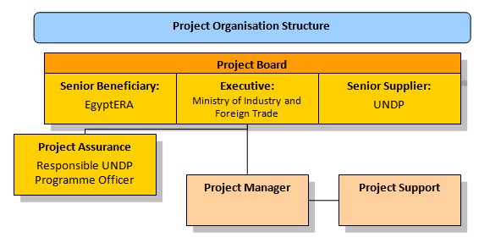
- This Project Document shall be the instrument referred to as such in Article I of the Standard Basic Assistance Agreement between the Government of Egypt and the United Nations Development Programme, signed by the parties on 19 January, 1987. The project will be nationally implemented by the Industrial Modernisation Centre (IMC) of the Ministry of Industry and Foreign Trade. UNDP will be accountable for the disbursement of funds and the achievement of the project goals, according to the approved work plan. The Project Implementing Partner will assign a senior officer as a Project Director to: (i) coordinate the project activities with activities of other Government entities; and (ii) certify the expenditures are in line with approved budgets and work-plans.
- A Project Board (PB) will be established at the inception of the project to monitor project progress, to guide project implementation and to support the project in achieving its listed outputs and outcomes. It will be chaired by the National Project Director and will include representatives of the Ministry of Electricity and Energy, MOFA, IMC, Egypt ERA, NREA, the Energy Efficiency Unit of the Cabinet of Ministers and UNDP. Other members can be invited at the decision of the PB on an as-needed basis, but taking due regard that the PB remains sufficiently lean to be operationally effective. The final list of the PB members will be completed at the outset of project operations and presented in the Inception Report by taking into account the envisaged role of different parties in the PB. The project manager will participate as a non-voting member in the PB meetings and will also be responsible for compiling a summary report of the discussions and conclusions of each meeting.
- The PB may also decide on the establishment of a management committee (as a sub-committee of the PB), including the Implementing Partner, UNDP and one or two more principal partners to meet more frequently than the PB in order to support Project Manager in operational decisions that do not require the entire PB.
- The project Implementing Partner, with the support of UNDP and other members of the PB, will have the main responsibility of coordinating the project activities with other ongoing initiatives and actions in Egypt and for ensuring that the various components of the project are in place when they are needed: e.g. financial instruments are ready when regulations come into place; technical capacity and equipment supply are available at the appropriate time etc.
- The day-to-day management of the project will be carried out by a Project Management Unit (PMU) under the overall guidance of the Project Board. The PMU will be established within the IMC and will coordinate its work with the IMC, EgyptERA and other key stakeholders of the project. The Project Manager will be selected jointly by UNDP and the Implementing Partner. The Terms of Reference of the key project personnel are presented in Section IV, Part IV of this Project Document. The key project personnel will be selected on a competitive basis in accordance with the relevant UNDP rules and procedures and in consultation with the UNDP-GEF Region-Based Technical Adviser.
- The project manager will be supported by international and national experts taking the lead in the implementation of specific technical assistance components of the project. Contacts with experts and institutions in other countries that have already gained experience in developing and implementing renewable energy policies and financial support mechanisms are also to be established.
- UNDP Egypt will maintain the oversight of the overall project budget. It will be responsible for monitoring project implementation, timely reporting of the progress to the UNDP Regional Centre and the GEF, as well as organising mandatory and possible complementary reviews, financial audits and evaluations on an as-needed basis. It will also support the Implementing Partner in the procurement of the required expert services and other project inputs and administer the required contracts. Furthermore, it will support the coordination and networking with other related initiatives and institutions in the country. A Letter of Agreement (Annex 7.9) describes all additional services required of UNDP beyond its role in oversight between the IP and UNDP. The direct project costs requested of UNDP are also detailed in the Total Budget Work Plan.
- For successfully reaching the objective and outcomes of the project, it is essential that the progress of different project components is closely monitored both by the key local stakeholders and authorities as well as by project’s international experts, starting with the finalisation of the detailed, component-specific work plans and implementation arrangements and continuing through the project’s implementation phase. The purpose of this is to facilitate early identification of possible risks to successful completion of the project together with adaptive management and early corrective action, when needed.
- In order to accord proper acknowledgement to the GEF for providing funding, a GEF logo should appear on all relevant GEF project publications, including any hardware purchased with GEF funds. Any citation on publications regarding projects funded by GEF should also accord proper acknowledgement to the GEF in accordance with the relevant GEF guidelines.
- The international experiences and lessons-learned from catalysing local renewable energy development, including those from the other GEF-financed energy efficiency and renewable energy projects in Egypt, have been taken into account in the design of this new project. The applicable parts of the information collected and the work and contacts initiated during the previous projects will be fully utilised, thereby not losing or duplicating the work already done. The activities of the other donors and the foreseen synergies and opportunities for cooperation have been discussed in detail in Chapter 1.4 of this project document. During implementation, proper care will be taken to have adequate communication and coordination mechanisms in place to ensure that areas of common interest can be addressed in a cost-efficient way.

Monitoring Framework and Evaluation

- The project will be monitored through the following M& E activities. The M&E budget is presented at the end of this chapter.
Project Start
- A Project Inception Workshop will be held within the first 4 months of project start with those with assigned roles in the project organisation structure, the UNDP Country Office and – where appropriate/feasible – regional technical policy and programme advisors as well as other stakeholders. The Inception Workshop is crucial to building ownership for the project results and to plan the first year annual work plan.
- The Inception Workshop should address a number of key issues, including:
- Assist all partners to fully understand issues and take ownership of the project. Detail the roles, support services and complementary responsibilities of UNDP CO and RCU staff vis-à-vis the project team. Discuss the roles, functions, and responsibilities within the project's decision-making structures, including reporting and communication lines, and conflict resolution mechanisms. The Terms of Reference for project staff will be discussed again as needed.
- Based on the project results framework and the relevant GEF Tracking Tool if appropriate, finalise the first annual work plan. Review and agree on the indicators, targets and their means of verification, including adding of, and agreement on, the mid-term targets of each outcome in the project’s M&E plan and re-check assumptions and risks.
- Provide a detailed overview of reporting, monitoring and evaluation (M&E) requirements. The Monitoring and Evaluation work plan and budget should be agreed and scheduled.
- Discuss financial reporting procedures and obligations, and arrangements for annual audit.
- Plan and schedule Project Board meetings. Roles and responsibilities of all project organisation structures should be clarified and meetings planned. The first Project Board meeting should be held within the first 12 months following the inception workshop.
- An Inception Workshop report is a key reference document and must be prepared and shared with participants to formalise various agreements and plans decided during the meeting.
Quarterly
- Progress made shall be monitored in the UNDP Enhanced Results Based Management Platform.
- Based on the initial risk analysis submitted, the risk log shall be regularly updated in ATLAS. Risks become critical when the impact and probability are high. Note that for UNDP-GEF projects, all risks associated with financial instruments such as revolving funds, micro-finance schemes or capitalisation of ESCOs are automatically classified as critical on the basis of their innovative nature (high impact and uncertainty due to no previous experience justifies classification as critical).
- Based on the information recorded in Atlas, Project Progress Reports (PPRs) can be generated in the Executive Snapshot.
- Other ATLAS logs can be used to monitor issues, lessons learned, etc. The use of these functions is a key indicator in the UNDP Executive Balanced Scorecard.

Annually
- Annual Project Review/Project Implementation Reports (APR/PIR): This key report is prepared to monitor progress made since project start and, in particular, for the previous reporting period (30 June to 1 July). The APR/PIR combines both UNDP and GEF reporting requirements.
- The APR/PIR includes, but is not limited to, reporting on the following:
- Progress made towards project objective and project outcomes – each with indicators, baseline data and end-of-project targets (cumulative)
- Project outputs delivered per project outcome (annual)
- Lessons-learned/good practice
- AWP and other expenditure reports
- Risk and adaptive management
- ATLAS QPR
- Portfolio-level indicators (e.g. GEF focal area tracking tools) are used by most focal areas on an annual basis as well.

Periodic Monitoring Through Site Visits
- The UNDP CO and the UNDP RCU will conduct visits to project sites based on the agreed schedule in the project's Inception Report/Annual Work Plan to assess first-hand project progress. Other members of the Project Board may also join these visits. A Field Visit Report/BTOR will be prepared by the CO and UNDP RCU and will be circulated no less than one month after the visit to the project team and Project Board members.

Mid-term of Project Cycle
- The project will undergo an independent Mid-Term Review at the mid-point of project implementation. The Mid-Term Review will determine progress being made towards the achievement of outcomes and will identify course corrections if needed. It will focus on the effectiveness, efficiency and timeliness of project implementation; will highlight issues requiring decisions and actions; and will present initial lessons-learned about project design, implementation and management. Findings of this review will be incorporated as recommendations for enhanced implementation during the final half of the project’s term. The organisation, terms of reference and timing of the Mid-Term Review will be decided after consultation between the parties to the project document. The Terms of Reference for this Mid-Term Review will be prepared by the UNDP CO based on guidance from the Regional Coordinating Unit and UNDP-GEF. The management response and the evaluation will be uploaded to UNDP corporate systems, in particular the UNDP Evaluation Office Evaluation Resource Center (ERC).
- The relevant GEF Focal Area Tracking Tools will also be completed during the mid-term evaluation cycle.

End of Project
- An independent Final Evaluation will take place three months prior to the final Project Board meeting and will be undertaken in accordance with UNDP and GEF guidance. The final evaluation will focus on the delivery of the project’s results as initially planned (and as corrected after the mid-term evaluation, if any such correction took place). The final evaluation will look at impact and sustainability of results, including the contribution to capacity development and the achievement of global environmental benefits/goals. The Terms of Reference for this evaluation will be prepared by the UNDP CO based on guidance from the Regional Coordinating Unit and UNDP-GEF.
- The Terminal Evaluation should also provide recommendations for follow-up activities and requires a management response which should be uploaded to PIMS and to the UNDP Evaluation Office Evaluation Resource Centre (ERC).
- The relevant GEF Focal Area Tracking Tools will also be completed during the final evaluation.
- During the last three months, the project team will prepare the Project Terminal Report. This comprehensive report will summarise the results achieved (objectives, outcomes, outputs), lessons-learned, problems met and areas where results may not have been achieved. It will also lay out recommendations for any further steps that may need to be taken to ensure sustainability and replicability of the project’s results.

Learning and Knowledge Sharing
- Results from the project will be disseminated within and beyond the project intervention zone through existing information sharing networks and forums.
- The project will identify and participate in, as relevant and appropriate, scientific, policy-based and/or any other networks, which may be of benefit to project implementation though lessons learned. The project will identify, analyse, and share lessons-learned that might be beneficial in the design and implementation of similar future projects.
- Finally, there will be a two-way flow of information between this project and other projects of a similar focus.

Communications and Visibility Requirements
- Full compliance is required with UNDP’s Branding Guidelines. These can be accessed at http://intra.undp.org/coa/branding.shtml, and specific guidelines on UNDP logo use can be accessed at: http://intra.undp.org/branding/useOfLogo.html. Amongst other things, these guidelines describe when and how the UNDP logo needs to be used, as well as how the logos of donors to UNDP projects need to be used. For the avoidance of any doubt, when logo use is required, the UNDP logo needs to be used alongside the GEF logo. The GEF logo can be accessed at: http://www.thegef.org/gef/GEF_logo.The UNDP logo can be accessed at http://intra.undp.org/coa/branding.shtml.
- Full compliance is also required with the GEF’s Communication and Visibility Guidelines (the “GEF Guidelines”). The GEF Guidelines can be accessed at: http://www.thegef.org/gef/sites/thegef.org/files/documents/C.40.08_Branding_the_GEF%20final_0.pdf.
- Amongst other things, the GEF Guidelines describe when and how the GEF logo needs to be used in project publications, vehicles, supplies and other project equipment. The GEF Guidelines also describe other GEF promotional requirements regarding press releases, press conferences, press visits, visits by Government officials, productions and other promotional items.
- Where other agencies and project partners have provided support through co-financing, their branding policies and requirements should be similarly applied.
M & E Workplan and Budget

Type of M&E activity | Responsible Parties | Budget US$  Excluding project team staff time
Inception Workshop and Report | Project Manager supported by an International Expert  UNDP CO, UNDP GEF | Indicative cost: 10,000
Measurement of Means of Verification of project results. | Project Manager will oversee the hiring of specific studies and institutions, and delegate responsibilities to relevant team members | Indicative costs: 15,000
Measurement of Means of Verification for Project Progress on output and implementation | Oversight by Project Manager  Project team | Indicative costs: 15,000
ARR/PIR | Project manager and team  UNDP CO, UNDP RTA | None
Periodic status/ progress reports | Project manager and team | None
Mid-term Evaluation | Project manager and team  UNDP CO, UNDP RCU  External Consultants (i.e. evaluation team) | Indicative cost: 20,000
Final Evaluation | Project manager and team,  UNDP CO  UNDP RCU  External Consultants (i.e. evaluation team) | Indicative cost: 20,000
Project Terminal Report | Project manager and team  UNDP CO  Local consultant | 15,000
Financial Audits | UNDP CO  Project manager and team | Indicative cost per year: 1,000
Visits to field sites | UNDP CO  UNDP RCU (as appropriate)  Government representatives | For GEF-supported projects, paid from IA fees and operational budget
TOTAL indicative COST  Excluding project team staff time and UNDP staff and travel expenses |  | US$ 100,000  (+/- 5% of total budget)

Legal Context
- This document, together with the CPAP signed by the Government of Egypt and UNDP which is incorporated by reference, constitute together a Project Document as referred to in the Standard Basic Assistance Agreement (SBAA) signed in 1987and all CPAP provisions apply to this document.
- Consistent with Article III of the Standard Basic Assistance Agreement, the responsibility for the safety and security of the implementing partner and its personnel and property, and of UNDP’s property in the implementing partner’s custody, rests with the implementing partner.
- The implementing partner shall:
- put in place an appropriate security plan and maintain the security plan, taking into account the security situation in the country where the project is being carried;
- assume all risks and liabilities related to the implementing partner’s security, and the full implementation of the security plan.
- UNDP reserves the right to verify whether such a plan is in place, and to suggest modifications to the plan when necessary. Failure to maintain and implement an appropriate security plan as required hereunder shall be deemed a breach of this agreement.
- The implementing partner agrees to undertake all reasonable efforts to ensure that none of the UNDP funds received pursuant to the Project Document are used to provide support to individuals or entities associated with terrorism and that the recipients of any amounts provided by UNDP hereunder do not appear on the list maintained by the Security Council Committee established pursuant to resolution 1267 (1999). The list can be accessed via:
http://www.un.org/Docs/sc/committees/1267/1267ListEng.htm.
This provision must be included in all sub-contracts or sub-agreements entered into under this Project Document.
- Audit Clause: The Audit will be conducted in accordance with UNDP Financial Regulations and Rules and applicable audit policies on UNDP projects.

7 ANNEXES

Annex 7.1. Offline Risk Log
# | Description | Date identified | Type | Probability &  Impact | Countermeasures / Mgt response | Owner | Submitted, updated by | Last Update | Status
1. | Lack of political will or strength to adopt the required legal and regulatory changes to promote small, decentralised RE (in particular PV) power generation and the related financial and fiscal incentive schemes. |  | Political | No policy basis and incentives to catalyse the RE market.  P = 2  I= 4 | The effort to secure reliable energy supply is likely to remain high on the political agenda, regardless of which party is in power. Individual entities within the Government structure, such as MoEE, EEHC and EgyptERA, may also proceed with many initiatives based on their own internal/board decisions only, being considerably simpler to obtain than passing new laws.  The proposed financial support schemes have been discussed with the Government during project preparation and have been assessed as feasible. The project design also contains some flexibility to adapt the proposed financial support strategy (subject to the availability of other co-financing sources) on the progress achieved with the GoO and net-metering schemes, while also proposing measures that do not place a direct burden on the State budget. Close co-operation with, and involvement of, EgyptERA since the original project design will also mitigate the political risks, since EgyptERA exerts a strong influence on the development of the electricity sector in Egypt. | Project Board |  | N/A | N/A
2. | Unstable and unpredictable market, policy and financing environment. |  | Political & Financial | Damaging ‘stop and go’ dynamics of the market.  P = 3  I = 4 | For the proposed net-metering scheme, the electricity tariffs are likely to increase rather than to decrease in the future, which is why no major risks are foreseen associated with tariffs and corresponding savings/revenues in the net-metering scheme.  Significantly higher risks are associated with the future market value of GoO certificates, but specific measures to mitigate these risks will be further studied and, as applicable, introduced as part of the scheme. Some regulatory measures, such as obligatory purchase of RE-generated electricity by some consumer groups to mitigate this market risk, have already been considered by EgyptERA.  Since the proposed complementary incentives to be provided by the UNDP-implemented, GEF-financed project are aimed at only ‘kick-starting’ the initial PV market and contribute less than one-third of the overall support, their removal after reaching the initial 4 MW_{p} target is not expected to have a major negative impact. By that stage, the market is expected to have developed a sustainable growth dynamic already. This needs to be closely monitored and assessed during project implementation, however. In this context, a gradually degressing GEF subsidy may also be considered. | Project Board |  | N/A | N/A
3. | Lack of available financing to cover the initial investment costs. |  | Financial | Investments not made.  P = 2  I = 5 | While the upfront grant cost-sharing provided by the UNDP-implemented, GEF-financed project will reduce the initial investment needs, it is also believed that, after the initial demand and adequate cost-recovery of PV investments with support of the proposed financial support mechanisms has been demonstrated, there are several international and national financing entities active in Egypt that are likely to recognise a new market niche. At the same time, however, active steps and measures are required by the project to mitigate the financing risk, which are addressed under Outcome 4. | Project Board
4. | Technical failures of the promoted PV technology. |  | Technology | Loss of consumer confidence in PV.  P = 2  I = 4 | The promoted PV technologies are considered to be technically mature technologies, so the risk of technical failure is considered to be low. This does not detract, however, from the importance of adequate quality control of both products and installations at all stages of implementation. | PMU
5. | Inadequate and/or non-capacitated human resources on the supply-side. |  | Operational | Anticipated project results and their mainstreaming not achieved.  P = 2  I = 5 | A cadre of technically-skilled personnel on the supply-side already exist, who, with appropriate training, are likely to be able to provide the required services. A typical project risk for training and capacity building activities is also that, after the completion of training, there will be no real demand for the services of the trained experts. The integrated approach adopted by the project is expected to mitigate this risk by combining the training with concrete possibilities to apply the new skills in practice. | PMU
6. | Climate change having an adverse impact on the market. |  | Environmental | Deteriorating performance of, or damage to, installed PV systems.  P = 2  I = 2 | No significant climate change-related risks are expected, and no major management measures are anticipated to be undertaken, except to ensure that the supporting structures and fixtures for installing PV modules can stand potentially stronger storms in the future and appropriate cleaning regimes are applied by households. | PMU
7. | Project management risk. |  | Operational | Project not achieving its expected results.  P = 3  I = 5 | Recruitment of the key project staff based on competitive selection procedures, emphasising the qualifications and requirements stipulated in the ToRs. Effective planning and day-to-day monitoring of the progress towards the set targets to complement regular annual monitoring, including the use of international expert support for project progress monitoring, adaptive management, technical backstopping and building up the local capacity from project inception. Such international support can be gradually reduced during project implementation, depending on how the project proceeds. | Project Board  PMU

Annex 7.2 Agreements
The co-financing letters are included below and as separate attachments.

Cofinancing letter UNDP

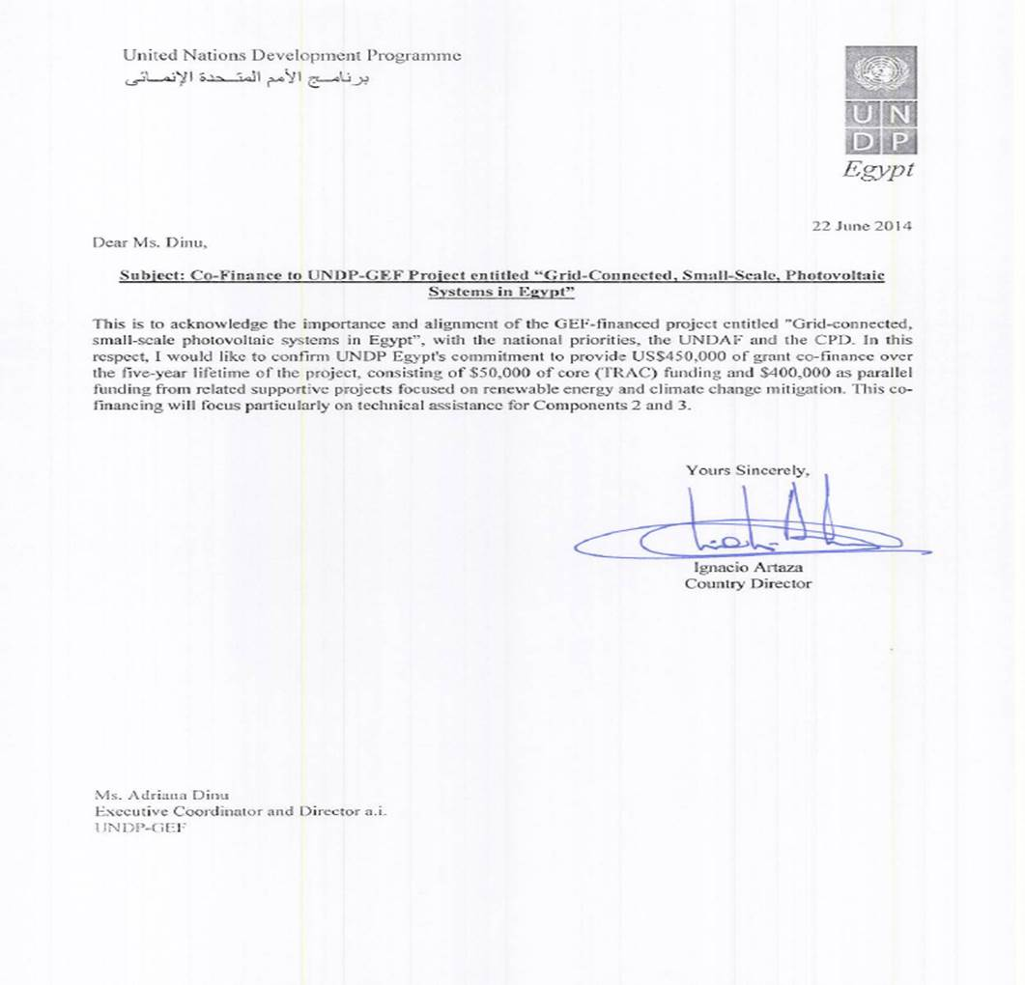

Co-financing letter: Industrial Modernisation Centre
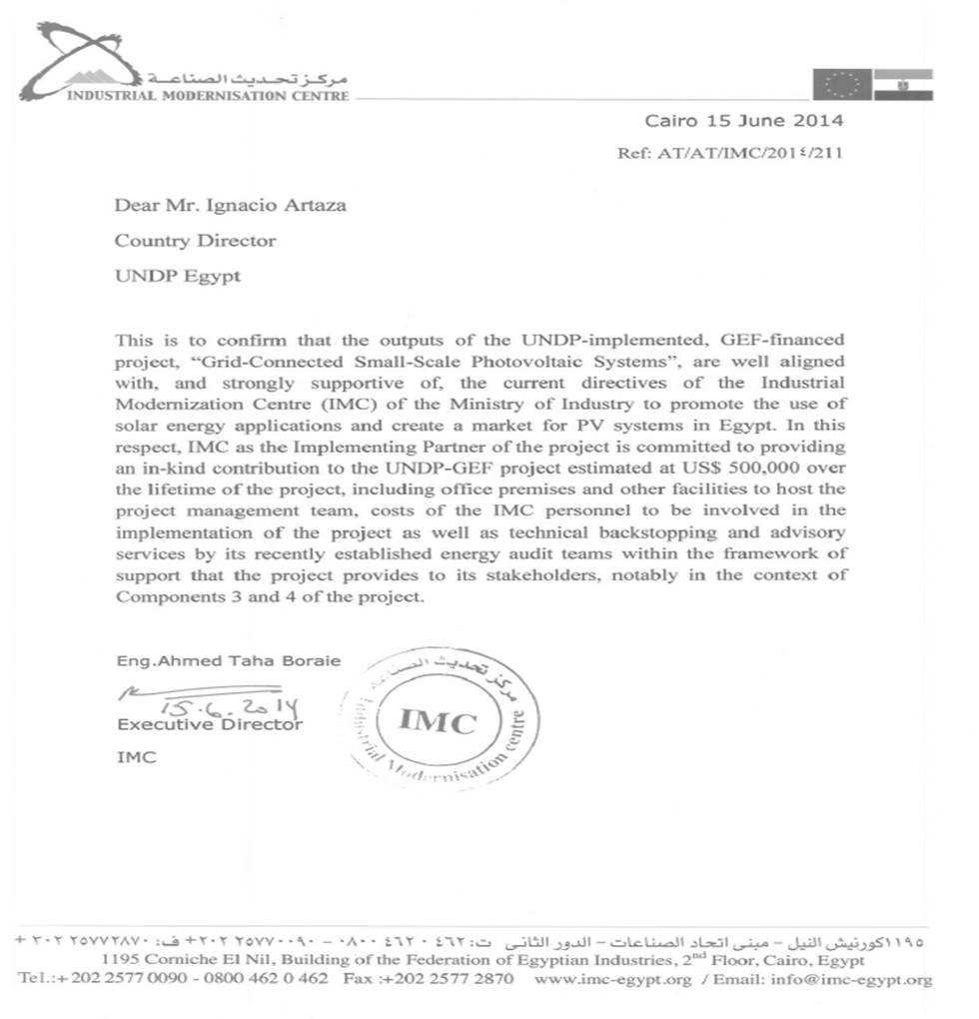

Co-financing letter: EgyptERA
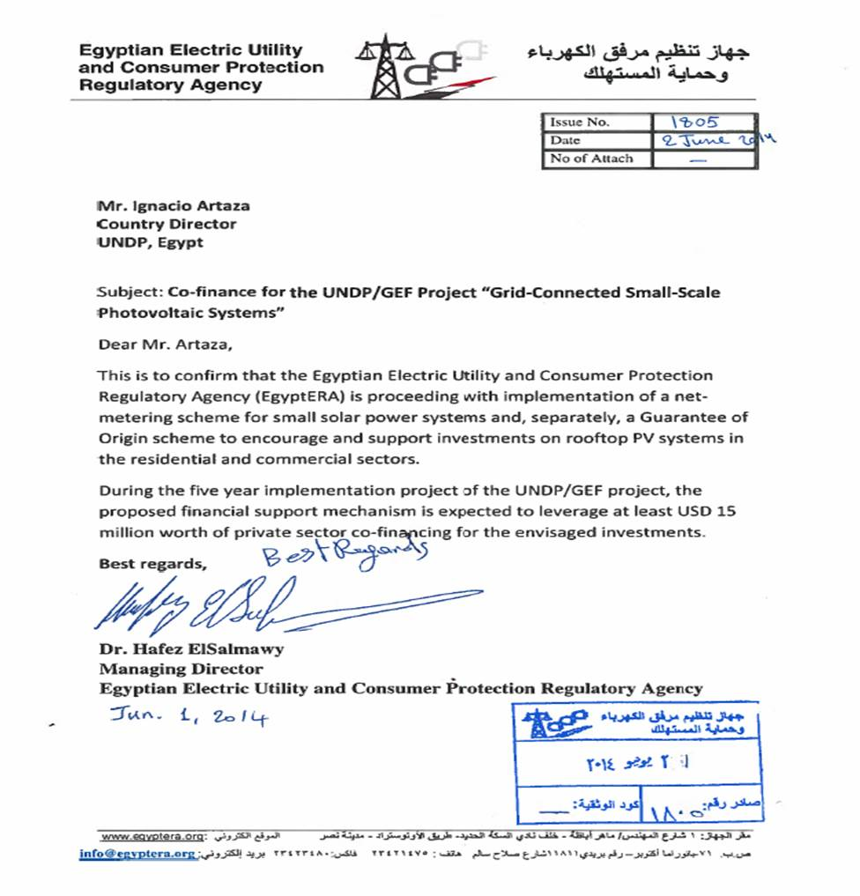

Co-financing letter: Ministry of Electricity & Energy

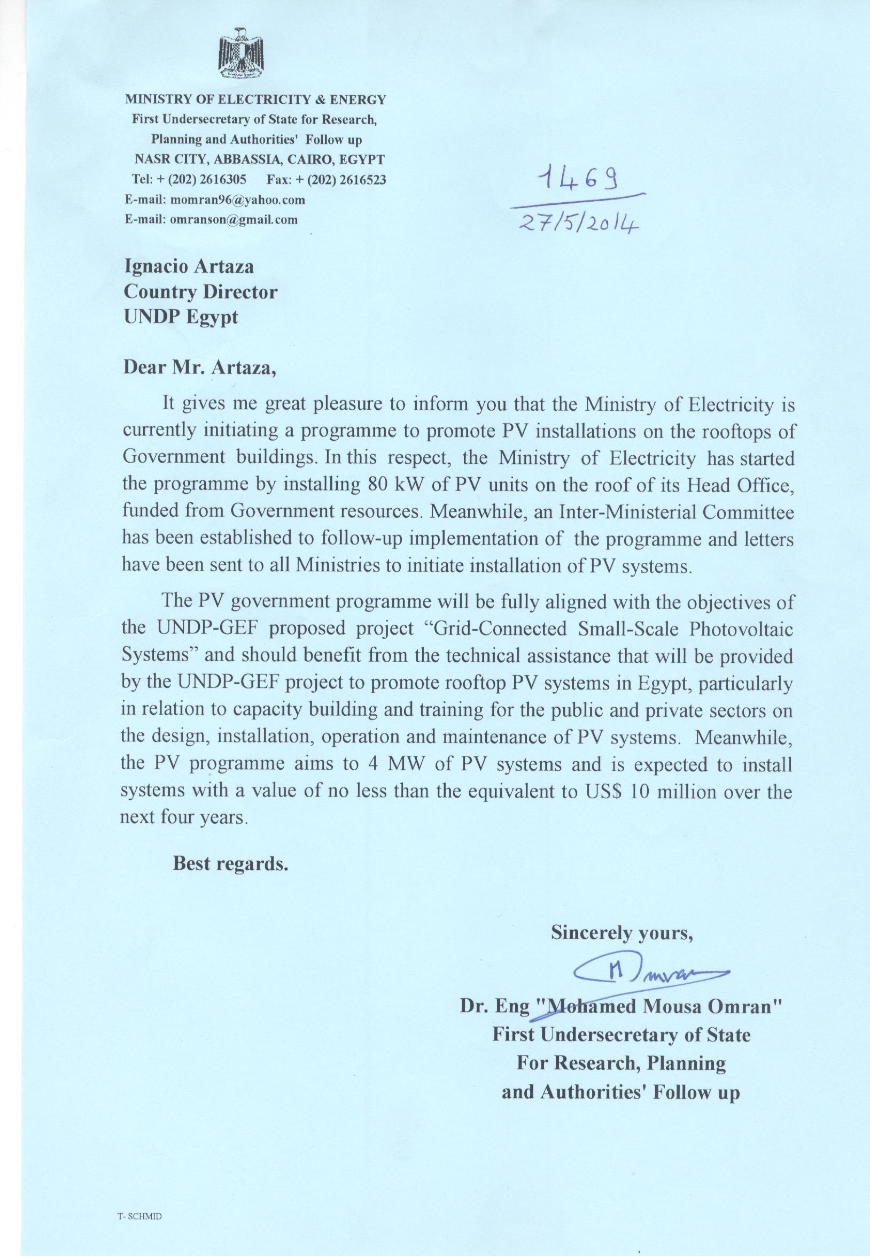

Co-financing letter: Energy Efficiency Unit of the Council of Ministers
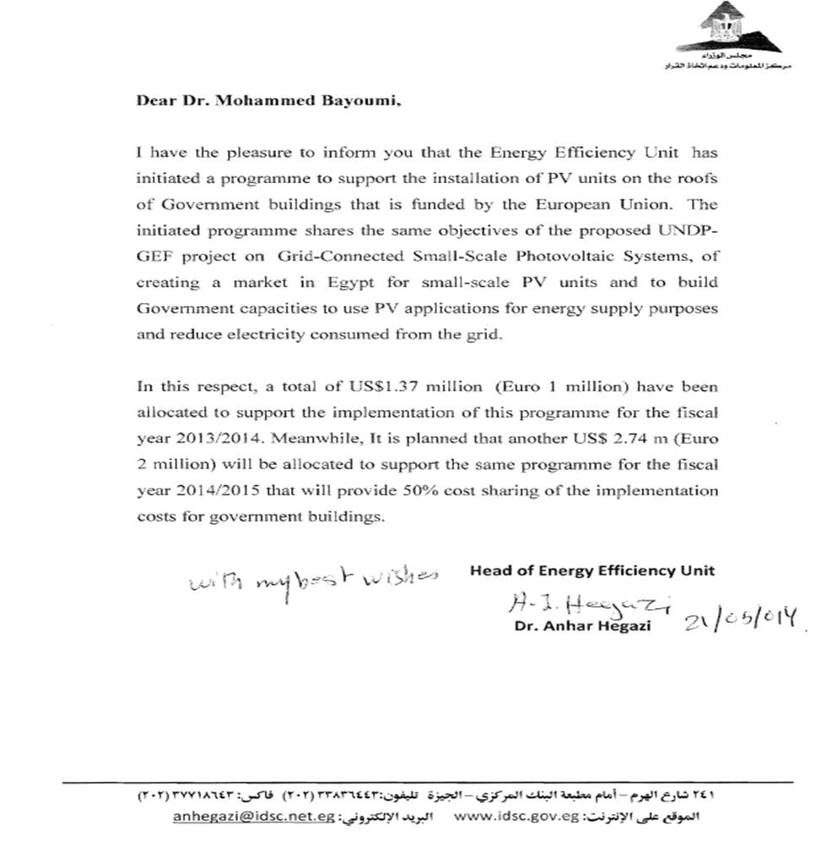

Co-financing letter: RCREEE

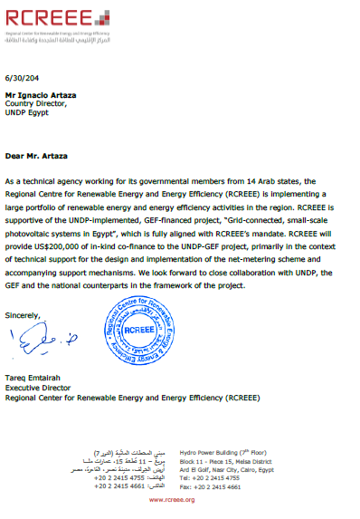

Annex 7.3 Summary of the Proposed PV Support Scheme and Related GEF Cost-Sharing
The proposed PV support scheme will build on and complement the plans of EgyptERA to introduce a Guarantee of Origin (GoO) scheme and a net-metering scheme to provide adequate financial incentives to the private sector (primarily households and small businesses) to invest in small, decentralised PV power generation.
The PV system costs are discussed in Chapter 2.1. Figures 2.1 and 2.2 illustrate the power purchase price (or, alternatively, the expected value of electricity saved – i.e. avoided costs) needed to reach a break-even of the investment at different PV system prices, discount rates and expected pay-back periods. The required power purchase price for a pay-back period of 25 years corresponds to the levelised cost of electricity (LCOE) over the entire lifetime of the PV system, given that the typical lifetime of such a system is of 25 years or more. Among the targeted private-sector investors (consisting of residential consumers and private SMEs), however, a significantly shorter pay-back period is typically required for a positive investment decision.
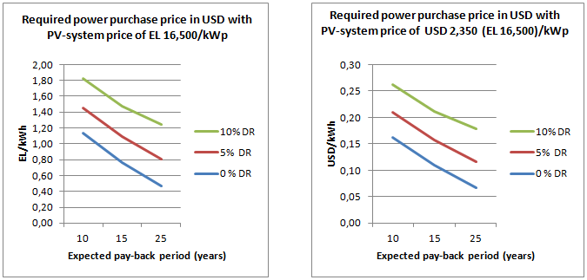
Figure 2.1 (from Chapter 2.1): An estimate of the required power purchase with different discount rates (DR) and with a PV system price of LE 16,500/kW_{p} (approximately USD 2,350 or EUR 1,680 per kW_{p}) including installation, and sales tax of 10% and assuming average annual production of about 1,500 kWh/kW_{p.}
By taking into account the current Government plans and available funding (including the resources of the UNDP-implemented, GEF-financed project) to boost the private-sector PV market and reach a target of 4 MW_{p} of installed capacity by the end of the project, the design of the proposed support scheme is based on the level of revenues equal to a power purchase price of LE 1.34 (19 US cents) per kWh. This is to be achieved by a combination of three different support schemes, as elaborated in further detail below. With such a revenue level, the pay-back period for the PV system can be brought down to approximately 8-15 years, depending on the discount rate used, after which the system can still continue to operate practically for free for another 10-15 years (aside from regular (small) maintenance costs and eventual need to replace some system components). This is expected to provide a sufficiently attractive financing framework to encourage the private-sector to invest in PV. The situation will, however, be evaluated on annual basis with related adaptive management actions when needed.
The proposed level of support equal to LE 1.34 (19 US cents) per kWh is envisaged to consist of LE 0.67 (9.5 US cents) per kWh from the net-metering scheme (being the highest residential tariff category at the moment), the anticipated value of LE 0.40 (5.7 US cents) per kWh of the RE GoO certificate, and a LE 0.27 (3.8 US cents) per kWh premium for 10 years to be paid by the UNDP-implemented, GEF-financed project as an upfront grant equal to LE 4,000 (USD 570) per kW_{p}. Subject to the further analysis to be done at the project inception phase, this grant can be paid either to the investor (i.e. the owner of the new PV system) or directly to the system supplier after the commissioning test has been successfully passed, thereby reducing the initial financing needs of the investor. As an option, and by building on the observed results of the first year, a gradually degressing support scheme can also be considered, with USD 570 per KW_{p} for the first year (or for reaching the first MW_{p} target), USD 550 per kW_{p} for the second year, etc.
Some key criteria for the project support are summarised below:
- Eligible applicants: Residential electricity consumers and private-sector SMEs
- Amount of support: LE 4,000 (USD 570) per installed kW_{p} to be paid as an upfront grant either to the investor (i.e. the owner of the new PV system) or directly to the system supplier after the commissioning test has been successfully passed (i.e. the quality of the installation has been verified and the system has entered successfully into operation);
- Eligible size of the systems: From 2 kW_{p} to 50 kW_{p}
- A call for investment proposals to be renewed annually for the duration of the project – subject to the availability of financial resources. In order to avoid damaging “stop and go” dynamics, the support scheme will be subject to an annual review concerning its performance and the related need for adaptive management regarding, among other considerations, the level of support, the eventual need to introduce annual MW_{p} caps, and the possibilities for leveraging complementary financial resources in the event that demand for support exceeds the available GEF resources.
In order the reach the set project target of at least 4 MW_{p} of new PV capacity to be facilitated by the project, the total GEF grant allocation required to serve the grant-based financial support mechanism is USD 2.3 million, with an average/typical system size of 2.5-3.0 kW_{p} and 1,300-1,600 systems in total. As such, the average GEF-financed upfront grant for each system is estimated to be in the range of USD 1,400-1,700. For paying the remaining system costs, the households and other targeted clients will use their own financial resources and/or apply for bank loans. Possible complementary financing mechanisms for this purpose are studied and, as applicable, further elaborated under Outcome 4 of the project.

Annex 7.4 Terms of Reference
Project Board
Duties and responsibilities:
The Project Board (PB) is the main body to supervise the project implementation in accordance with UNDP rules and regulations and referring to the specific objectives and the outcomes of the project with their agreed performance indicators.
The main functions of the PB are:
- General monitoring of project progress in meeting its objectives and outcomes and ensuring that they continue to be in line with national development objectives;
- Facilitating co-operation between the different Government entities, whose inputs are required for successful implementation of the project, ensuring access to the required information, and resolving eventual conflict situations arising during the project implementation when trying to meet outcomes and stated targets;
- Supporting the elaboration, processing and adoption of the required institutional, legal and regulatory changes to support the project objectives and overcoming of related barriers;
- Facilitating and supporting other measures to minimise the identified risks to project success, remove bottlenecks and resolve eventual conflicts;
- Approval of the annual work plans and progress reports, the first plan being prepared at the outset of project implementation;
- Approval of the project management arrangements; and
- Approval of any amendments to be made in the project strategy that may arise due to changing circumstances, after careful analysis and discussion of the ways to solve problems.
Project Board Structure
The Project Board will be chaired by the Project Director The PB will include representatives from the key Ministries and Agencies involved in the project and, as applicable, representatives of the project’s other co-financing partners. A draft list of the permanent members of the PB is provided under section 4 of the Project Document: “Project Management and Implementation Arrangements”. Other participants can be invited to the PB meetings at the decision of the PB.
Project Director
As a representative of the Government and the project’s Implementing Partner, the Project Director has the main responsibility to ensure that the project is executed in accordance with the Project Document and the UNDP guidelines for nationally executed projects.
His/her main duties and responsibilities include:
- Supervise and guide the work of the Project Manager with the work of the national implementing agency through meetings at regular intervals to receive project progress reports and provide guidance on policy issues;
- Certifying the annual and, as applicable, quarterly work plans, financial reports, and ensuring their accuracy and consistency with the project document and its agreed amendments;
- Signing contracts and other project financial documents as needed
- Taking the lead in developing linkages with the relevant authorities at national, provincial and governmental level and supporting the project in resolving any institutional- or policy-related conflicts that may emerge during its implementation.
Project Manager (full-time)
Duties and responsibilities:
Operational project management in accordance with the Project Document and the UNDP guidelines and procedures for nationally executed projects, including:
- General coordination, management and supervision of project implementation, including suggestions for required adaptive management actions when and as needed;
- Managing the procurement and the project budget under the supervision of UNDP and Implementing Partner to assure timely involvement of local and international experts, organisation of training and public outreach, purchase of required equipment etc. in accordance with UNDP rules and procedures;
- Submission of annual project workplan, budget revisions, implementation reviews and other required progress reports (such as QPRs) to the Project Board, Implementing Partner and UNDP in accordance with the section “Monitoring and Evaluation” of the Project Document;
- Ensuring effective dissemination of, and access to, information on project activities and results, (including a regularly updated project website);
- Supervising and coordinating the contracts of the experts working for the project;
- As applicable, communicating with the project’s international partners and attracting additional financing in order to fulfill the project objectives; and
- Ensuring otherwise successful completion of the project in accordance with the stated outcomes and performance indicators summarised in the project’s log-frame matrix and within the planned schedule and budget.
Expected Qualifications:
In evaluating the candidates applying for the position of the project manager, it is to be emphasised that a committed, full-time project manager with adequate outreach and networking skills is absolutely essential for the success of the project. Therefore, a specific emphasis in the evaluation will be placed on the demonstrated and proven capacity and results of the applicants to: (i) have a clear vision on where the project is heading to and how to reach its targeted development goal(s) and outcome targets; (ii) engage the key stakeholders in constructive discussion about future development of the decentralised RE (in particular PV) power generation market in Egypt; (iii) guide and supervise the studies done and effectively co-operate with the international experts who are engaged to support this work; (iv) present their findings and recommendations in a convincing manner to key policy-makers and opinion leaders by taking into account the main macroeconomic and policy drivers for the development of local RE market; and (v) to identify areas of future work.
Contributing to the requirements above, the candidates applying for the position are expected to have:
- Advanced university degree and at least 7 years of professional experience or a university degree with 10 years of professional experience in the specific areas the project is dealing with, including solid knowledge of international renewable energy experiences, state-of-the-art approaches, and best practices in catalysing the renewable energy market (by applying different policy measures, new financing mechanisms, etc.);
- Experience in managing projects of similar complexity and nature, including demonstrated capacity to actively explore new, innovative implementation and financing mechanisms to achieve the project objective;
- Demonstrated experience and success in the engagement of, and working with, the private sector and NGOs, creating partnerships and leveraging financing for activities of common interest;
- Good analytical and problem-solving skills and the related ability to adaptively manage with prompt action on the conclusion and recommendations coming out from the project’s regular monitoring and self-assessment activities as well as from periodic external evaluations;
- Ability and demonstrated success to work in a team, to effectively organise it, and to motivate its members and other project counterparts to effectively work towards the project’s objective and expected outcomes;
- Good communication skills and competence in handling the project’s external relations at all levels; and
  - Fluent/good knowledge of Arabic and English languages;
  - Familiarity and prior experience with UNDP and GEF requirements and procedures are considered an asset.

Project Engineer
Duties and responsibilities:
The project engineer will contribute to and supervise the technical aspects of the project, including:
- Elaborating the technical and other quality criteria for the PV systems, installations and supply-side service providers to benefit from the UNDP-implemented, GEF-financed project support and participate in the 4 MW_{p} programme.
- Technical due diligence of the PV investment proposals received;
- Quality control of PV products and installation of projects receiving GEF support, including the required inspections and tests at the commissioning stage;
- Supervising the monitoring of the annual performance of the PV investments supported by the project and analyzing the results, including interaction with the grid;
- As applicable and in co-operation with the local and /or international grid analysis expert, drafting recommendations for required changes and improvements to the existing grid code for small, decentralised PV systems on the grid and operating them without distorting the grid balance;
- By building on the previous work both in Egypt and abroad, elaborating a quality control and certification scheme applicable for Egyptian conditions for both products and installation, and facilitating its adoption by initiating required stakeholder consultations, drafting of proposals and eventual new regulations or standards required for the implementation of the scheme;
- Local capacity building - preparation of training materials for and organising/providing the actual training on the different technical aspects of the project, including PV system design, selection and installation, implementation of the quality control and certification scheme, product maintenance during operation, product performance monitoring and testing, etc.
- Exploring opportunities for cooperation with local universities, professional and vocational schools and initiating and developing activities of common interest such as new courses and curricula for PV systems designers and installers and opportunities for practical training of the students.
- Supporting and contributing to the implementation of other technical aspects of the project, as requested by the project manager.
Expected Qualifications:
- Advanced university degree and at least 2 years of professional experience or graduate university degree with 4 years in electrical engineering, including grid management or a related field;
- Familiarity with the key characteristics of small, decentralised PV applications and hands-on experience with their proper installation and operation in Egyptian conditions;
- Demonstrated experience and success in the engagement of, and working with, the private sector;
- Good analytical and problem-solving skills and the related ability to adaptively manage with prompt action on the conclusions and recommendations coming out of the project’s regular monitoring and self-assessment activities as well as from periodic external evaluations;
- Ability and demonstrated success to work in a team, to effectively organise it, and to motivate its members and other project counterparts to effectively work towards the project’s objective and expected outcomes;
- Good communication skills and competence in handling project’s external relations at all levels; and
- Fluent/good knowledge of the Arabic and English languages.
Project Assistant (full-time)
Duties and responsibilities:
Supporting the project manager in the implementation of the project, including:
- Responsibility for logistics and administrative support of project implementation, including administrative management of the project budget, required procurement support, etc.
- Maintaining up-to-date business and financial documentation, in accordance with UNDP and other project reporting requirements;
- Organising meetings, business correspondence and other communications with the project partners;
- Supporting the project outreach and PR activities in general, including keeping the project website up to date;
- Managing the projects files and supporting the project manager in preparing the required financial and other reports required for monitoring and supervision of project progress;
- Supporting the project manager in managing contracts, in organising correspondence and in ensuring effective implementation of the project generally.
Expected Qualifications:
- Fluent/good knowledge of Arabic and English;
- Demonstrated experience and success of working in a similar position;
- Good administration and interpersonal skills;
- Ability to work effectively under pressure;
- Good computer skills.

INTERNATIONAL PROJECT EXPERTS (PART-TIME)
International project adviser (part-time)
Duties and Responsibilities:
Support UNDP and the project management in monitoring the progress of the project and its different sub-components and, as needed, build the capacity of the local experts working for the project to successfully implement the project activities, ensuring that they comply with the agreed benchmarks and success indicators of the project as well as international best practices and lessons-learned. The expected level of involvement will be 20-40 days (including 2-4 missions) per year, which may gradually reduce towards the end of project implementation depending on how the project proceeds.
The specific responsibilities include, among others, to:
- Support the local project management team in organising and planning the implementation of the project’s different sub-components at the inception phase, including support to the project manager in the preparation of the project inception report and the annual output specific work plans, drafting of Terms of Reference for the national and, as needed, additional international experts and sub-contractors, required tender documents, etc;
- Support adaptive management by annually (or semi-annually) reviewing the progress of the project and its different sub-components and making suggestions for changes and/or complementary activities;
- Review and propose methodologies for market monitoring and for assessing the GHG reduction impact of the project and its outputs;
- By building on international experiences and lessons-learned from promoting small, decentralised RE power generation, contribute with policy recommendations to the implementation of activities under Outcome 2 of the project;
- Support the project manager in supervising the work of the contracted individual experts and companies, including review of the feasibility studies and the technical design, financing and implementation arrangements of the planned pilot projects;
- Support the project management in the consultations with different financing entities active in Egypt towards reaching the target of Outcome 4 of the project;
- Support the project manager in arranging cooperation with the already-identified key stakeholders and, as applicable, support the identification and establishment of new national and/or international partnerships and to support the project goals and objectives; and
- Support the local project team in monitoring and evaluating the performance and the outcome of the pilot projects under implementation.
Expected Qualifications:
- A university degree in the project related field;
- Demonstrated experience and success in supporting similar projects (or sub-components);
- Solid knowledge of international experiences, state-of-the-art approaches and best practices in the specific areas the project and its sub-components are dealing with, including both technical knowledge and capacity to assess the technical aspects of the project and experience on financial structuring and development on new financing mechanisms to support PV market development ;
- Good analytical skills and effective communication and training skills, and competence in handling external relations at all levels;
- Ability to work in a team and to motivate other team members and counterparts;
- Fluency in English; and
- Familiarity with UNDP and GEF requirements is considered an asset.
Electricity Grid Analysis and Management Expert (as needed)
Duties and Responsibilities:
- Supporting the local project engineer in elaborating the technical and other quality criteria for the PV systems, installations and supply-side service providers to benefit from the UNDP-implemented, GEF-financed project support and to participate in the 4 MW_{p} programme.
- By building on the analysis of the performance of the first systems installed, supporting the project engineer in drafting recommendations for the eventually required changes and improvements to the existing grid code for connecting small, decentralised PV systems onto the grid and operating them without distorting the grid balance;
- Perform other duties in the area of training the local stakeholders and supporting the project activities, as elaborated in greater detail during project implementation.
Quality control (and PV testing expert), as needed.
Duties and Responsibilities:
- In cooperation with the Grid Analysis and Management Expert (as applicable), supporting the local project engineer in elaborating the technical and other quality criteria for the PV systems, installations and supply-side service providers to benefit from the UNDP-GEF project support and to participate in the 4 MW_{p} programme.
- Support and train the local stakeholders on the technical due diligence of the PV investment proposals received, and the quality control of the PV products procured and installations undertaken at the commissioning stage;
- Supporting the local project engineer and other key local stakeholders in elaborating a more permanent quality control and certification scheme applicable to Egyptian conditions (including eventual testing facilities) for both products and installation, including the required follow-up consultations;
- Perform other duties in the area of training the local stakeholders and supporting the project activities, as elaborated in greater detail during project implementation.

Annex 7.5 Greenhouse Gas Emission Reduction Analysis
The GHG emissions reduction analysis follows the standard GEF methodology, showing the results of the direct, direct post-project, indirect bottom-up and indirect top-down impact analysis and by using a causality factor for the latter.
The direct GHG reduction benefits of the project have been estimated at 66 kilotonnes of CO_{2eq} resulting from the installation of at least 4 MW_{p} of new small, grid-connected RE capacity during the lifetime of the project and calculated over the investments’ default lifetime of 20 years.
No direct post-project impact has been considered in the analysis since the GEF resources will be used as one-time capital grant support without expected pay-back: i.e. no new loan or loan guarantee mechanism will be created with the GEF funds.
For assessing the project’s indirect impact, it was assumed that, over the influencing period of 10 years after the project end, the project’s market development activities together with the introduction of new financial and fiscal support mechanisms influenced by the project will facilitate the installation of 20,000-25,000 new rooftop PV systems at an average capacity of 3 kW_{p} each and total capacity reaching 60-70 MW_{p} by 2029.
For a bottom-up analysis, the figures above correspond with an assumption that, in 2019, a total of 2 MW_{p} of new, decentralised PV capacity would be installed in residential buildings as an indirect impact of the project, after which the capacity of new installations would grow by an average of 20% per year over the next 10 years, resulting in 64 MW_{p} of total installed capacity of PV rooftop systems in residential buildings by 2029. For a top-down approach, it can be assumed that at least 15% of the current high tariff category electricity customers (of which there are 150,000 households) have installed a rooftop PV system of 3 kW_{p} each by 2029, resulting in total installed capacity of 67 MW_{p}.
Both estimates above can be considered to be conservative given the overall potential of over
1,000 MW_{p} if all the current 500,000 residential customers in the highest and second-highest tariff categories installed rooftop systems of 2.5 kW_{p} each, and without accounting for commercial and industrial customers. Furthermore, according to EgyptERA, about 4% of customers each year are moving from a lower tariff category to a higher one.
For public buildings, the announced target of the Ministry of Electricity and Energy is to install 1,000 rooftop PV systems of about 40 kW_{p} each, with a total capacity of 40 MW_{p}, over the next few years. The Egyptian Solar Plan agreed by the Cabinet of Ministers in July 2012 aims at 3,500 MW_{p} of total installed solar power capacity (including both CSP and PV – centralised and decentralised) by 2027.
A summary of the results and key assumptions of the project’s greenhouse gas emission reduction analysis is presented in Table 7.5.1.

Table 7.5.1 Summary of the GHG Reduction Analysis
 | Lifetime direct | Lifetime post-project | Lifetime indirect  bottom-up | Lifetime indirect top-down
New installed RE capacity (MW_{p}) | 4 | NA | 64 | 67.5
Timeframe of the analysis | Investments made during project implementation between 2014-2019 with a default lifetime of 20 years | NA | Investments made in 2019-2029 (within 10 years after the project end) with a default lifetime of 20 years | Investments made by 2029 with a default lifetime of 20 years
Annual power generation per installed MW (MWh/MW_{p}) | 1,500 | NA | 1,500 | 1,500
Annual generation (MWh) | 6,000 | NA | 96,451 | 101,250
Total electricity generation over the default lifetime (MWh) | 120,000 | NA | 1,929,025 | 2, 025,000
Average baseline emission factor  (tonnes of CO_{2eq}/MWh) | 0.550 | NA | 0.550 | 0.550
Calculated GHG reduction  (tonnes of CO_{2eq}) | 66,024 | NA | 1,061,355 | 1,114,160
Causality factor | 100% | NA | 60% | 60 %
Project impact  (tonnes of CO_{2eq}) | 66,024 | NA | 636,813 | 668,496
Baseline Emission Factor
As the baseline grid emission factor, 0.550 tCO₂eq/MWh has been used, calculated on the basis of the reported fuel consumption of Egyptian power plants, the net electricity generation in 2012/2013, network losses of 11% as per the annual report of EEHC 2012/2013, and the IPCC emission factors from 2006. The figures used are summarised in Tables 7.2 – 7.5 below.
Table 7.5.2 Structure of Electric Power Generation in Egypt (TWh) | 2007/08 | 2008/09 | 2009/10 | 2010/11 | 2011/12 | 2012/13
EEHC Thermal | 95,782 | 101,898 | 111,576 | 118,500 | 129,361 | 135,473
Private Sector Thermal (BOOT) | 12,642 | 13,241 | 13,184 | 13,309 | 12,855 | 14,264
IPPs (Thermal) | 14 | 17 | 26 | 27 | 29 | 33
Isolated Plant Units (Thermal) | 350 | 271 | 218 | 209 | 223 | 240
Subtotal Thermal Power Generation | 108,788 | 115,427 | 125, 004 | 132, 045 | 142,468 | 150,010
Hydro | 15,510 | 14,682 | 12,863 | 13,046 | 12,934 | 13,121
Wind | 831 | 931 | 1,133 | 1,485 | 1,525 | 1,260
Solar |  |  |  | 219 | 479 | 237
Total Power Generation | 125,129 | 131,040 | 139,000 | 146,795 | 157,406 | 164,628
Import | 251 | 126 | 183 | 152 | 102 | 77
Export | -814 | -1 022 | -1 118 | -1 595 | -1 679 | -474
Total Domestic Supply | 124,566 | 130,144 | 138,065 | 145,352 | 155,829 | 164,231

Table 7.5.3  Fuel consumption of the power plants (ktoe) | Year | EEHC | BOOT | Isolated | IPPs | TOTAL | Emission Factors (IPCC 2006)
 |  |  |  |  |  |  | kg/TJ | tonnes/ktoe
Natural gas | 2011/12 | 22,458 | 2,606 |  |  | 25,064 | 56,000 | 2,344
Natural gas | 2012/13 | 22,162 | 2 936 |  |  | 25,098 | 56,000 | 2,344
Heavy Fuel Oil (HFO) | 2011/12 | 4,560 | 39 |  |  | 4,599 | 77,400 | 3,240
Heavy Fuel Oil (HFO) | 2012/13 | 6,545 | 3 |  |  | 6,548 | 77,400 | 3,240
Light Fuel Oil (HFO) | 2011/12 | 65 | 0 | 76 |  | 141 | 74,100 | 3,102
Light Fuel Oil (HFO) | 2012/13 | 104 |  | 78 |  | 182 | 74,100 | 3,102
TOTAL | 2011/12 | 27,083 | 2,645 | 76 |  | 29,804
TOTAL | 2012/13 | 28,811 | 2,939 | 78 |  | 31,828

Table 7.5.4 Conversion efficiency and GHG emissions in 2011/2012 on net consumption | EEHC | BOOT | Isolated | IPPs | All | With network losses of 11% included
Conversion efficiency | 41.1 % | 41.8 % | 25.1 % |  |  | With network losses of 11% included
Total GHG emissions (Mtonnes of CO₂eq) | 67.62 | 6.24 | 0.24 |  | 74.09 | With network losses of 11% included
Specific GHG emissions of thermal power gen. (tonnes of CO₂eq/MWh produced) | 0.523 | 0.485 | 1.06 |  | 0.520 | 0.584
Average GHG emissions of all power generation (tonnes of CO₂eq/MWh produced) | 0.469 | 0.485 | 1.06 |  | 0.471 | 0.529

Table 7.5.5 Conversion efficiency and GHG emissions in 2012/2013 on net consumption | EEHC | BOOT | Isolated | IPPs | All | With network losses of 11% included
Conversion efficiency | 40.4 % | 41.7 % | 26.5 % |  |  | With network losses of 11% included
Total GHG emissions (Mtonnes of CO₂eq) | 73.48 | 6.89 | 0.24 |  | 80.62 | With network losses of 11% included
Specific GHG emissions of thermal power gen. (tonnes of CO₂eq/MWh produced) | 0.542 | 0.483 | 1.01 |  | 0.517 | 0.581
Average GHG emissions of all power generation (tonnes of CO₂eq/MWh produced) | 0.490 | 0.483 | 1.01 |  | 0.490 | 0.550

Annex 7.6 Stakeholder Involvement Plan

Stakeholder | Role
Industrial Modernisation Centre of the Ministry of Industry and Foreign Trade | The Industrial Modernisation Centre of the Ministry of Industry and Foreign Trade will be the National Implementing Partner (executing agency) for the project. Its principal role will be to support the development of a local supply chain of components to ensure economic and accessible equipment needs are met and to help create opportunities for skilled jobs. As the sustainability of small-scale installations (in the few kilowatt range) relies on the development of local technical and manufacturing capacity, the IMC/Ministry is ideally suited to help develop a local industry that will be able to sustain itself after the closure of the UNDP-implemented, GEF-financed project.
Ministry of Electricity and Energy | Main stakeholder and spearhead of the PV and EE lighting programme for Government buildings.
Egyptian Electricity Holding Company (EEHC) and the distribution companies working under it | Key project stakeholders in supporting and supervising the connection of PV systems into the grid.
Ministry of Water Resources and Irrigation | A key stakeholder on any PV applications dealing with irrigation and other water pumping, and/or rural energy applications generally.
Egyptian Electric Utility and Consumer Protection Regulatory Agency (EgyptERA) | EgyptERA will play a central role in establishing the baseline project, in the form of the GoO and net-metering schemes, which will provide the architecture and partial financing to purchase PV-generated power. EgyptERA will also play a central role in designing the legislation and policy to support the development of a PV market, and administering the funds obtained through the GoO scheme.
New and Renewable Energy Authority (NREA) | NREA serves as the focal point for expanding the use of renewable energy sources in Egypt and implements projects involving the use of wind energy, solar energy and biofuels. NREA also has a well-equipped testing laboratory for different electric and renewable appliances, and is expected to be one of the key UNDP-implemented, GEF-financed project stakeholders in the context of testing-related activities.
Energy Efficiency Unit of the Cabinet of Ministers | Project co-financing partner to promote the small PV market, with a particular focus on public buildings.
Banks and financial institutions | Possible project financing partners to be engaged in detailed discussions during project implementation, with regard to the eventually-required complementary financing for PV system upfront costs.
Investors (households and small- and medium-sized enterprises) | The investors will buy and operate the PV units and sell power to the grid. A significant aspect of the project will involve coordination with the owners and providing them with support as they work with financial institutions, unit suppliers and installers, and as they fulfil the regulatory requirements for installation of the PV units and connecting to the grid.
Egyptian Environmental Affairs Agency (EEAA) | The Egyptian Environmental Affairs Agency (EEAA) is the body responsible for climate change mitigation in Egypt and is the UNFCCC focal point. The EEAA is currently developing several climate finance-related tools, including Nationally Appropriate Mitigation Actions (NAMAs), which may support the proposed project.
Regional Centre for Renewable Energy and Energy Efficiency (RCREEE) | Anticipated project partner in the areas of policy dialogue, capacity development, drafting of supportive policies and regulations, research and market monitoring, public awareness-raising and international co-operation, including support for further developing the GoO and net-metering schemes.
Egyptian-German High Level Joint Committee for Cooperation on Renewable Energy, Energy Efficiency and Environmental Protection (JCEE) | Anticipated project partner in the areas of policy dialogue, capacity development, public awareness raising and international co-operation.

Annex 7.7 Electricity tariffs and consumers as of 2012-2013 (Source: EgyptERA)

Residential Sector

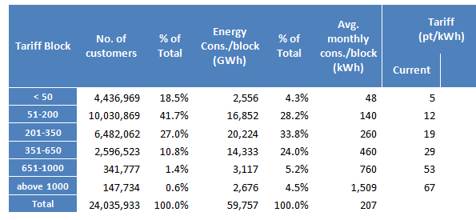

* Customers with zero meter reading (1.5 million) are not included.

Annex 7.8 UNDP Environmental & Social Safeguards
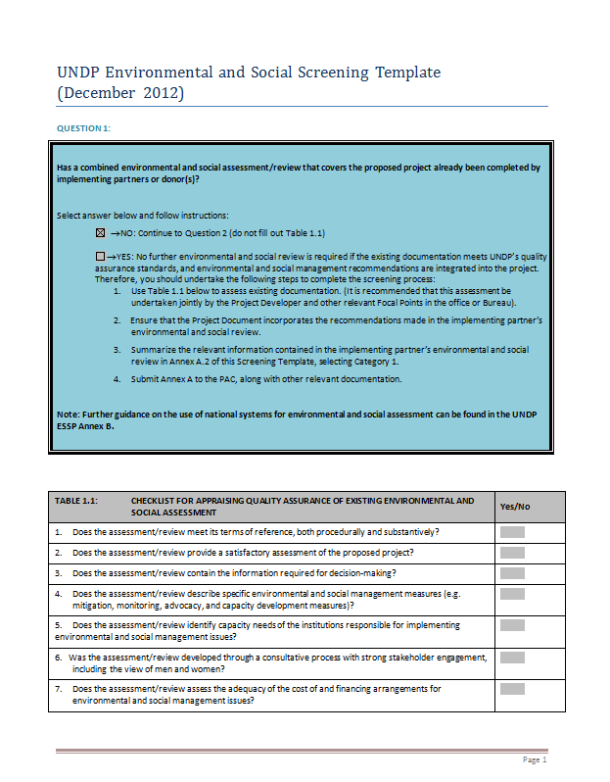

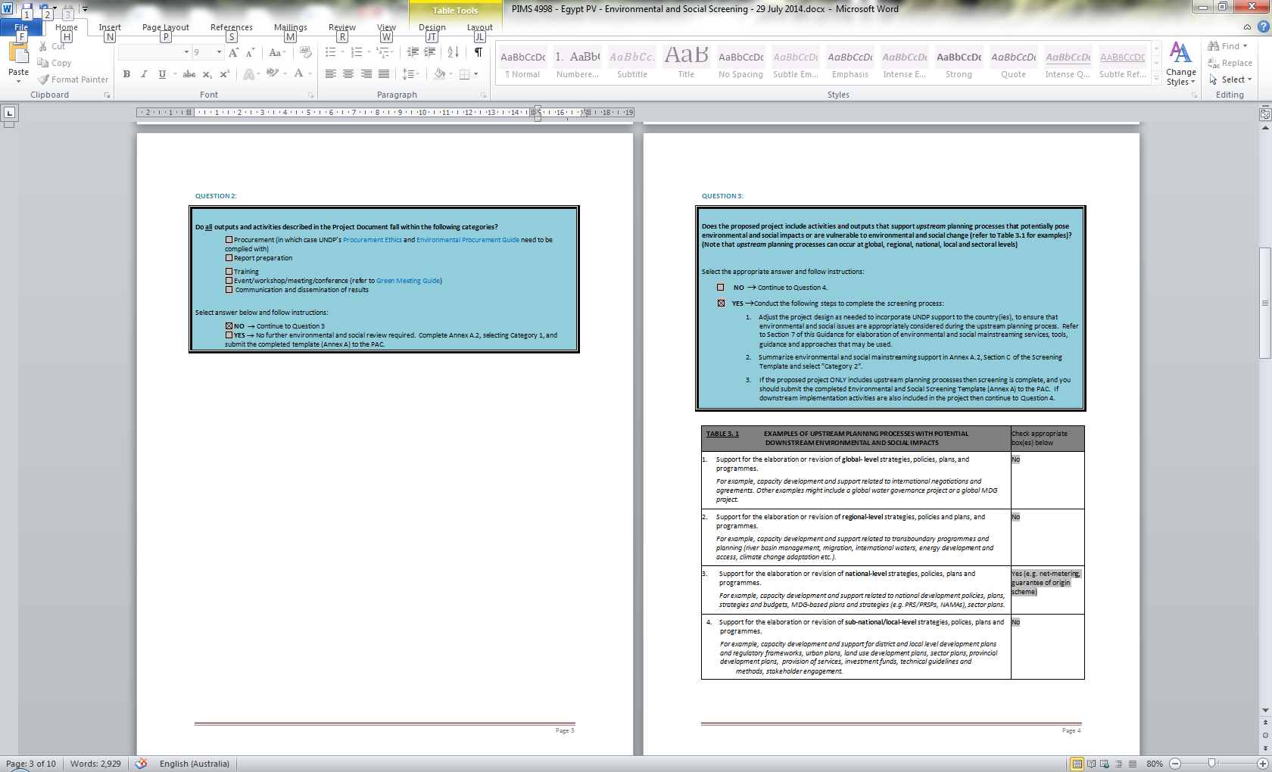

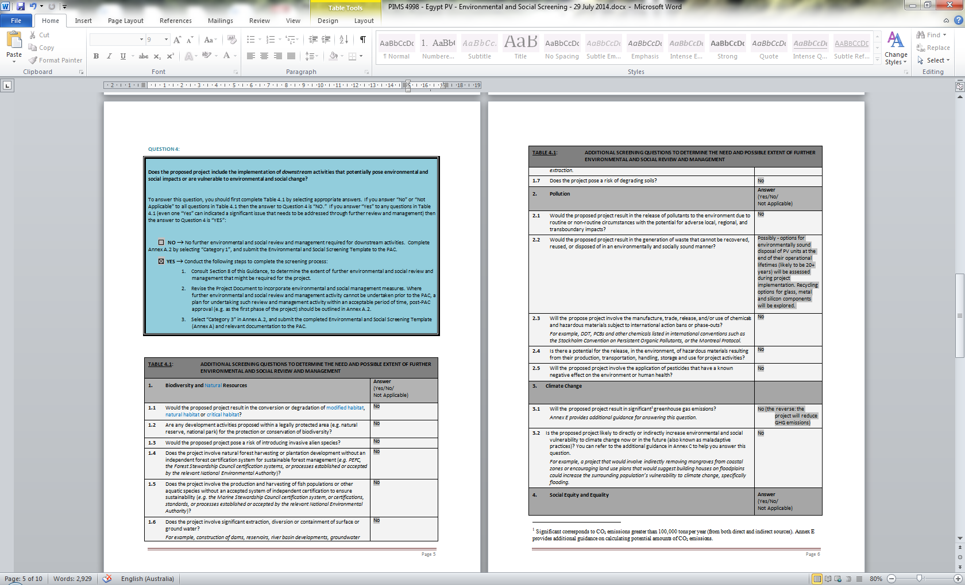

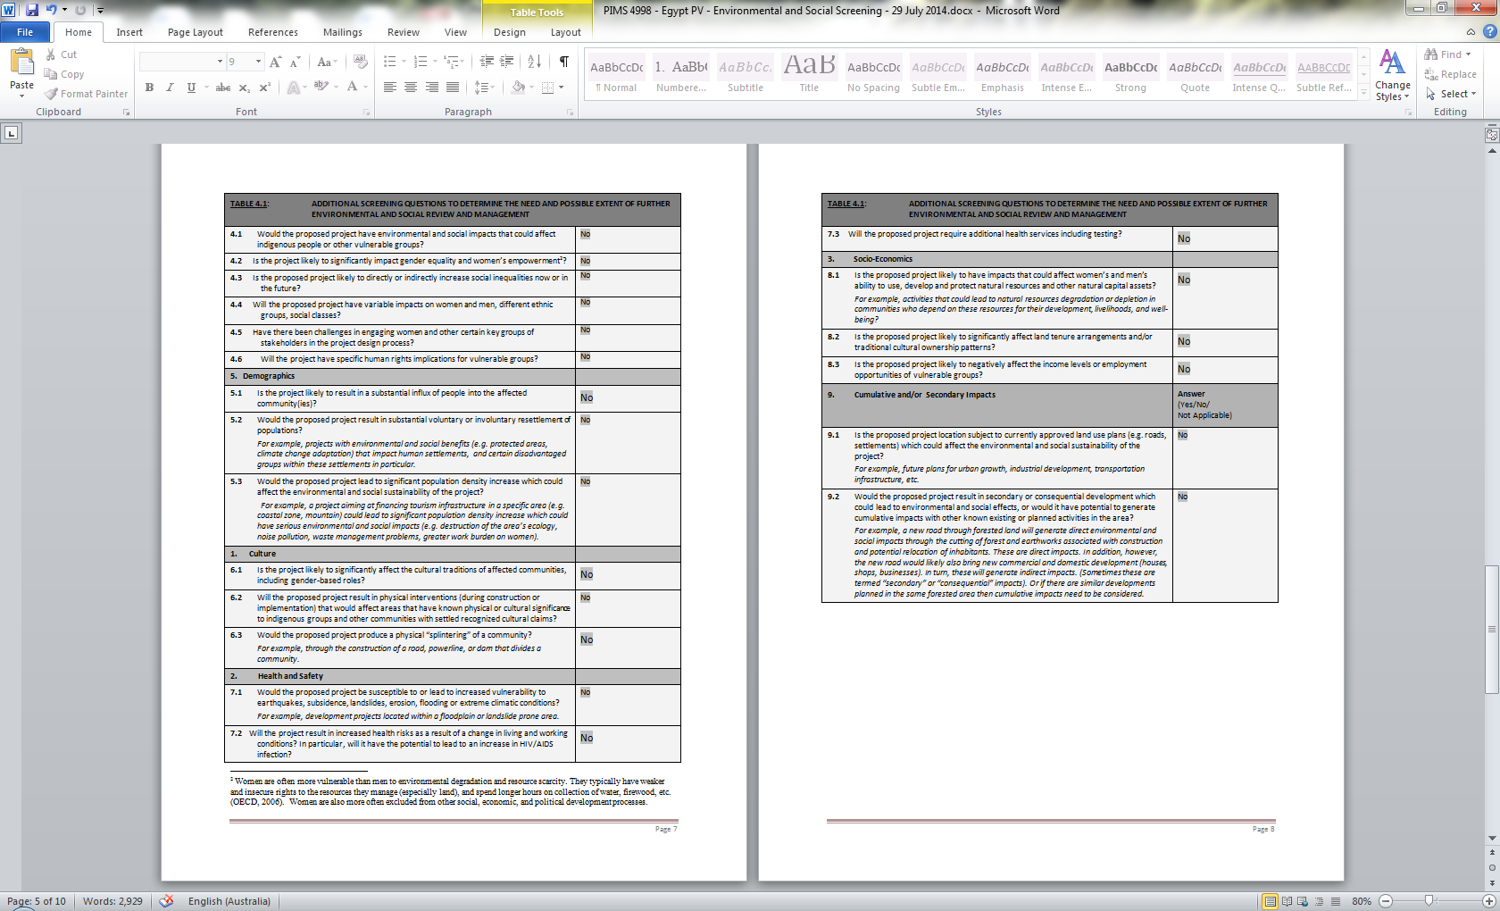

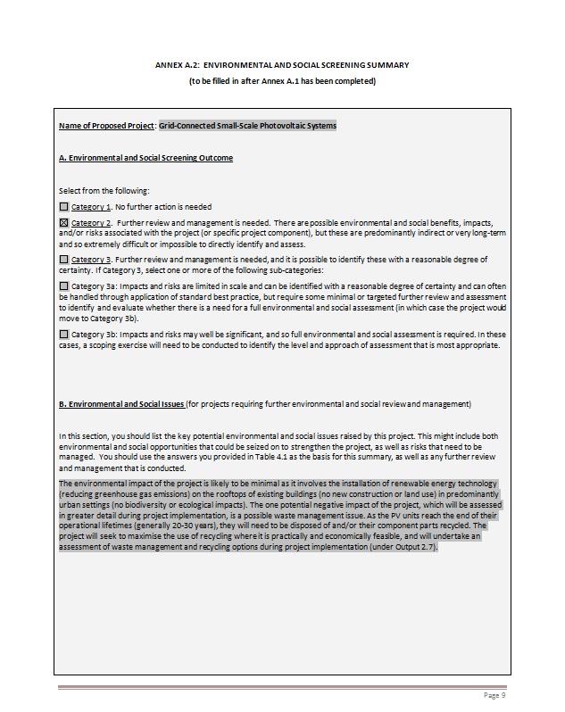

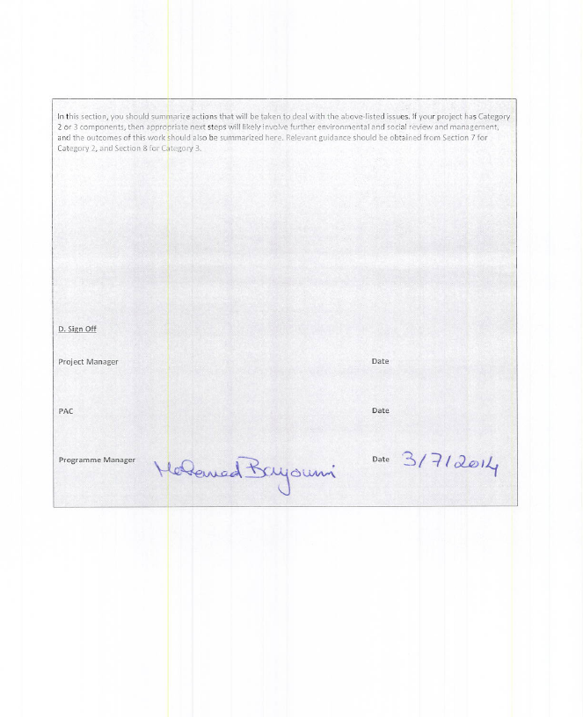

Annex 7.9 Letter of Agreement between UNDP and the Industrial Modernisation Center of Egypt

United Nations Development Programme

STANDARD LETTER OF AGREEMENT BETWEEN UNDP AND
INDUSTRIAL MODERNISATION CENTER, EGYPT
FOR THE PROVISION OF SUPPORT SERVICES

Under project "Grid-Connected Small-Scale Photovoltaic Systems of Egypt"
Sir,
- Reference is made to consultations between officials of the Government of Egypt (hereinafter referred to as "the Government") and officials of UNDP with respect to the provision of support services by the UNDP country office for nationally managed programmes and projects. UNDP and the Government hereby agree that the UNDP country office may provide such support services at the request of the Government through its institution designated in the relevant project document, as described below.
- The UNDP country office may provide support services for assistance with reporting requirements and direct payment. In providing such support services, the UNDP country office shall ensure that the capacity of the Government-designated institution is strengthened to enable it to carry out such activities directly. The costs incurred by the UNDP country office in providing such support services shall be recovered from the administrative budget of the office.
- The UNDP country office may provide, at the request of the designated institution, the following support services for the activities of the project:
  - Identification and/or recruitment of project and programme personnel;
  - Identification and facilitation of training activities;
  - Procurement of goods and services;
  - Financial support services
- The procurement of goods and services and the recruitment of project and programme personnel by the UNDP country office shall be in accordance with the UNDP regulations, rules, policies and procedures. Support services described in paragraph 3 above shall be detailed in an annex to the project document, in the form provided in the Attachment hereto. If the requirements for support services by the country office change during the life of a project, the annex to the project document is revised with the mutual agreement of the UNDP resident representative and the designated institution.

- The relevant provisions of the UNDP Standard Basic Assistance Agreement with the Government of Egypt dated 19 January 1987 (the "SBAA"), including the provisions on liability and privileges and immunities, shall apply to the provision of such support services. The Government shall retain overall responsibility for the nationally managed project through its designated institution. The responsibility of the UNDP country office for the provision of the support services described herein shall be limited to the provision of such support services detailed in the annex to the project document.
- Any claim or dispute arising under or in connection with the provision of support services by the UNDP country office in accordance with this letter shall be handled pursuant to the relevant provisions of the SBAA.
- The manner and method of cost-recovery by the UNDP country office in providing the support services described in paragraph 3 above shall be specified in the project document.
- The UNDP country office shall submit progress reports on the support services provided and shall report on the costs reimbursed in providing such services, as may be required.
- Any modification of the present arrangements shall be effected by mutual written agreement of the parties hereto.
- If you are in agreement with the provisions set forth above, please sign and return to this office two signed copies of this letter. Upon your signature, this letter shall constitute an agreement between your Government and UNDP on the terms and conditions for the provision of support services by the UNDP country office for nationally managed programmes and projects.

Your sincerely,

______________________
Signed on behalf of UNDP
Ignacio Artaza
Country Director

________________
For the National Implementing Agency:

Industrial Modernization Center, Egypt

Attachment 1

DESCRIPTION OF UNDP COUNTRY OFFICE SUPPORT SERVICES
- In accordance with the provisions of the letter of agreement and the project document, the UNDP country office shall provide support services for the project “Grid-Connected Small-Scale Photovoltaic Systems of Egypt” as described below.
- Support services to be provided:
Support services | Schedule for the provision of the support services | Cost to UNDP of providing such support services (where appropriate) | Amount and method of reimbursement of UNDP (where appropriate)
Services related to procurement (including but not limited to):  Procurement of goods  Procurement of services  - Consultant recruitment  - Advertising  - Short-listing & selection  - Contract issuance | Throughout project implementation when applicable | As per the pro-forma costs:  50 days over 60 months of GS5 Procurement Assistant: $ 7,712  15 days over 60 months of NOB Procurement Manager: $ 5,866 | UNDP will directly charge the project upon receipt of request of services from the Implementing Partner (IP)
Services related to finance (including but not limited to):  - Payments | Ongoing throughout implementation when applicable | As per the pro-forma costs:  118 days over 60 months of GS5 Finance Associate: $18,200  15 days over 48 months of NOB Finance Manager: $7,822 | As above
Total |  | $ 39,600

- For procurement services, Implementing Partner and UNDP will agree on the needed services in advance on quarterly basis
- UNDP service fees will be according to UN Universal Price List (UPL)

SIGNATURE PAGE
UNDAF Outcome(s)/Indicator(s): Environment and Natural Resources Management
CPAP Outcome(s)/Indicator(s): The Government of Egypt, private sector and civil society have complied with Multilateral Environmental Agreements, adopted policies, and implemented operational measures towards a green and sustainable economy and society including, EE, RE, low carbon cleaner technologies, SWM, POPs, ODS, and carbon finance mechanisms.
Executing Entity/Implementing Partner: Industrial Modernisation Centre of the Ministry of Industry and Foreign Trade
Implementing entity/Responsible Partner: United Nations Development Programme
Country: Egypt
Programme Period: 2014-2019
Atlas Award ID: 00080742
Project ID: 00090324
PIMS # 4998
Start date: March, 2015
End Date August, 2019
Management Arrangements NIM
PAC Meeting Date 29 March 2015

Total resources required US$ 33,796,364
Total allocated resources: US$ 33,796,364
- Regular UNDP (TRAC-Cash) US$ 50,000
- UNDP projects (Cash) US$ 400,000
- Other:
  - GEF (cash) US$ 3,536,364
  - EgyptERA (Parallel) US$ 15,000,000
  - MoEE (Parallel) US$ 10,000,000
  - EEU (Parallel) US$ 4,110,000
  - IMC (in-kind) US$ 500,000
  - RCREEE (in-kind) US$ 200,000

Agreed by (Executing Entity/Implementing Partner):
Date/Month/Year

Agreed by (UNDP):
Date/Month/Year

For UNDP supported GEF-funded projects, as this includes GEF-specific requirements
Including “isolated plants”, mainly diesel and gas turbine units with total capacity of 238 MW and one 5MW wind farm in Hurghada, installed in remote areas and connected to the local distribution networks.
Source: EEHC Annual Report, 2012/2013 (http://www.egelec.com/mysite1/annual%20report/annual%20report.htm)
Calculated on the basis of the fuel consumption data reported in the EEHC Annual Report, 2011/2012. The CAPMAS 2013 Statistical Yearbook provides a figure of 67.66 Mtonnes of CO₂, which likely consists of the GHG emissions from EEHC-managed power plants only.
http://www.iea.org/publications/freepublications/publication/KeyWorld2013.pdf
http://www.egyptindependent.com/news/minister-power-outage-could-reach-6-hours-daily-due-fuel-shortage
In 2011, power generation was using about 58% of all domestic gas supply.
http://www.rasmala.com/equity_report/Mena_Strategy_14Oct11.pdf
A more recent price of USD 1.8 per MBtu was brought up in discussions during project preparation, but has not yet been published on the website of the Ministry of Petroleum.
http://www.egyptoil-gas.com/read_article_issues.php?AID=646.
http://www.pavingtheway-msp.eu/index.php?option=com_downloads&task=category&cid=7&Itemid=56.
Based on unverified information about new gas tariffs for power generation received during the project development mission in January 2014. CC: combined cycle, ST: steam turbine and GT: gas turbine plant.
http://www.egyptera.com/en/Bill_Tariffs.htm.
Estimated price based on informal communication with the Ministry of Electricity and EgyptERA.
Source: PWMSP Egypt Power System Report 2020 (http://www.pavingtheway-msp.eu/).
http://www.afdb.org/fileadmin/uploads/afdb/Documents/Publications/ENERGY%20mpa%20ENG%20Power%20Sector%20Emer.pdf
https://www.mobinil.com/en/about/company-overview/social-responsibility/environment/documents
http://www.hsbc.com.eg/1/2/eg/about-hsbc-egypt/hsbc-in-the-community/community-2011
Source: http://www.epia.org/news/publications/
NREA Annual Report 2012, http://www.nrea.gov.eg/annual%20report/ANNUAL_EN_2011_2012.pdf.
Egypt receives an average of 5.5-7 kWh/m²/day over its entire land area, making it one of the sunniest countries in the world. Average onshore wind speeds in the Gulf of Suez area have been measured at 10.5 m/s at 60 m height, providing some of the best wind resources globally.
http://www.nrea.gov.eg/annual%20report/ANNUAL_EN_2011_2012.pdf.
Funds and technical assistance for the implementation of these projects were provided through mutual governmental agreements by Denmark (180 MW); Germany (160 MW); Spain (85 MW) and Japan (120 MW).
PWMSP Egypt Country Report (benchmarking) Power System Report 2020 (http://www.pavingtheway-msp.eu/.
As of March 2014, 200 MW of this is under construction. Agreements for complementary funding of new projects by KfW, EIB, French AFD, Japanese and Spanish Governments, EU Neighborhood Investment Facility (NIF), AfDB and others are in place and add up to total capacity of 1,340 MW.
http://www.undp.org/content/undp/en/home/librarypage/environment-energy/low_emission_climateresilientdevelopment/derisking-renewable-energy-investment/
See Chapter 1, footnote 2.
http://www.egyptera.org/en/t3reef.aspx.
Eventually requiring further discussion, as the system costs for smaller systems per installed kW_{p} are typically more expensive than for larger systems. In the German feed-in tariff system, for instance, a higher tariff is offered for PV systems under 10 kW_{p} (Source: http://www.germanenergyblog.de/?p=15234#more-15234).
http://www.egyptera.com/en/pdf/Seminar_EGYPT_Electricity%20Markets3.1_DAY2_Codes.pdf.
http://cdm.unfccc.int/methodologies/standard_base/index.html.
The studies should remain accessible on the PWMSP website www.pavingtheway-msp.eu, two years after the PWMSP projects’ closure i.e. until August 2015.
http://www.solarwirtschaft.de/preisindex.
With exchange rates of LE 1 = USD 0.1422 or EUR 0.1021 as of May 2014.
Equal to about 0.27 LE/kWh x 1,500 kWh/kW_{p} x 10 years with a 0% discount rate.
Based on an average consumption of 1,500 kWh per month, the amount exceeding the highest tariff category threshold would be 500 kWh per month or 6,000 kWh (12 x 500 kWh) per year.
By assuming average annual production of about 1,500 kWh/kW_{p}.
Considered a realistic target on the basis of consultations with EgyptERA.
http://www.pvlegal.eu
http://www.epia.org/projects/ec-projects/pv-grid.html
According to the Egyptian Central Agency for Public Mobilisation and Statistics (CAPMAS), the average household income in Egypt is around 25,000 LE/year. Households are divided into six income categories. The highest category starts at 50,000 LE/year.
‘Small, Decentralised Renewable Energy Power Generation’, UNDP-GEF, PMIS 4749.
‘Energy Efficiency Improvement and Greenhouse Gas Reduction Project’, UNDP-GEF, PMIS 3832.
PIMS 267
References: Egypt Second National Communication under the United Nations Framework Convention on Climate Change, May 2010 (http://unfccc.int/resource/docs/natc/egync2.pdf); Michel David (2010), "Coastal Zones and Climate Change", (http://www.stimson.org/images/uploads/research-pdfs/Title.pdf).
“A fifth of Egyptian youth unemployed in 2010: new data”, Ahram Online, http://english.ahram.org.eg/NewsContent/3/12/18653/Business/Economy/A-fifth-of-Egyptian-youth-unemployed-in--New-data.aspx.
“Power and water cuts across Egypt spark various protests” - http://thedailynewsegypt.com/2012/07/22/power-and-water-cuts-across-egypt-spark-various-protests/.
The Global Gender Gap Report, 2013, http://www3.weforum.org/docs/WEF_GenderGap_Report_2013.pdf.
Objective (Atlas output) monitored quarterly ERBM and annually in APR/PIR
All outcomes monitored annually in the APR/PIR. It is highly recommended not to have more than 4 outcomes.
Summary table should include all financing of all kinds: GEF financing, co-financing, cash, in-kind, etc.
All baseline activities and associated co-financing amounts presented in the table relate to the period after the approval of the PIF (or prodoc ?) . Baseline expenditures for activities already undertaken or which are expected to be undertaken after the end of the GEF project are not included in the PIF. Furthermore, the co-financing amounts stated in the table above are considered to be conservative estimates All co-funding from is in the form of parallel fund or in-kind contribution that will be managed by the relevant entity and no funds will be transferred to the UNDP accounts. The only funds that will be directly managed by the project management unit will be the GEF and UNDP funds
Senior Supplier: individual or group representing the interests of the parties concerned which provide funding for specific cost-sharing projects and/or technical expertise to the project. Senior Beneficiary: individual or group of individuals representing the interests of those who will ultimately benefit from the project.
Probability from 1 (low) to 5 (high)
Impact from 1 (low) to 5 (high)
Equal to about 0.27 LE/kWh x 1,500 kWh/kW_{p} x 10 years with a 0% discount rate.
GEF/C.33/Inf.18, Manual for calculating GHG benefits of GEF projects: energy efficiency and renewable energy projects, April 2008. For the default lifetime of the investments, the GEF manual gives for off-grid PV 10 years and for building integrated PV, wind and small-hydro 20 years. For good-quality PV panels, the guarantee provided by manufacturers is typically at least 20 years, with a real-life expectancy of around 25-30 years before the performance starts to significantly deteriorate. For the reasons above and considering the type of RE systems considered for this project, the use of a default lifetime of 20 years is justified.
More discussion about the default lifetimes used in the calculations can be found later in this Annex.
Calculated on the basis of an estimated 2 MW_{p} of new installed PV rooftop systems in 2019 (as an indirect impact of the project) and with an average annual growth rate of 20% in new installed capacity over 10 years subsequently.
Calculated on the basis of an estimate that 15% of the current high tariff category electricity customers of 150,000 households have installed a 3 kW_{p} rooftop PV system by 2029.
The 60% causality factor for the indirect impact of the project is chosen based on an assessment that the contribution of the UNDP-implemented, GEF-financed project to this impact is substantial, but modest development of the PV market would also likely to be observed in the baseline.

